2 July 2021

New mobile application from OneOcean enables a higher standard for HSEQ compliance

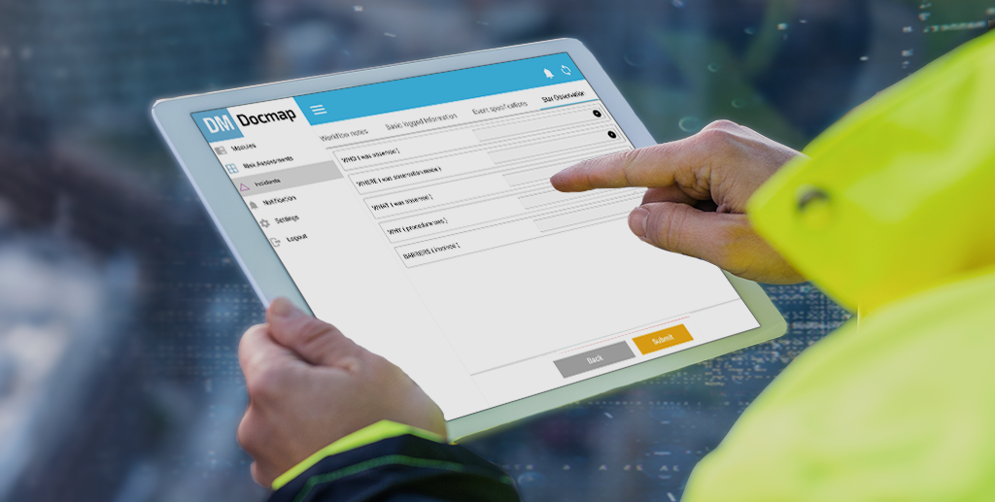
A new app allows users to easily access Docmap onboard, on and offline
OneOcean is excited to announce the launch of a mobile application as part of the latest update to Docmap, its acclaimed paper-free solution for HSEQ (Health, Safety, Environment and Quality) management.
Following a year of intensive development, Docmap 2021 now features a new app that allows users to easily access, complete and submit important reports through their mobile devices. Digital records, like risk assessments, checklists, incident reports, meeting minutes, near miss reports and observation reports that comprise a vessel’s Safety Management System (SMS) can be completed on the go, automatically syncing when the device connects to the internet. The app will save valuable time for crews and provide peace of mind. When a report is due, crew members can be notified through the app and complete the task using forms that are stored and saved in the application.
For ship management, the benefits are numerous. Companies design and upload forms for a variety of reports, allowing them to determine what information they need and receive back standardised responses that can then be easily tracked, validated, and compared. If there is an incident onboard, fleet managers can receive detailed reports right away through Docmap, allowing them to plan immediate remedial actions.
Shoreside users can analyse responses across their fleet, allowing them to spot trends, identify gaps and plan preventative actions that reduce risk. The result is a more robust safety management system that provides the visibility and oversight needed to maintain a higher standard of safety.
This flexibility and ease of use contributes to the rapid implementation of safety improvement measures both on individual vessels and at fleet level. “The updates are enormously beneficial for shore-based staff and vessel crews alike,” says Martin Taylor, OneOcean CEO. “Workflows will be streamlined, reducing stress and providing peace of mind. The new functionality provides a much higher level of convenience and efficiency. If there is an incident, all parties can take corrective actions much more quickly.”
To find out more about Docmap can help your organisation, contact our team today.

ENDS

For press enquiries please contact:
Steph Raikes-Cairns
Head of Marketing
+44 1992 805 478
Steph.RaikesCairns@oneocean.com

About OneOcean

OneOcean is the largest single digital solutions company in the maritime industry and the global leader in digital navigation and voyage compliance. The business supports over 15,000 vessels in their regulatory and navigational activities, making life easier for ship owners and managers, both onboard and onshore. Its aim is to simplify e-navigation and compliance with the powerful OneOcean platform built for the future while giving onboard and onshore teams the real-time information they need when they need it.

For further information, visit www.oneocean.com

