

Fact Sheet

Logitech® G933 Artemis Spectrum™ Wireless 7.1 Gaming Headset
Gaming headphones for serious audiophiles.

Announcement Date: Aug. 27, 2015 Shipping: October 2015
Price: €199.99 Available at: gaming.logitech.com

Product Description
Experience your gaming and audio like never before with the Logitech® G933 Artemis Spectrum™ 7.1 Wireless Headset. Compatible with PC, consoles, mobile devices and home theater devices, the Logitech G933 features patent pending Pro-G™ audio drivers and were designed by Logitech’s sound engineering team, with more than 25 years in audio development. With 7.1 Dolby® Surround Sound and DTS Headphone:X*, these headphones deliver a superior all-around audio experience. The G933 is customizable, featuring RGB lighting, swappable backlit speaker plates, programmable G-keys and onboard software equalizer to customize audio settings and create personal sound profiles.

Key Features
- Superior All-Around Audio: From your favorite music to expansive game soundtracks, the patent pending Pro-G audio drivers deliver both clean and accurate highs as well as a deep rich bass that you would expect from premium headphones. These are also the first headphones to offer both Dolby and DTS Headphone:X* surround options to gamers. The Pro-G audio drivers and surround sound technologies create lifelike in-game spatial awareness, allowing you to clearly hear enemies sneaking around, or special ability cues. DTS Headphone:X* technology utilizes calibration and processing that brings gamers and audio fans closer to the studio experience than ever before, supporting up to 7.1 channels of audio and multiple options for personalization.
- Multi-Platform Support and Sound Mixing: Logitech G933 works with PCs, mobile devices and consoles – including PlayStation® 4 and Xbox One™– and features one USB mix adapter and two analog inputs that connect and mix sound from up to three devices. As you are fending off your gaming enemies from your PC, you can simultaneously order a pizza on your cell phone without missing a moment of action. Additionally, it works with your home theater (through a USB port and RCA audio out) to provide the perfect wireless home theater experience, so you can listen in your living room to anything connected to your home receiver or TV, from movies to vinyl records, without any cables.
- Personalized Programmability and RGB Lighting: Use Logitech Gaming Software to program lighting, audio and buttons. Adjust RGB lighting from up to 16.8 million colors and assign custom game macros on three programmable G-keys for a seamless gaming experience. A software equalizer lets you customize audio settings and create personal sound profiles so you can listen to music, games and movies with preset audio preferences.
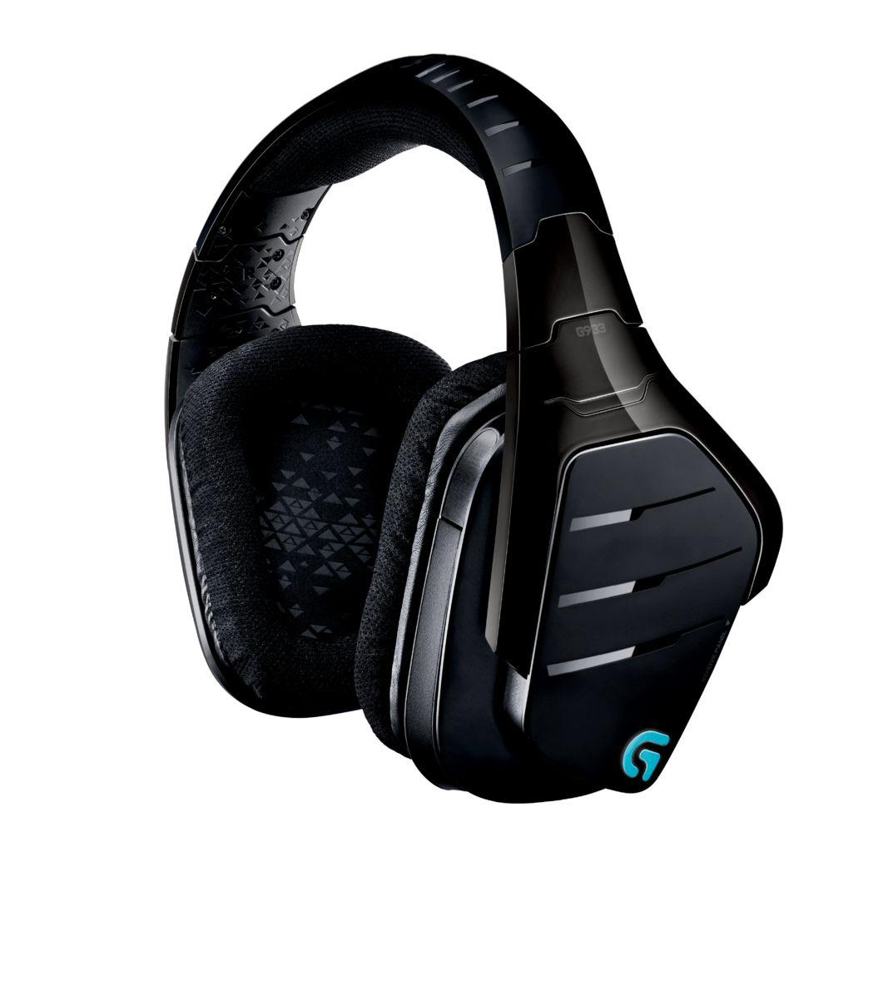
- Game Wired or Wirelessly: Logitech G933 offers the option to play wired or wirelessly, with ultra-low latency on 2.4GHz wireless. Alternatively, use the included analog cable and 3.5 mm analog input on the headset to play without using battery power. The wireless USB mix adapter allows you to use your analog audio or mobile devices wirelessly.
- Foldaway, Noise-Cancelling Mic: Logitech G933 features a crystal-clear noise-cancelling boom mic. An indicator LED lets you know when your microphone is on mute. When not in use, the mic can be folded back into the headset.

System Requirements
- Windows® 7 or higher
- Internet connection for Logitech Gaming Software installation
- USB port, 3.5 mm audio port or RCA audio output ports
- 7.1 surround sound, DTS Headphone:X*, lighting configuration, and G-key programming require Logitech Gaming Software

Product Specifications
- Headphones
  - Driver: 40 mm
  - Frequency response: 20Hz-20KHz
  - Impedance: 39 Ohms (Passive), 5k Ohms (Active)
  - Size: 190 mm x 180 mm x 94 mm
  - Weight :374 grams (13.19 oz)
  - Sensitivity: 107dB SPL/mW
- Microphone
  - Size: 4 mm
  - Type: Condenser-Cardioid
  - Frequency response: 100Hz-20KHz

Warranty
- 2-year limited hardware warranty

*DTS Headphone:X support will be available through a Logitech Gaming Software update in early Oct. 2015

Press Contact
Wendy Spander
Logitech
510-713-5393
wspander@logitech.com

