Press Release
Stockholm, February 8, 2016

Svenskt Tenn exhibits – As If By Chance

In conjunction with the Stockholm Furniture & Light Fair, Svenskt Tenn recreates three interiors by Josef Frank. The exhibition “As If By Chance” reflects Frank’s philosophy of Accidentism – the idea to fashion the room in a seemingly random way.

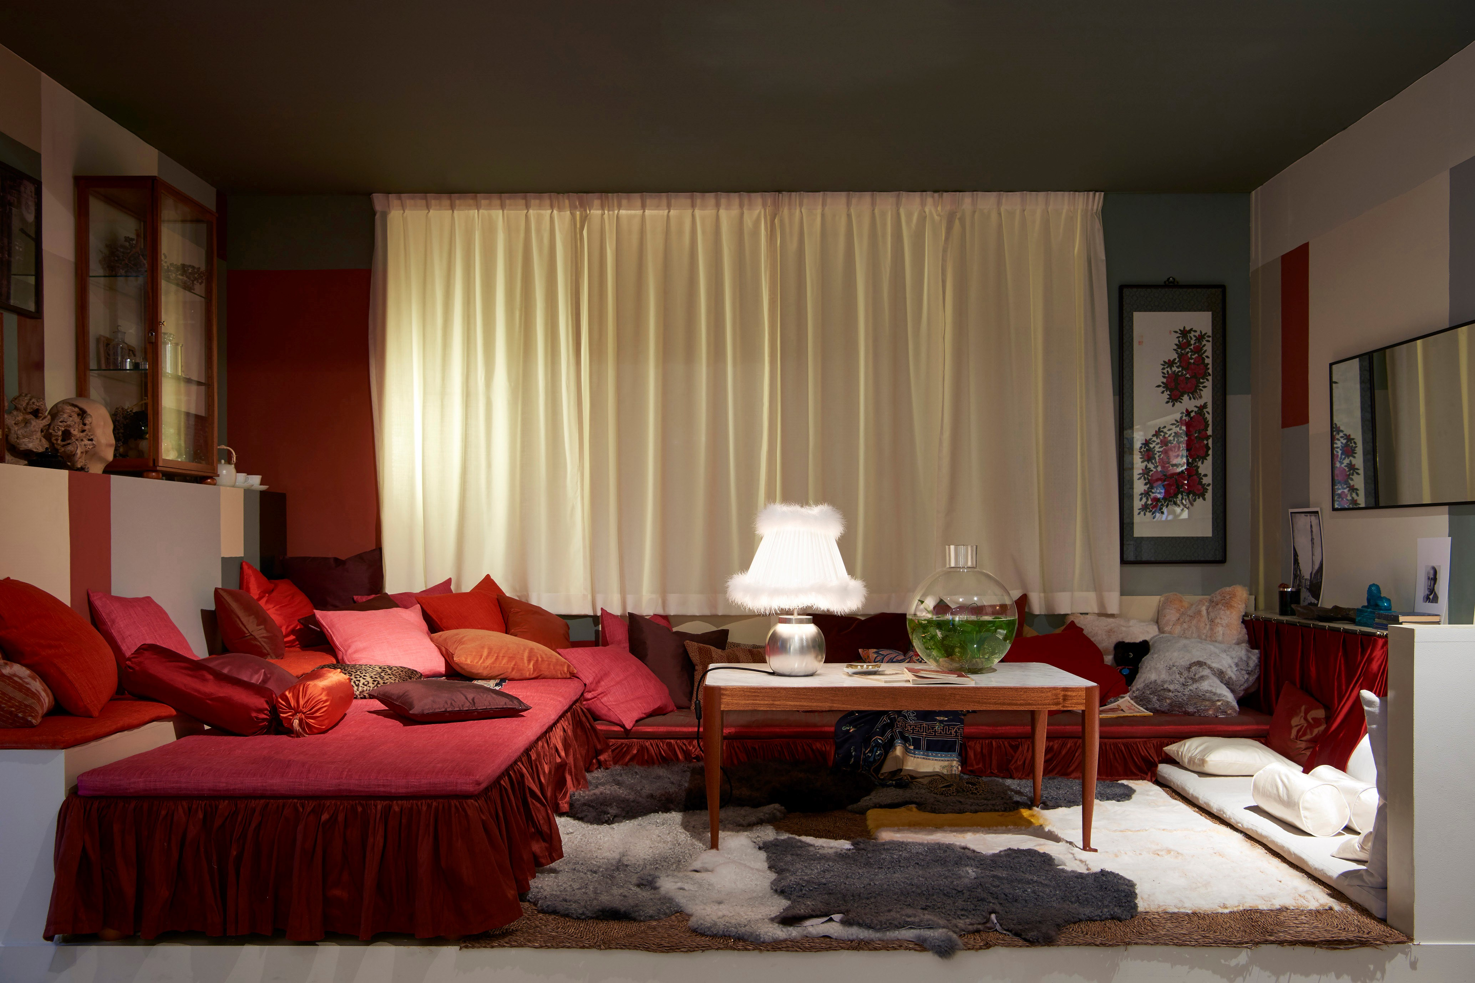
Josef Frank’s personal style went completely against the strict functionalist ideals of the 1930s. He used colours and patterns, included both high and low, and did unabashed borrowing from various cultures and eras. Josef Frank called this “Accidentism” or “The philosophy of fortunate coincidence.”

The architects Mikael Bergqvist and Olof Michélsen wrote the book Accidentism, published in 2005. In the new exhibition “As If By Chance”, they have used parts of Svenskt Tenn’s current product range to restage three interiors by Josef Frank.

“The first is a boudoir exuding a slightly decadent atmosphere,” says Mikael Bergqvist. “The second environment comprises a dinner setting where randomness and disorder are the dominant precepts. The third environment is a motley collection of furniture and lamps that brings to mind a conversation between a group of individuals, each with different characteristics and modes of expression.”

Through the exhibition, Svenskt Tenn intends to animate Josef Frank’s thoughts on creating a timeless, personal style where no two interiors will look alike.

“The exhibition interiors have been meticulously planned, but are presented as if they were configured by chance, showing how Josef Frank’s ideas on Accidentism can be realised,” says Thommy Bindefeld, Marketing Director at Svenskt Tenn. “Art, furniture, carpets and accessories appear to be randomly placed.”

The exhibition runs from February 9 through March 29, 2016.

For further information, please contact:

Vicky Nordh, Press Contact: +46 8-670 16 23 or vicky.nordh@svenskttenn.se

Thommy Bindefeld, Marketing Director: +46 8 670 16 02 or thommy.bindefeld@svenskttenn.se

Svenskt Tenn is an interior design company with retail stores at Strandvägen in Stockholm and online. Since 1975, Svenskt Tenn is owned by the Kjell and Märta Beijer Foundation, which provides research grants within ecology, medicine and the preservation of Swedish interior design tradition.

