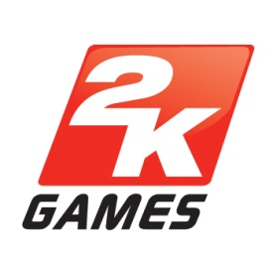

MEDIA ADVISORY

2K Games and Gearbox Software to unveil interactive digital artwork at gamescom 2012

Europe’s top graffiti artists to produce a live-streamed Borderlands® 2 mural

Windsor, UK, August 17, 2012 – Borderlands 2 fans are in for a treat at this year’s gamescom after 2K Games and Gearbox Software today announced a ground-breaking project to celebrate the unique art style and direction of the game.

Leading graffiti artists Sam Hope (UK) and Dave More (Germany) will collaborate to create a 20ft mural of the colourful world of Borderlands 2’s Pandora, featuring key characters, items and environments, which will be live-streamed online.

Taking the project one step further in true Borderlands style, individual artwork will reveal exclusive online content as sections of the mural are completed, transforming it into one of the largest interactive digital artworks ever created.

A select number of lucky fans will also get the chance to take away a piece of Borderlands 2 history; from the 21st August, the completed individual artworks will be given away for free via a Sweepstakes on Twitter.

Gamescom attendees can watch the mural taking shape on Friday 17th August from 9am CET outside the Koelnmesse Convention Centre, and the live-stream will be available for everyone worldwide at www.aworkofart.eu.

Borderlands 2 is the sequel to the critically acclaimed four-player cooperative shooter-looter that combined intense first-person mayhem with role-playing gameplay. Borderlands 2 features all-new characters; skills; imaginative, diverse new environments with unique missions and enemies; and more exciting and fun weapons, equipment and loot than ever before. All of these features come together in a story that takes players to the world of Pandora to take down the notorious Handsome Jack and his corrupt Hyperion Corporation as a solo campaign or with up to four cooperative players.

Borderlands® 2 will be available internationally on September 21st 2012, and in North America on September 18th 2012. Borderlands® 2 is not yet rated by PEGI. For more information please visit: www.borderlands2.com.

2K Games is a division of 2K, a publishing label of Take-Two Interactive Software, Inc. (NASDAQ: TTWO).

All trademarks and copyrights contained herein are the property of their respective holders.

# # #
CONTACT:
Name
2K Games
Tel
E-mail

