 FOR IMMEDIATE RELEASE

Contacts:

|  |  |  |  |
| --- | --- | --- | --- |
| EU: | Daniela Karthaus | Japan: | Kazuki Fujiwara |
|  | Hitachi Rail Europe Ltd. |  | Hitachi, Ltd. |
|  | +44-7920 205 631 |  | +81-3-5208-9324 |
|  | daniela.karthaus@hitachirail-eu.com |  | kazuki.fujiwara.td@hitachi.com |

**Hitachi Begins Shipment of Trains from Kasado Works   
for the UK Intercity Express Programme**

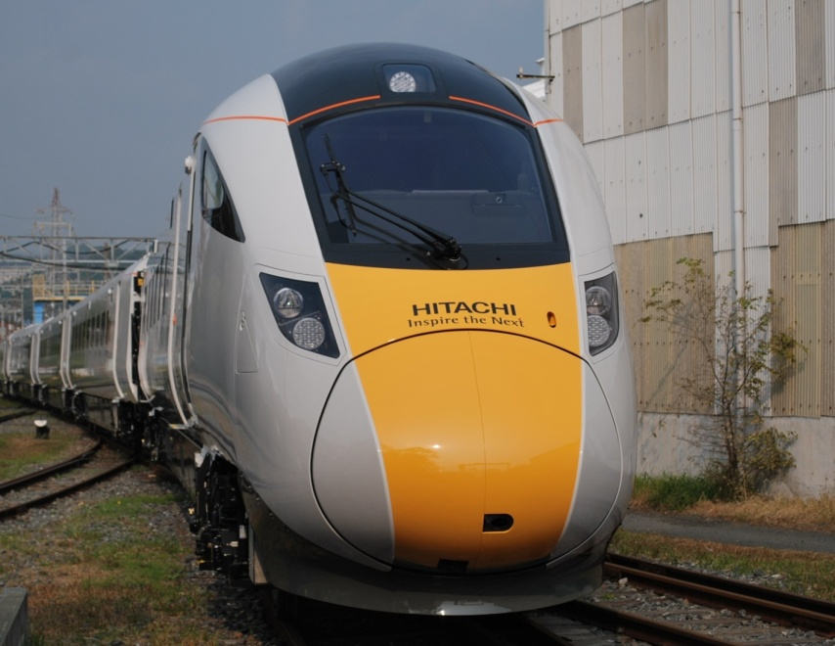

A Class 800 train is being loaded for shipment

**Tokyo, Japan, January 7, 2015** --- Hitachi, Ltd. (TSE:6501, “Hitachi”) announced today that it has begun shipment of the first completed pre-series Class 800 train unveiled in November 2014. The train has been produced for the UK Department for Transport’s Intercity Express Programme (IEP), and following its recent completion is now being shipped from Kasado Works in Kudamatsu City, Yamaguchi Prefecture.

This project is being undertaken based on a Public Private Partnership (PPP) scheme led by the British Department for Transport. Financial support is being provided by the Japan Bank for International Cooperation (JBIC) and Nippon Export and Investment Insurance (NEXI), among other organisations.

The train being shipped will arrive in the UK in March of this year, after which it will be equipped with various measurement devices for testing. This train is scheduled to begin running tests, as well as serving for training of onboard staff, from April of this year. The running tests are to be carried out on the UK Rail Network by Hitachi Rail Europe, to enable acceptance by Agility Trains, the special-purpose company that will own the trains, and who will provide the trains for the operating companies First Great Western and Inter City Railways.

The train shipped today will arrive at Kobe Port on January 22, and will be bound for the UK after being loaded on a large ship.

Hitachi is currently in the process of building a Rail Vehicle Manufacturing Facility at Hitachi Rail Europe in Newton Aycliffe, County Durham, in the UK. This plant, which represents an investment of approximately £82 million, will be completed in summer 2015, and production of Class 800 series trains is scheduled to begin in 2016. The hiring of employees for the train plant has already begun, and a total of approximately 730 staff members are eventually expected to be hired, including research and development facilities staff.

**About Hitachi, Ltd.**

Hitachi, Ltd. (TSE: 6501), headquartered in Tokyo, Japan, delivers innovations that answer society’s challenges with our talented team and proven experience in global markets. The company’s consolidated revenues for fiscal 2013 (ended March 31, 2014) totalled 9,616 billion yen ($93.4 billion). Hitachi is focusing more than ever on the Social Innovation Business, which includes infrastructure systems, information and telecommunication systems, power systems, construction machinery, high functional materials and components, automotive systems, healthcare and others. For more information on Hitachi, please visit the company's website at <http://www.hitachi.com>.

**# # #**