The New Podcast Series from HISTORY:

NOT WHAT YOU THOUGHT YOU KNEW SERIES 2
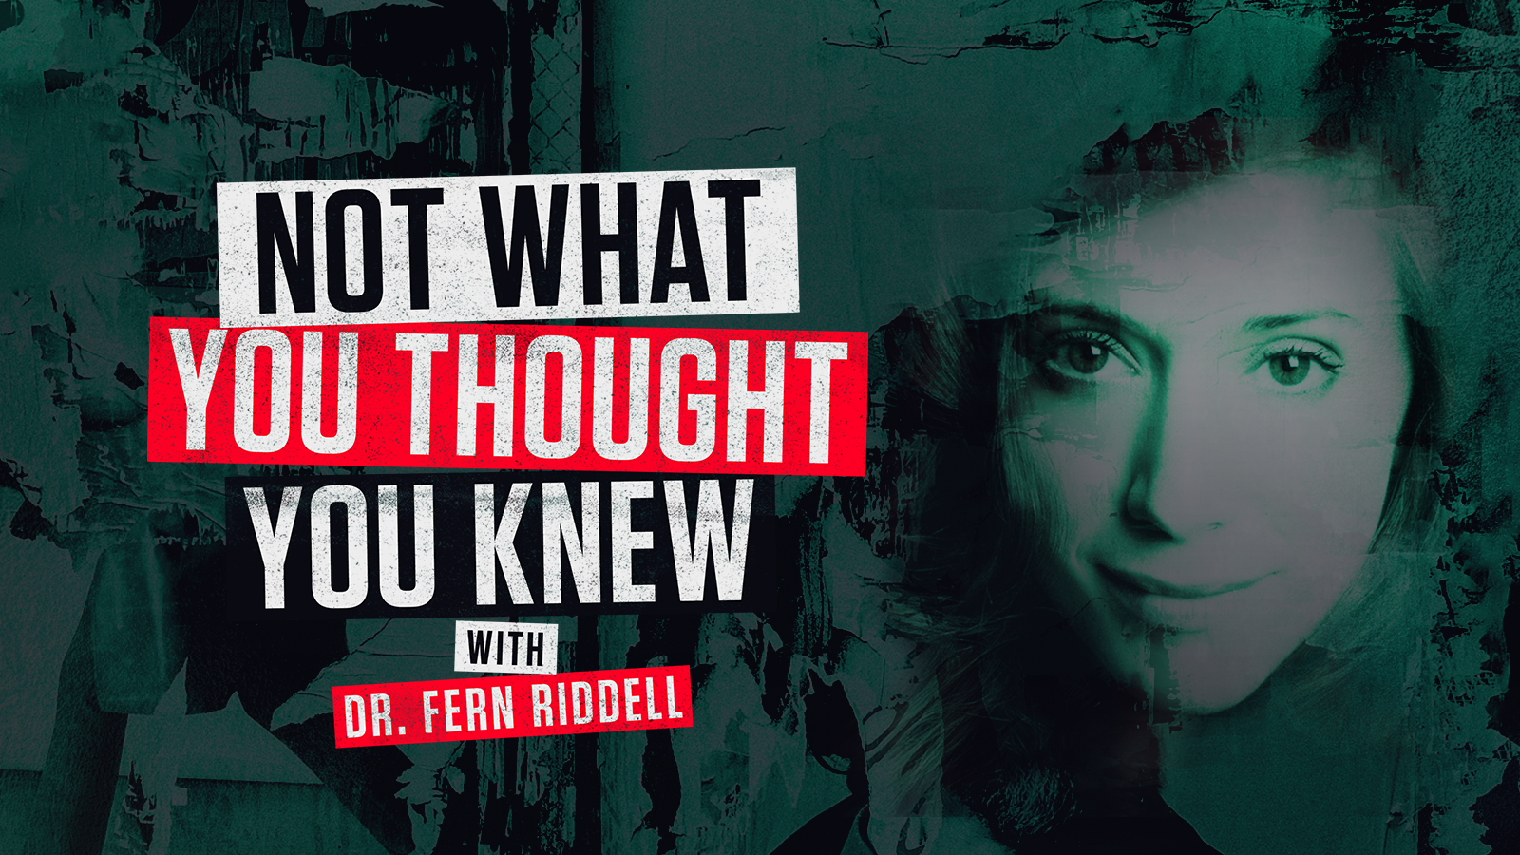
EPISODES AVAILABLE WEEKLY FROM TUESDAY 15 SEPTEMBER
Podcast available on Apple Podcasts, Acast, Spotify

Download images from the series here
#NotWhatYouThought
@HISTORYSverige @HISTORYNorge @HISTORYDanmark
@FernRiddell

Not What You Thought You Knew from HISTORY, with leading British historian Dr Fern Riddell, launches Tuesday 15th September on all major podcasting platforms.

The new eight-part podcast series focuses on fascinating and little-known stories and characters from history, shedding new light on events you may have thought you knew all about but probably didn’t…Or, at least, not this aspect of them….

Each chapter unearths largely unknown personalities and details from history; from the incredible facts about female Viking warriors and the elite Theban warrior core, (made up of 150 pairs of male lovers), to Europe’s first openly transgender combat soldier and the Soviet Night Witches; the fearless Russian female fighter-bomber pilots who struck terror into the hearts of German troops on the Eastern Front in World War 2.

Episodes four to seven of the podcast focus on Black History Month in October and feature the remarkable story of Britain’s first black footballers, as well as Allen Noel Mins, whose bravery in the Royal Army Medical Corps earned him the Military Cross and DSO, and Olaudah Equiano who, despite being bought and sold as a slave several times throughout his life, helped pave the way for abolitionism in Britain.

Dr Fern Riddell said: “Hosting Not What You Thought You Knew is a joy. I’ve never had the opportunity to investigate historical stories with other experts before, and to sit and have a conversation with leaders in their field, about things that will challenge and surprise our listeners, well it’s just a dream come true. We have a great young team committed to breaking apart stereotypes, and that’s at the heart of every episode we make.”

Think you know history? Think again.

The first episode of Not What You Thought You Knew launches on Tuesday 15 September with Inghen Ruaidh and the Birka Viking grave, with the following episodes released weekly thereafter.

DR FERN RIDDELL IS AVAILABLE FOR INTERVIEW ON REQUEST
EPISODES

Episode 1: Inghen Ruaidh and the Birka Viking Grave
More than a millennium ago in Sweden, a wealthy Viking warrior was laid to rest, in a grave filled with swords, arrowheads, and two sacrificed horses. The site reflected the ideal of a Viking male warrior life but new DNA analyses of the bone the grave belonged to a woman. Does this help back up legendary representations of Viking warrior women such as Inghen Ruaidh?

Episode 2: The Chevalier d'Éon
A soldier and diplomat he was one of the most colourful and celebrated characters in eighteenth-century Britain. Although born in France, he lived in London from 1762-1777 as a man, and from 1786-1810 as a woman - she was the first openly transgender person in European history.

Episode 3: The Night Witches of WW2
They flew at night in plywood biplanes. They braved bullets and frostbite in the air, while battling scepticism and sexual harassment on the ground. They were feared and hated so much by the Nazis that any German airman who downed one was automatically awarded the prestigious Iron Cross medal. They were a crucial Soviet asset to winning the Second World War.

Episode 4: Olaudah Equiano
Kicking off Black History Month, the podcast topic is Olaudah Equiano. He was known for most of his life as Gustavus Vassa, was a writer from the Eboe region of the Kingdom of Benin. Enslaved as a child, he was taken to the Caribbean and sold as a slave to a Royal Navy officer. He was sold twice more but purchased his freedom in 1766. In 1783 he played an integral role in a famous court case that spurred on the abolitionist movement.

Episode 5: The Ivory Bangle Lady
The Ivory Bangle Lady is the name given to remains discovered in York in 1901 which are now on display in the York Museum. Archaeological analysis reveals that although she was born in Roman Britain, she’s likely to be of North African descent. She was found with jet and elephant ivory bracelets, earrings, pendants, beads, a blue glass jug and a glass mirror; so clearly a person of some note and reverence.

Episode 6: Allan Noel Minns
A black military officer during the Great War and the son of Britain’s first Black mayor, Allan Noel Minns was an English doctor of African-Caribbean descent who served as an officer in the British Army.

Episode 7: Britain’s First Black Footballers
In 1925, Jack Leslie had his England international call-up taken away, 44 years after Scotland’s Andrew Watson had become Britain’s first Black international player. We look at historic representations of footballers in newspaper coverage and compare it to today, where we are still on the hunt for equality in the beautiful game.

Episode 8: The Sacred Band of Thebes
Thebes was one of the powerful city-states that in the 4th century controlled modern-day Greece and one of the main rivals to the empire of Athens. The Sacred Band were an elite troop of warriors within the Theban army formed by the Theban general Gorgidas that consisted of 150 pairs of male lovers.

ENDS
Editor’s Notes
- Sky HISTORY is the flagship brand of the A+E Networks UK portfolio and was rebranded from HISTORY in the UK only in May 2020. Not What You Thought You Knew podcast from Sky HISTORY appears globally via all major podcast providers
- Clips, viewing materials and images to be provided on request.
- Images available here.
- Interviews with production team available on request.
- Facebook: @HISTORYSverige / @HISTORYNorge / @HISTORYDanmark; Instagram: @HISTORYSverige| #NotWhatYouThought

For more information please contact:

Jo Fellows at A+E Networks UK / Joanna.Fellows@aenetworks.co.uk / +44 7583 022 665
Adel Brandlin at A+E Networks UK / Adel.Brandlin@aenetworks.co.uk

About HISTORY®
HISTORY is the flagship brand of the A+E Networks UK portfolio which is made up of true crime channel Crime+Investigation®, entertainment channel Lifetime®, HISTORY2® and free to air channel BLAZE.

About A+E Networks® UK
A+E Networks® UK, a joint venture between Hearst and Sky, is a leading media network reaching 60 million homes across 100 countries. With our portfolio of popular, high-performing and creative brands - HISTORY®, Crime+Investigation®, Lifetime®, HISTORY2® and UK free to air BLAZE® - we have entertained and inspired audiences for over 20 years; telling the stories that need to be told. Our award-winning factual and entertainment content includes global hit franchises like Forged in Fire and Born this Way, must see dramas Knightfall and Vikings as well as original local commissions including: Al Murray’s Why Does Everyone Hate the English and Murdertown with Katherine Kelly (UK), Married at First Sight (Africa) and The Hunt for Baltic Gold (Poland). We complement our programming with innovative talent-led exclusive digital content and top-rated podcasts. We currently partner with over 360 operators broadcasting throughout the Nordics, Benelux, Central Europe, the Middle East and Africa. We have offices in London, Warsaw, and Johannesburg. https://www.aenetworks.tv / @AENetworksUK

