FOR IMMEDIATE RELEASE

Pan Pacific Singapore Welcomes the Year of the Rat with Convivial Dining Experiences for the Whole Family

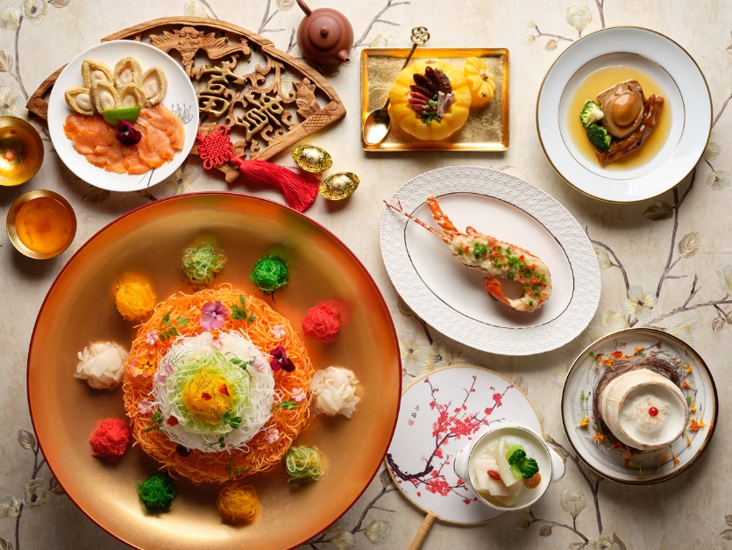
Luxurious Celebratory Set Menus at Hai Tien Lo
Singapore, 21 November 2019 — Pan Pacific Singapore presents the perfect venue for families to create cherished memories and celebrate the dawn of new beginnings. Capturing the spirit of joy and prosperity of the Lunar New Year, guests can sample a fine display of culinary artistry in the form of delectable dining experiences curated for the whole family from 30 December 2019 to 8 February 2020.

Luxuriate in an exquisite selection of set menus showcasing the best of Cantonese fine dining at Hai Tien Lo (海天楼), savour the multitude of time-honoured favourites at Edge, or experience the decadence of Chinese culture combined with Japanese savoir-faire with the specially crafted yu sheng at Keyaki. For guests who are looking to celebrate with their business associates or extended family, the Keyaki Garden Pavilion and Pacific Ballroom are great alternatives. Guests can also bring home a treasure trove of auspicious treats and signature goodies from Pacific Marketplace, ideal as gifts and for celebrations at home.

Prosperous Celebrations at Hai Tien Lo featuring Premium Ingredients (9 January to 8 February 2020)

Headed by Executive Chef Ben Zeng, Hai Tien Lo presents nine luxurious set menus showcasing the finest Cantonese delicacies available from 9 January to 8 February 2020.

The auspiciously-named menus showcase a remarkable array of superb ingredients featuring classic celebratory fare such as Double-boiled Chicken Soup with Whole Abalone, Sea Conch and Korean Ginseng; Baked Fillet of Sea Perch in Champagne Sauce; and Double-boiled Bird’s Nest with Almond Cream served in Young Coconut. Specially curated for vegetarian diners, the restaurant’s Blossoming Spring Set Menu comprises a feast of meatless delights from a nourishing Double-boiled Maltose with Bamboo Pith, Matsutake Mushrooms and Chinese Herbs to the aromatic Braised Bean Gluten with Sliced Vegetarian Abalone and Chinese Mushrooms in White Truffles Sauce for a western touch.

A plethora of mouth-watering a la carte selections are also available for revellers such as the hearty Double-boiled Sea Treasures with Whole Abalone, Sea Cucumber, Fish Maw, Dried Scallops, Fresh Prawn and Pine Mushrooms served in Young Coconut bursting with the most luxurious seafood of the season, a fragrant Bi Fong Tong Style Wok-fried Lobster with Fermented Minced Garlic accompanied with Fish Noodles; and the satisfying Steamed Boston Lobster Dumplings.

Plentiful Dim Sum Buffet
Diners can re-unite with their loved ones over Hai Tien Lo’s tantalising Lunar New Year Weekend Buffet. The extravagant feast features decadent Chef specialties of Egg Tart with Swiftlet’s Nest, Braised Classic Whole Abalone with Dried Oysters and Black Moss and Sliced Barbecued Honey-glazed Pork with Osmanthus. The sumptuous experience also includes all-you-can-eat Dim Sum such as Steamed Charcoal Barbecue Pork Bun with Black Truffle, Steamed Chicken Feet with Black Pepper Sauce and Pan-fried Rice Flour Rolls with Dried Scallops in Chef’s Signature Homemade XO Chilli sauce. Every table, with a minimum of two diners, will receive a complimentary Abundance Yu Sheng with Smoked Salmon and Crispy Silver Whitebait.

Refer to Appendix B for Hai Tien Lo’s Chinese New Year Set Menus.

To a Fortune-filled Year Ahead

Hai Tien Lo presents six indulgent Yu Sheng platters for diners to toss their way to a year of abundance and prosperous fortune. The delicious assortment includes the Chef’s Recommended Nutritious Blossoming Treasures Yu Sheng that packs a healthful punch with Gold and Silver Flakes, Hokkaido Scallops, Walnuts, Shredded Mixed fruits and Vegetable Salad in Sweet and Sour Thai Sauce (SGD138 serves four to six / SGD198 serves seven to ten), and the ultra-luxe Fortune Yu Sheng with Lobster, Surf Clams, Crispy Whitebait and Jelly Fish (SGD128 serves four to six / SGD188 serves seven to ten). Priced between SGD48 and SGD188 per platter, Hai Tien Lo’s decadent Yu Sheng platters* are available in both small and large portions for dine-in and takeaway from 30 December to 8 February 2020.

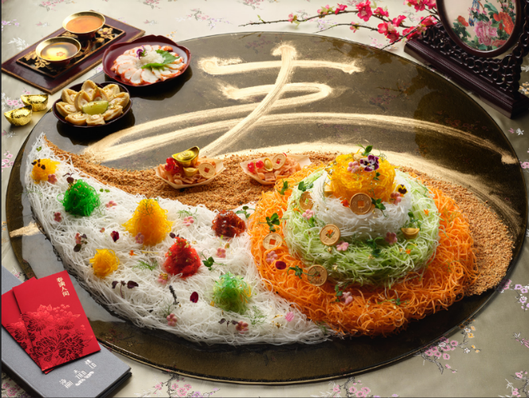
An admirer and collector of traditional Chinese painting featuring natural landscapes, Chef Ben has thoughtfully conceptualised a beautifully scenic Abundant Wealth Yu Sheng (SGD388 serves seven to ten, available for dine-in upon advanced order and not for takeaway) inspired by - “Shan Shui” (Mountain Water). Showcasing Chef Ben’s artistic prowess, shredded vegetables are used to create a breathtaking masterpiece creatively depicting a majestic mountain towering over a cluster of smaller mountains, representing flourishing growth. Symbolising an abundance of wealth for the coming year, paper boats containing deep-fried flour crisps appear to “cruise” along a meandering river made with peanut crumbs. Chef Ben’s exquisite creation, auspiciously-named 丰山水起齐齐发, is served with Lobster, Abalone and accented with Gold and Silver Flakes.

Bountiful Treasures of Spring at Hai Tien Lo
A must-have classic in any Chinese New Year feast, diners can delight in Hai Tien Lo’s opulent Poon Choy (or Pen Cai) made up of premium produce simmered to fragrant perfection.

Synonymous with abundance and good fortune, the restaurant’s signature Premium Wealth Treasure Pot (SGD468, serves six / SGD738, serves ten) with 12 stellar ingredients of Whole Abalone, Fresh Lobster, Goose Web, Dried Oysters, Sea Cucumber, Fish Maw, Pork Knuckle, Roasted Duck, Bean Gluten, Chinese Mushrooms, Black Moss and White Radish. This elaborate traditional dish involves meticulous preparation, strong culinary finesse and long hours of cooking, resulting in a magnificent delicacy overflowing with robust flavours and exquisite taste. These indulgent Poon Choy are available for both dine-in and takeaway from 9 January to 8 February 2020.

Bring Home Auspicious Goodies from Hai Tien Lo and Pacific Marketplace
(30 December to 8 February 2020)

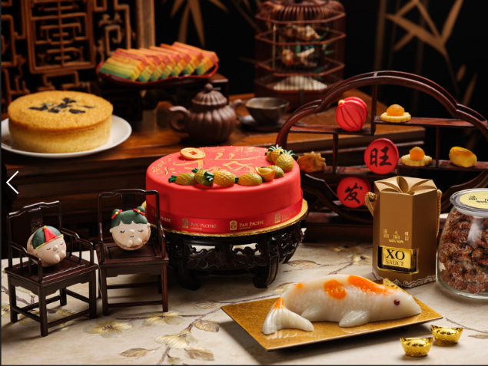
Ushering the new year in abundance, Hai Tien Lo and Pacific Marketplace presents a delicious assortment of Chinese New Year treats that are impressive for gifting and perfect table centrepieces for convivial gatherings with the loved ones. Original highlights include a delightful Pineapple Prosperity Pound Cake with pineapple jam and buttercream as well as a Cantonese Sponge Cake with Truffle and Pumpkin Seeds for a fusion twist. Other perennial favourites include the best-selling Rainbow Kueh Lapis and crunchy Homemade Caramel Walnuts with Sesame Seeds.

Revellers can also elevate their celebrations with thoughtful gifts such as the Premium Treasure Set or Prosperity Hamper featuring tasty fare such as Chinese Pork Sausages handcrafted by the hotel’s in-house Master Butcher and the well-loved Traditional Stewed Chicken.

Other delectable goodies not to be missed is Hai Tien Lo’s Premium Wealth Treasure Pot (Poon Choy), a luxurious assortment of Yu Sheng Platters and barbecued treats.

From 30 December 2019, guests may pre-order the Chinese New Year goodies from ppsinshop.sg and collect their purchases from 9 January to 8 February 2020 at Hai Tien Lo between 12:00pm to 2:00pm and 6:30pm to 8pm (except 24 January 2020 – collection ends at 2:00pm). Complimentary delivery to one location is available for orders of SGD800+ and above. For guests who wish to enjoy the delivery service for orders below SGD800+ or to more than one location, a delivery charge of SGD80 will be applicable for each location.

To place an order, speak with us at 6826 8240, email dining.sin@panpacific.com., or visit ppsinshop.sg
Refer to Appendix C for full list of Yu Sheng, Poon Choy and other Chinese New Year Takeaway Goodies at Hai Tien Lo and Pacific Marketplace.

A Sumptuous Spring Reunion at Edge (25 January to 8 February 2020)

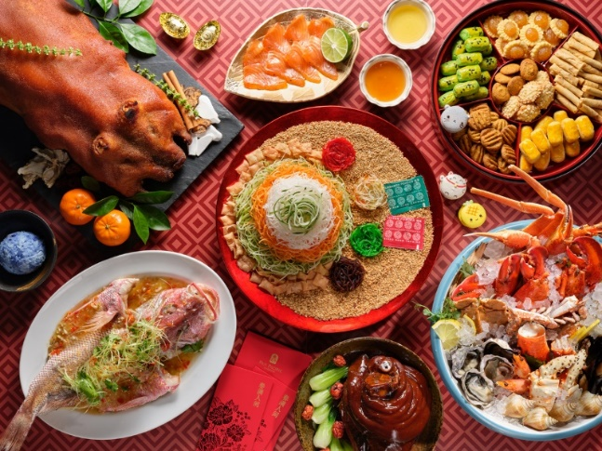
Get an auspicious head start into the year of the Metal Rat with a delightful line-up of Lunar New Year dishes at Edge. Toss to new beginnings with the Blossom Yu Sheng featuring Osmanthus Home Cured Salmon before indulging in the season’s favourites including Grilled Chicken Bak Kwa, Double-boiled Fish Maw Soup, Roasted Whole Suckling Pig with Sesame Hoi Sin Dip, and Steamed Red Snapper with Garlic and Preserved Radish. Conclude the celebrations with traditional House-made Pineapple Tarts and Eight Treasures Soup symbolising abundance and prosperity.

Bountiful Blessings at Keyaki (10 January to 8 February 2020)

Keyaki joins in the Lunar New Year festivities with a specially curated Keyaki Garden Pavilion Luncheon Package. Celebrate new beginnings with business associates or loved ones at Keyaki Garden Pavilion, situated at the heart of a beautifully sculpted Japanese garden that opens up to lush green landscape and a beautiful koi pond. The two set menus are priced at SGD2,888 or SGD3,288 for 20 persons (SGD110 and SGD130 per additional person respectively, maximum of 30 persons).

Sashimi lovers will love Keyaki’s special Wafu Yu Sheng (SGD128, serves four to six guests), featuring generous servings of Tuna, Salmon, Yellowtail and Tobiko, as well as the indulgent Premium Yu Sheng (SGD338, serves eight to ten persons) which includes luxurious premium ingredients of Sea Urchin and Lobster. Perfectly complementing the dining experience, both Japanese-inspired Yu Sheng creations are topped with Ponzu sauce and available exclusively for dine-in only from 10 January to 8 February 2020.

Refer to Appendix D for Keyaki Garden Pavilion Luncheon Package set menus.

Celebrate New Beginnings with Prosperity Dining Packages at our Event Suites or Ballroom (25 January to 8 February 2020)
Usher in a prosperous Year of the Rat and start the New Year on an auspicious note with our Prosperity Dining Packages. Host your event at one of our grand pillar-less ballrooms or event suites on level 22 offering magnificent views of the city skyline. Choose from our sumptuous menus, specially crafted for the Chinese New Year, and enjoy additional treats when you book your luncheon or dinner with us.

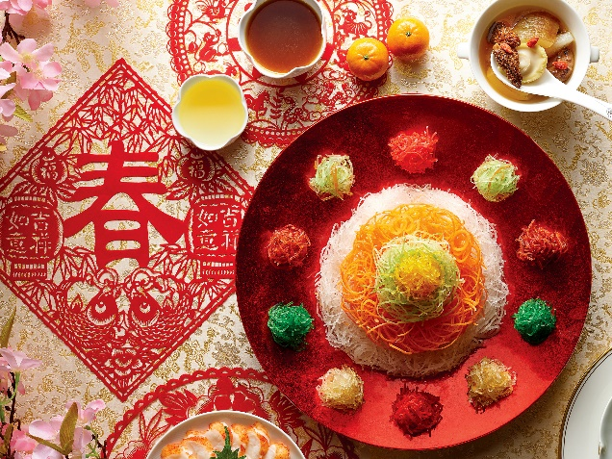
Available for events held from 25 January to 8 February 2020, choose from the sumptuous seven-course set lunch package at SGD888 per table of 10 persons or eight-course set dinner package at SGD1,088 per table of 10 persons. Packages include Chef’s specially crafted menus, unlimited soft drinks, Chinese New Year-themed centrepieces for all tables and a pair of Mandarin oranges with a set of red packets for all guests.

For bookings and enquiries for this or other corporate packages, please speak with us at 6826 8052 / 6826 8055, email celebrate.ppsin@panpacific.com or visit www.panpacific.com/singapore

A Heart-warming Reunion (24 January 2020)

This year, guests can enjoy a heart-warming reunion in grand style at Pan Pacific Singapore’s luxurious pillar-less Pacific Ballroom on 24 January 2020. The sumptuous Chinese New Year Themed Buffet Spread includes unlimited soft drinks and Chinese tea. Priced at SGD108 per adult and SGD68 per child (aged six to 12 years old), the experience is inclusive of a pair of Mandarin oranges with a set of red packets.

For bookings and enquiries for this or other corporate packages, please speak with us at 6826 8052 / 6826 8055, email celebrate.ppsin@panpacific.com or visit www.panpacific.com/singapore

All prices quoted above are subject to 10% service charge and prevailing Goods and Services Tax.

For dining reservations or enquiries, please call 6826 8240 or email dining.ppsin@panpacific.com
High-resolution Images can be downloaded here.

Please refer to the Appendix A below for a breakdown of promotional dates and pricing at our dining establishments and corporate venue.
ENDS

Media Contact
Melissa Ng
Senior Marketing Communications Executive
Pan Pacific Singapore
Email: melissa.ng@panpacific.com
Tel: +65 6826 8094

Annie Choy
Director of Marketing Communications
Pan Pacific Singapore
Email: annie.choy@panpacific.com
Tel: +65 6826 8079

About Pan Pacific Singapore
Located in the heart of Marina Bay and with easy access to world-class shopping, Suntec Singapore International Convention and Exhibition Centre and the Central Business District, Pan Pacific Singapore offers 790 contemporary rooms and suites that are ideal for business or leisure. Savour epicurean delights at our award-winning restaurants and bars or rejuvenate at our swimming pool and spa. Pan Pacific Singapore is proud to be named Asia’s Leading Business Hotel by the World Travel Awards from 2006 to 2012, World’s Leading Business Hotel by the World Travel Awards from 2007 to 2010 and 2012, and World’s Leading City Hotel by the World Travel Awards in 2011. The hotel was also recently named a “Four-Star Hotel” by Forbes Travel Guide 2019 and Top 25 Hotels in Singapore in Tripadvisor’s 2019 Traveller’s Choice Awards.

About Pan Pacific Hotels and Resorts
With hotels, resorts and serviced suites across Asia, Oceania and North America, Pan Pacific provides a safe harbour in an ever-changing world. Places with less worry about because, when you stay with us, rest assured that all will be taken care of. For this is where you will find your balance.

About Pan Pacific Hotels Group
Pan Pacific Hotels Group is a wholly-owned hotel subsidiary of Singapore-listed UOL Group Limited, one of Asia’s most established hotel and property companies with an outstanding portfolio of investment and development properties.

Based in Singapore, Pan Pacific Hotels Group owns and/or manages more than 40 hotels, resorts and serviced suites including those under development across 24 cities in Asia, Oceania, North America and Europe.

Voted “Best Regional Hotel Chain” by readers in Asia in 2017 and 2018, Pan Pacific Hotels Group comprises two acclaimed brands: its signature brand, Pan Pacific and its deluxe brand, PARKROYAL.

Sincerity is the hallmark of Pan Pacific Hotels Group. The Group is known to its guests, partners, associates and owners for its sincerity in people and the sense of confidence which alleviates the stresses of today’s complex world.

About Hai Tien Lo
Helmed by Executive Chef Ben Zeng, Hai Tien Lo epitomises traditional Cantonese dining with a contemporary twist. Enjoy exquisite dim sum, double boiled soups, Peking duck and classic braised dishes, in addition to modern interpretations like the “Australian Abalone with Japanese Mushrooms and Black Truffles” or “Double-boiled Chicken Soup with Abalone, Dried Scallops, Fresh Prawns and Chinese Mushrooms served in Young Coconut”.

About Pacific Marketplace
This gourmet grocery and café provides classic three-tier afternoon tea, croissants and pastries, as well as an extensive selection of cakes, chocolates, Asian delights, sandwiches and salads. The hotel’s signature Pan Pacific sausages and other exquisite deli goods are available for purchase at ppsinshop.sg

About Edge
Edge presents an engaging gastro-tainment dining experience and a culinary tour of Singapore, the region and the Pacific Rim. Awarded ‘Best All-Day Dining Buffet’ and ‘Award of Excellence’ at the G Restaurant Awards 2016 organised by The Peak Selections: Gourmet and Travel, and ‘Best Buffet’ at both the Wine & Dine Singapore’s Top Restaurants Guide 2015 and 2016, as well as the Epicurean Star Award 2014 organised by the Restaurant Association of Singapore (RAS), the seven ‘live’ food theatres present a la minute cuisine which include a variety of delectable Asian and Pacific cuisines – including Chinese, Malay, Indian, Singaporean, Japanese and Pan Pacific’s signature “Pacific Cuisines”. For the ultimate indulgence, Sunday Champagne Brunch is a convivial event with traditional roasts, crustacean on ice, freshly-made pasta, 30 types of cheeses and 20 varieties of desserts.

About Keyaki
The award-winning restaurant, Keyaki, is renowned for its use of fresh ingredients imported from Japan. Our team of dedicated Chefs presents an array of authentic and immaculately presented sashimi, sushi, teppanyaki and much more. Perched on Level 4 of the hotel, Keyaki is surrounded by a beautifully sculpted Japanese garden and a new Garden Pavilion which opens up to lush green landscape and a beautiful koi pond. This private dining space can be customised for any occasion, from private luncheons and dinners to cocktail receptions and intimate weddings.

About Poolside Bar
Set amidst lush greenery, this urban tropical bar offers icy cold beverages, delicious cuisines and mouth-watering desserts. Bask in the relaxing poolside ambience sipping refreshing cocktails, bubblies or fresh juices, while enjoying the comfort of luxurious cabanas and sun loungers.

