FundedByMe COO to step down

Stockholm, 15 August 2016: FundedByMe COO, Pontus Frohde, this week announced that he’d be leaving Scandinavia’s fastest-growing crowdfunding platform to focus on other opportunities. Frohde has been at the operational helm of FundedByMe since April 2013 and will remain active within the company until the end of November 2016.
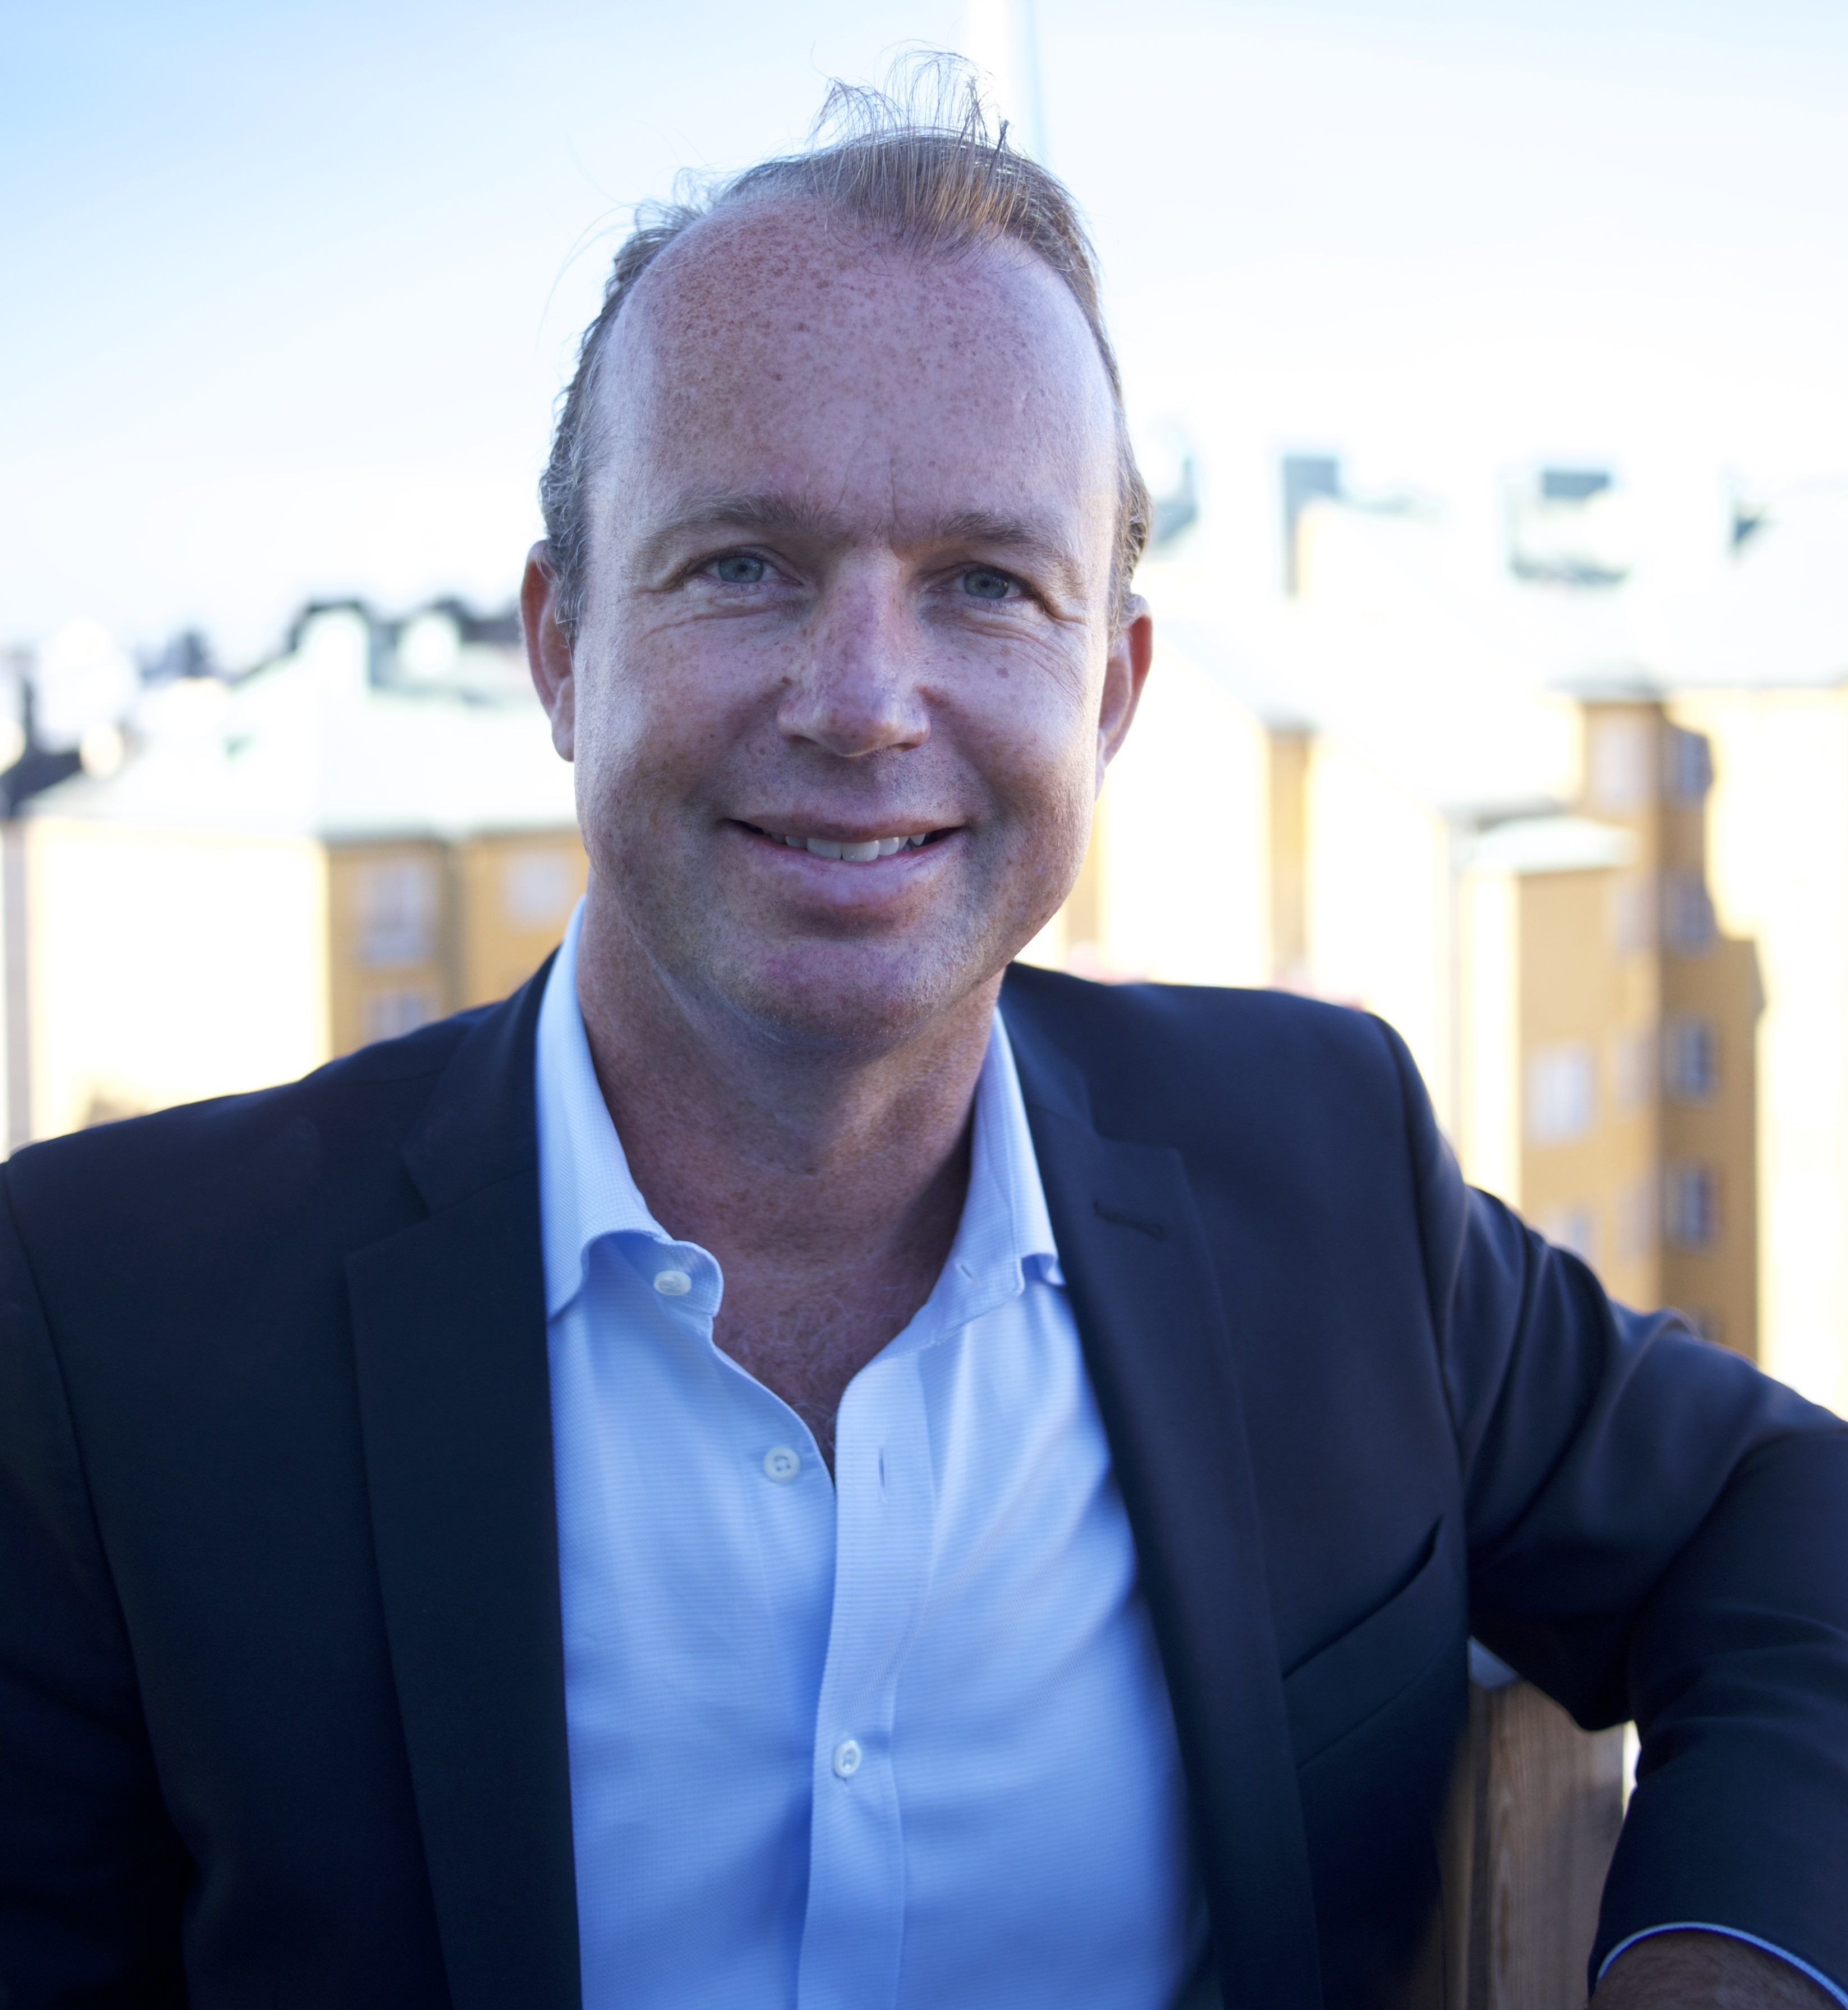
“The decision to say goodbye to FundedByMe was not an easy one, but it’s time for me to focus on the next phase of my career,” Frohde says about the decision to resign. “Pontus has been an integral part in building the FundedByMe business model and setting the tone for who we are as a company. We wish him only the very best on his next venture,” says CEO and co-founder Daniel Daboczy, who will be taking over all operational responsibility. Frohde plans to stay on in the FinTech industry, though he’s still keeping mum on what his future plans are.

FundedByMe recently closed an equity crowdfunding round on its own platform where it gained 376 new investors who invested a total of SEK10,9 million.

- ENDS

About FundedByMe
FundedByMe is one of a few full-service crowdfunding platforms offering capital through equity and loans. In the past years, some 452 companies from 25 different countries have been successfully funded with more than €23,9 million. The member base is a rapidly expanding network of more than 68,900 investors from over 178 countries around the world. FundedByMe headquarters are in Stockholm, Sweden, with a local presence in Finland, Singapore and Malaysia. For more information, visit www.fundedbyme.com.

