**For immediate release**

The complete Vogel’s RingO® Universal Mounting System for iPad

*Easily mount an iPad anywhere for any purpose*

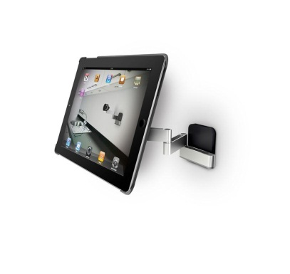**IFA 2012** – Vogel’s is pleased to announce a complete new line up of user packs for Vogel’s RingO® , including a new ultra thin wall mount to its patented tablet mounting system. RingO is stylish and flexible, allowing iPad users to place their tablet virtually anywhere.

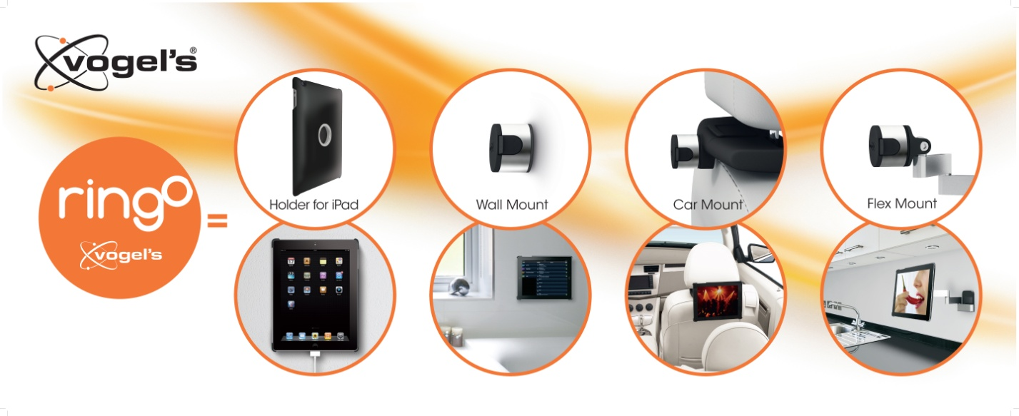

The system includes a protective tablet holder and mounting ring, which can be clicked on to a wall mount, flexible arm, car mount or table stand. With this system, iPad owners can easily watch a movie in the back seat of a car without tiring their arms or look up a recipe in the kitchen without getting the tablet dirty or knocking it off the table.

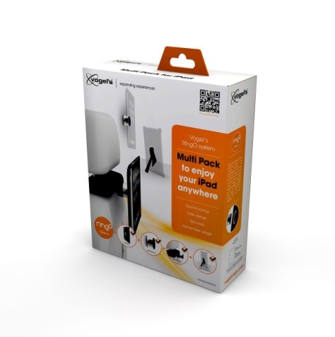

**One system to enjoy a tablet anywhere**

In an instant, an iPad can be mounted on the living room wall as a weather station, in the bedroom as an entertainment system, or in the kitchen as a virtual cookbook. To attach the holder to the different mounts, users simply squeeze the side buttons together. RingO® also protects the back of the iPad, when used with Apple’s Smart Cover, to keep the iPad in mint condition.

**Vogel’s introduces a new adhesive RingO Wall Mount – Stick it or drill it?**

With this ultra thin new Wall Mount, you can easily hang your iPad on any flat surface. This wall mount is ideal for mounting an iPad in places where drilling is not an option, such as a boat, caravan or a tiled bathroom. The RingO wall mount comes with an adhesive disk that has super strong double-side tape that’s been tested to hold the weight of an iPad securely. The Wall Mount can be quickly and easily stuck to any suitable surface.

The new Wall Mount is available in the Wall Mount Double Pack, which features two wall mounts, two adhesive disks and all necessary mounting material.

**New combined user packs**

The different user packs now available are: Wall Pack, Car Pack, Flex Pack and Multi Pack. All packs include the holder for an iPad and one specific mounting solution. Additional accessories can be purchased separately to expand tablet usage throughout the house. These are the Flex Mount, Car Mount and Wall Mount Double Pack.

**Award winning design**

The unique design of this system is highly appreciated by consumers and industry experts. It won the Plus X Award and the IF Design Award in 2010 and 2011, respectively, and is now the best selling tablet mounting system on the market.

###

Follow us

[www.youtube.com/VogelsExperience](http://www.youtube.com/VogelsExperience)

[www.facebook.com/VogelsExperience](http://www.facebook.com/VogelsExperience)

During the IFA 2102: [www.twitter.com/VogelsEvents](http://www.twitter.com/vogelsevents)

Press releases, background information and High Res images can be downloaded directly from the website [www.vogels.com](http://www.vogels.com), Press area.

For more information, please contact:

|  |  |
| --- | --- |
| Vogel’s Headquarters  Ingrid Rutjens  +31 (0) 40 26 47 400  [press@vogels.com](mailto:press@vogels.com) | Local contact: Aurora Group  Richo Ask Jacobsen  +45 53 74 58 00  raj@auroragroup.eu |

**About Vogel’s**Vogel’s is the expert and European market leader in mounts and support systems for audio / video equipment. Vogel’s solutions have stood for ingenuity, quality and reliability for almost 40 years. Since developing the world’s first loudspeaker mount in 1973, this Dutch company has produced a steady stream of award-winning solutions that make people’s lives more enjoyable. Today, Vogel’s designs, develops and markets mounting solutions for LCD, Plasma and LED screens, audio / video equipment and projectors for different areas in the home. The latest breakthroughs include the revolutionary THIN products and mounting systems for tablets like the Apple iPad. For more information, please visit [www.vogels.com](http://www.vogels.com),