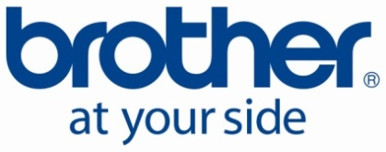
Nyhetsmelding
11. februar 2013

European Product Innovation Aaward for
Brother MFJC4510DW printer
At Brother we are pleased to share the news that our new MFC-J4510DW Business Inkjet has won the New Product Innovation Award at the European Office Products Awards (EOPA) 2013.
The EOPAs are organised by the Office Products International (OPI) publication and are well-respected across the industry. The announcement was made at a ceremony in Frankfurt, which was held during this year’s Paperworld exhibition.
Winning this prestigious award is a great independent endorsement for our new A4/A3 Business Inkjet range. It reinforces the messaging in our Print 3.0 campaign and is a significant accolade to make our trade partners aware of.
Here are some of the judges’ comments:
“The judges saw this Brother printer as truly innovative. Engineers have redesigned a printer from top to bottom to create a new technology which takes up less space, solving a problem that offices have had for years. The design is attractive, and the judges could see sales of this printer going extremely well”.
Bilder:
Brother MFCJ4510DW blekkskriver
Logo Winner New Product Innovation

For mer informasjon, vennligst kontakt:
Country Manager Geir Langedrag, Brother Norge, filial til Brother Nordic AS
E-post: geir.langedrag@brother.no
Hjemmeside: ww.brother.no

Om Brother
Brother Nordic A/S er en ledende leverandør til det nordiske marked. Selskapet er eneimportør av Brother skrivere, multifunksjonsskrivere, telefakser, etikettskrivere og merkesystemet P-touch. Brother leverer produkter av høy kvalitet med ytelse og funksjonalitet i toppklasse – alt sammen til konkurransedyktige priser. Flere av Brothers produkter er markedsledende. Brothers produkter selges og distribueres gjennom et bredt nett av forhandlere og distributører. Brother Nordic A/S har 78 medarbeidere på sine kontorer i København, Göteborg, Helsingfors og Oslo. Les mere på www.brother.no eller www.brother.com

