

News Release 　　　 October 28th, 2020

Yanmar Holdings Co., Ltd.

**Tuff Torq Breaks Ground on State-of-the-art Product Development Test Facility**

Tuff Torq breaks ground on a new testing center.

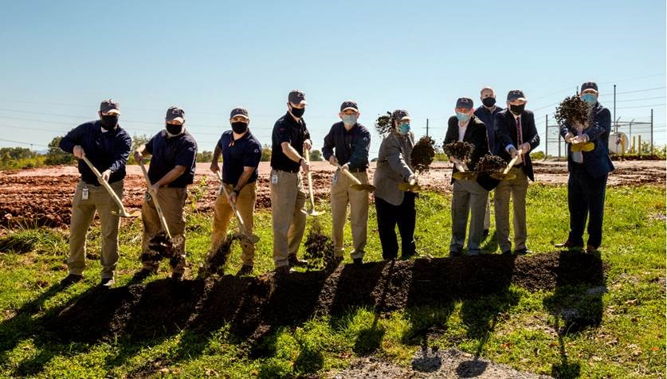

October 28th, 2020 (Morristown, TN) Yanmar Group company, Tuff Torq Corporation, a global manufacturer of hydrostatic, mechanical, electric, and hybrid drivetrain solutions for the outdoor power equipment industry held a groundbreaking ceremony on October 14th to begin construction on a 16,000 square foot state-of-the-art product development test facility.

“Tuff Torq products can be found in most riding mowers across the world and this new facility will increase our capabilities and capacity to test our components for riding lawn equipment and ROV, SXS, and ATV off-road vehicles,” says Naoki Yamakaji, President of Tuff Torq. With a global roster of OEM clients and a workforce approaching 500 people, Tuff Torq has been producing world-class transmissions from Morristown, TN since 1989.

Tuff Torq has been on a non-stop growth trajectory. Keith Andrews, VP of R&D says “this new facility and its best-in-class equipment will enable us to meet and exceed our goals over the next phase of growth for our company.” Mr. Andrews further comments that “construction will be completed by June 2021 and doors will open soon thereafter.”

**About Tuff Torq**

Tuff Torq Corporation is based in Morristown, Tennessee and handles all manufacturing functions for products within U.S. facilities. We are committed to being an American made product and, thus, we are driven to ensure our product quality reflects this heritage. Established in 1989 by Kanzaki Kokyukoki Mfg. Co. Ltd of Amagasaki, Japan, Tuff Torq Corporation was created to be a domestic manufacturing base for drive systems for the lawn and gardening industries.

For more details, please visit the official website:

<https://www.tufftorq.com/>

**About Yanmar**

Founded in Osaka, Japan in 1912, Yanmar was the first ever to succeed in making a compact diesel engine of a practical size in 1933. A pioneer in diesel engine technology, Yanmar is a global innovator in a wide range of industrial equipment, from small and large engines, agricultural machinery and facilities, construction equipment, energy systems, marine, to machine tools, and components — Yanmar’s global business operations span seven domains.

On land, at sea, and in the city, Yanmar provides advanced solutions to the challenges customers face, towards realizing A Sustainable Future.

For more details, please visit the official website of Yanmar Holdings Co., Ltd.

<https://www.yanmar.com/global/>

＜NOTE＞

The contents of this news release reflect what was mentioned in the press announcement. Please be aware that the contents of this release may differ with new information and developments.

Inquiries

Corporate Communications, Yanmar Global Expert Co., Ltd.

newsroom@yanmar.com