**PRESS RELEASE**2015-05-07  
  
**Sweden’s top computer dealer opened its sixth store on April 25-26 in Barkarby**

**”Just an amazing opening weekend in Barkarby!”**

**On 25-26th of April, Inet opened its second store in Stockholm and the sixth in total. The turnout exceeded all expectations and people lined up around the block hours before the doors opened. The successful opening will be followed up by a gaming event when world famous e-sport team NiP, Ninjas in Pyjamas, will come to the store to play later in May.**

**– Three hours before the store opened on Saturday morning, the line stretched hundreds of meters, and the store was packed all weekend long. We had thousands of items on discount and a record number of 2,233 people visited the store during the two-day opening, says Erik Wickman, CEO of Inet.**

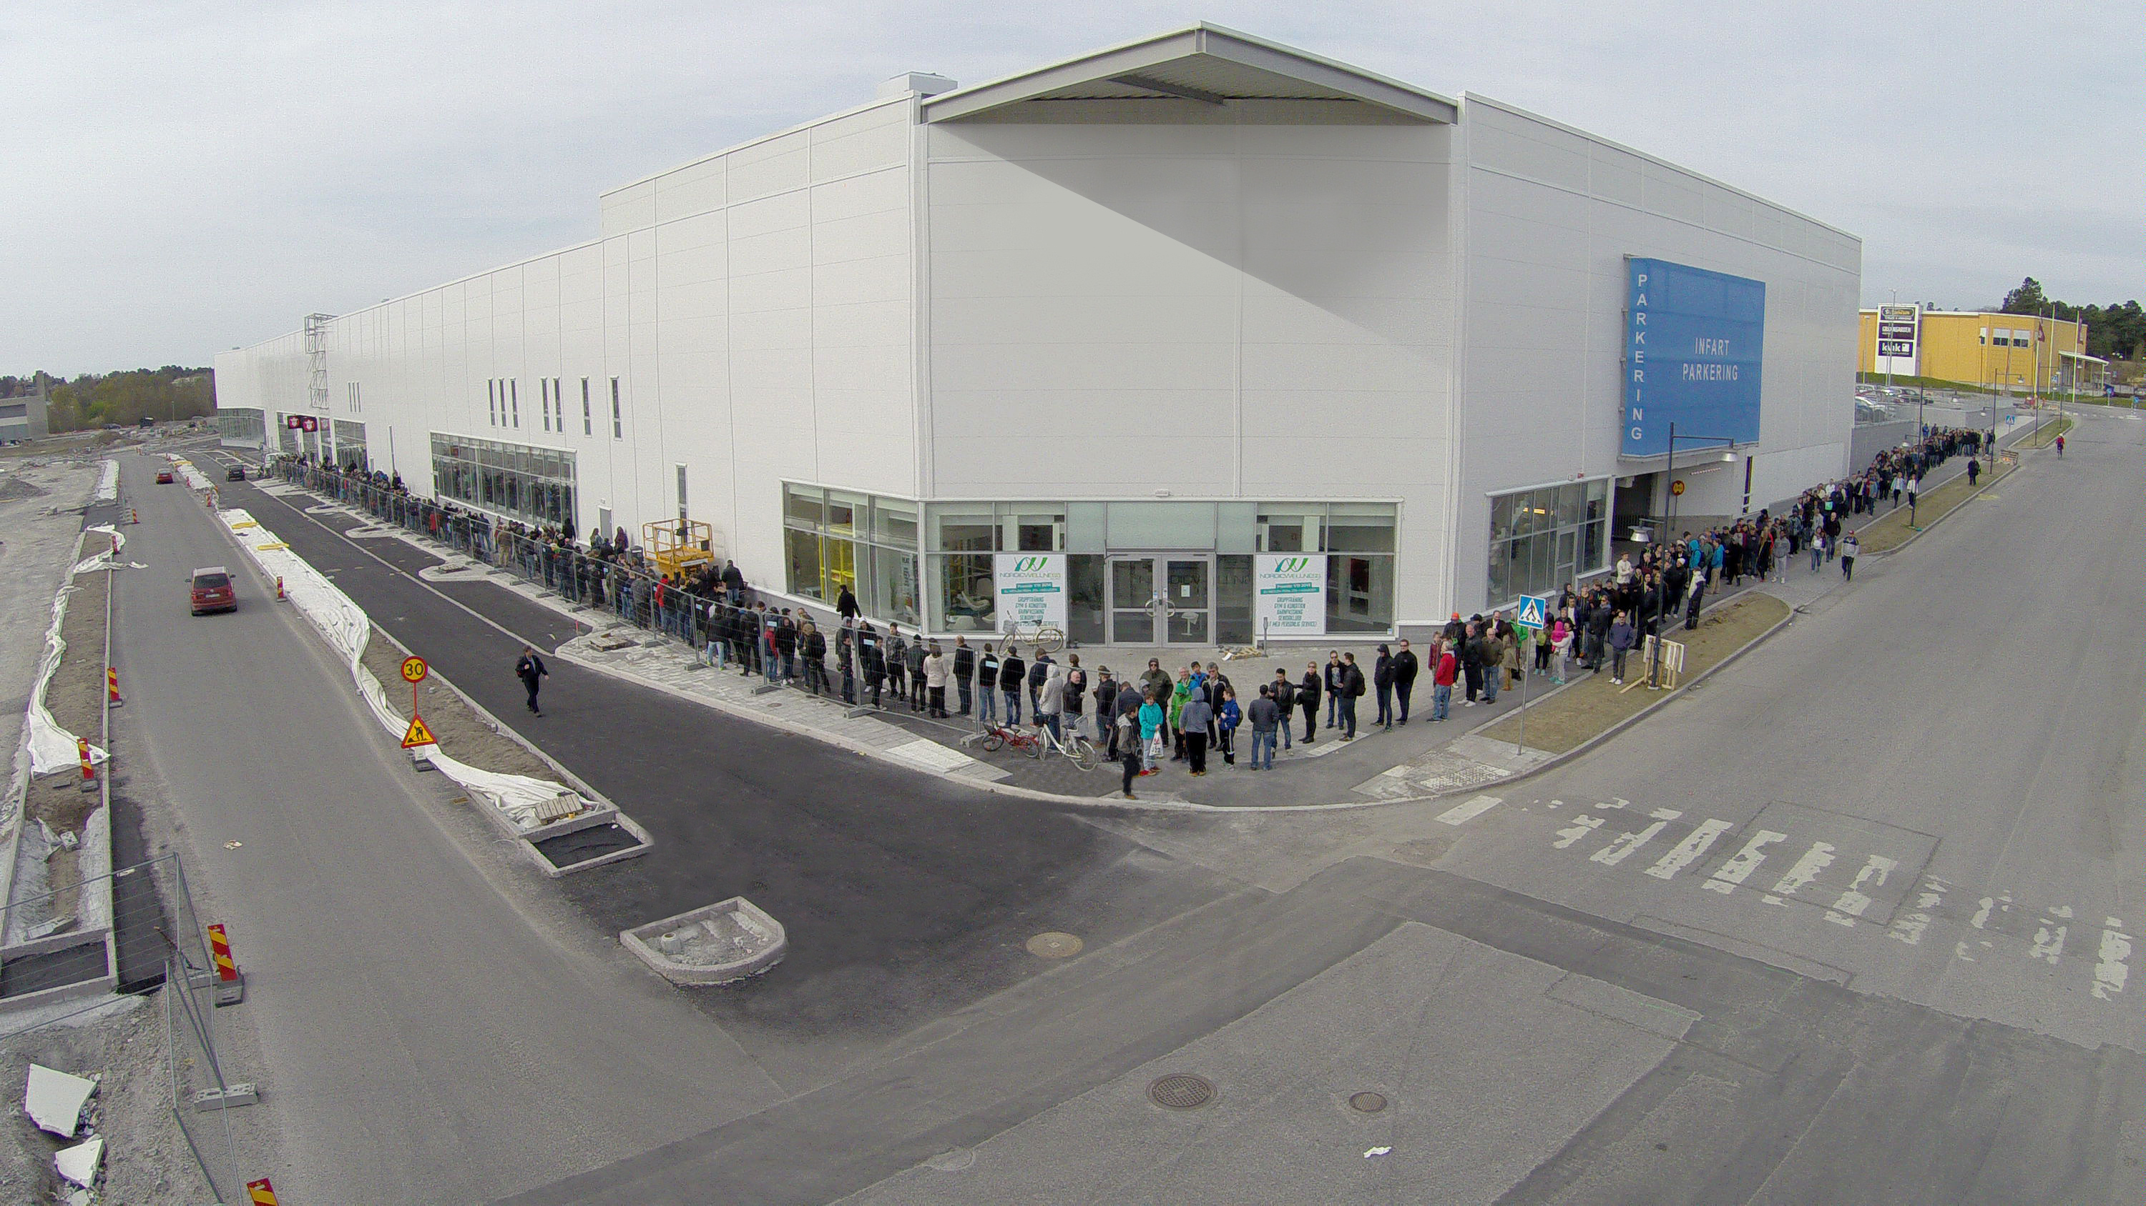Long lines wrapping around the block are now a common sight for gaming and computer enthusiasts’ favorite, Inet. Gaming events, campaigns and of course store openings attracts full houses.

– The store opening was amazing, even better than we could’ve dreamed of with over 2,200 customers and nearly 3,300 items sold. Barkarby really is the right location for our new store.

Inet’s store opening in Barkarby attracted thousands of people. The line stretched round the block early on Saturday morning.

People started lining up on Friday night, the evening before the store opened. Three of Inet’s most enthusiastic customers arrived at two in the morning, and was among the first to be welcomed into the store.

– We drove here from Enköping and knew we had to be here early. We got hold of what we were looking for, says Mikael Simonsson with friends Malin and Andreas.

Inet’s next big event is coming up on May 23rd.

– It’s a gaming event with the legendary NiP team. They will come to the store in Barkarby and compete with our customers. It’ll be great fun, says Erik Wickman, CEO of Inet.

**For further information**

Erik Wickman, CEO Inet, +46 (0) 708-65 27 02, [erik.wickman@inet.se](mailto:erik.wickman@inet.se)   
Johan Wahlberg, Marketing Director Inet, +46 (0) 739-88 27 29, [johan.wahlberg@inet.se](mailto:johan.wahlberg@inet.se)

Magnus Sjöbäck, Press Officer Inet, +46 (0) 704-45 15 99, magnus.sjoback@inet.se

<http://www.inet.se/>