**HISTORICAL DISCOVERY AT VEMORK!**

**A historical industrial-archeological find has been made at Vemork, the site of the WWII sabotage of German heavy water production. The actual ‘heavy water cellar’ where the sabotage took place has been found – intact and in very good condition.**

# The Norwegian Industrial Workers Museum (NIA) began the excavation on September 11 using an industrial-archeological excavation method. The Hydrogen Production Factory had been demolished in 1977, but this archeological discovery of October 5th 2017 will help us all gain a better understanding by current and future generations.

The photos show the east corner of the building, and we can observe the cellar through one of the windows in the front of that same cellar. The adjacent room is the heavy water cellar where the sabotage operation took place in the early morning hours of February 28, 1943. We can also see a number of very interesting artifacts and details such as the tiles on the wall. The floor itself has not yet been inspected.

The archeologists will now begin to dig out the door on the south wall. Should we find that the wall is intact, the team will fortify the building such that it can be entered safely. Once this has been achieved, the NIA will invite the media to join us in an inspection.

**A New Museum Facility**

After the excavation is completed, a new museum facility will be constructed, and will present the historic heavy water cellar in its actual original state, part of the NIA’s work to preserve and present cultural heritage.

The heavy water cellar is part of the Hydrogen Production Factory that was completed in 1929. The factory as an important part of Norsk Hydro’s development, established in the early 1900s in Notodden and Rjukan, and a key element in the development of the 2nd Industrial Revolution where water power was harnessed to create hydroelectric power as a driving force for industry.

 The establishment of Norsk Hydro is the best example of Norway’s key part in this 2nd Industrial Revolution, which contributed to changing the young nation of Norway and thus creating what still stands as one of the world’s best examples of a modern social-democratic society.

**For more information, please contact:**

**Contact:**

Runar Lia Director, Norwegian Industrial Workers Museum

Cell.: +47 932 49 766, e-post: runar.lia@nia.museum.no

Rita Engedalen Press and Marketing, Norwegian Industrial Workers Museum

Cell.: +47 920 94 584, e-post: [rita.engedalen@nia.museum.no](mailto:rita.engedalen@nia.museum.no)

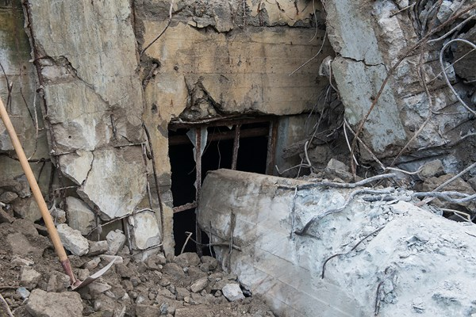

Photo Credit: Ingelinn Kårvand/NIA

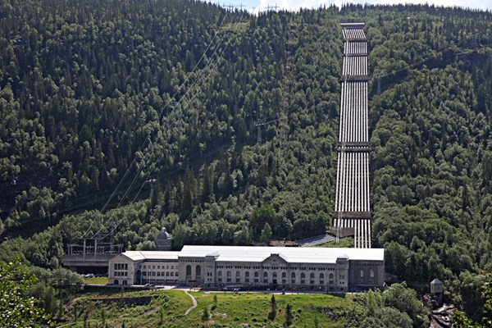

Photo Credit: Ingelinn Kårvand / Nia