AddQ presented MSA at the Nordic Test Forum in November
Between the 25-26th of November the Nordic Test Forum ran in Malmö, Sweden.
NTF is a popular event for exchange of experience and know-how in the field of “production test for electronics”.
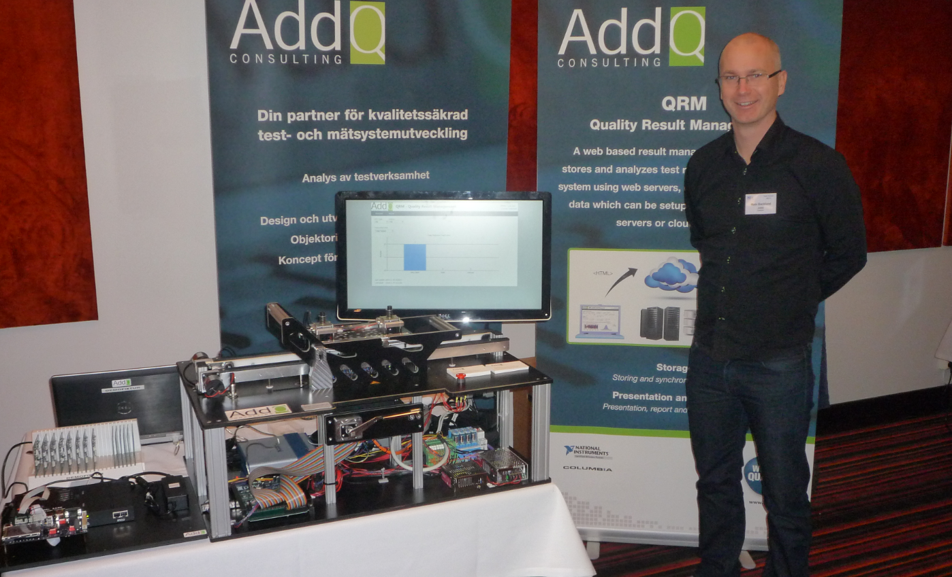
It is clear that the complexity of systems are increasing, this means that the customer demand for complex solutions are rising. As an example, a single chip today is more complex than the most advanced PCB Assembly five years ago. The evolutions of electronics are requiring a lot from test engineers in order to guarantee that the quality of future products is met.
At our booth the team presented a scaled down version of a fully automated test cell for functional testing of PCB Assemblies, while at the same time discussing result management and boundary scan tests. All results are stored in AddQs result management system QRM – Quality Result Management and instantly presented and analyzed in a regular web browser.
During the day, our very own Mattias Ericsson, held a fully booked seminar with the subject “Measurement System Analysis – Can You Trust Your Measurements”
Measurement System Analysis or MSA (for short) is used to determine the quality of the measurement data, by determining the source of the variations in the measurement system and how much of that derives from the device that it is measured upon compared to the measurement system itself.

För mer information samt pressbilder, vänligen besök:
http://www.addq.se/test-och-matsystem/kretskorttest/
http://www.nordictestforum.org/2014

För ytterligare frågor, vänligen kontakta:
Lasse Holmberg, VD på AddQ Consulting, +46 (8) 501 108 90
Mats Backlund, Säljansvarig på AddQ Consulting, +46 (735) 142 190

