A new approach to amplifying DNA; A small paradigm shift within molecular photocopying
Analyzing DNA is useful for a number of vital applications. This includes diagnosis and monitoring of diseases, identification of criminals, and studying the function of a targeted segment of DNA. However, methods used for analyses often require more DNA than may be available in a typical sample. ‘Therefor, amplification is necessary, but not always straightforward. The most widely used amplification or photocopying method is the polymerase chain reaction (PCR). A new PCR method could help the amplification process, and thus develop robust assays that previously would not have been possible.
Deoxyribonucleic acid (DNA) is a molecule found in the nucleus of cells and carries the 'instructions' for the development and functioning of living organisms. It is often compared to a set of blueprints since it contains the instructions needed to build cells. These instructions are divided into segments along a strand of DNA.
Replication
DNA is made up of a double helix of two complementary strands made of nucleotides, a structure often compared to a ladder. When it is time to replicate, the two DNA strands – or ‘sides’ of the ladder- unwind and separate. An enzyme called DNA polymerase reads the individual strands and matches complementary bases - the ‘rungs’ of the ladder - to the original strand. New strands are produced on both sides of the original DNA, making two identical DNA double helices composed of one original and one new strand. This process occurs in all living organisms and is the basis for biological inheritance.
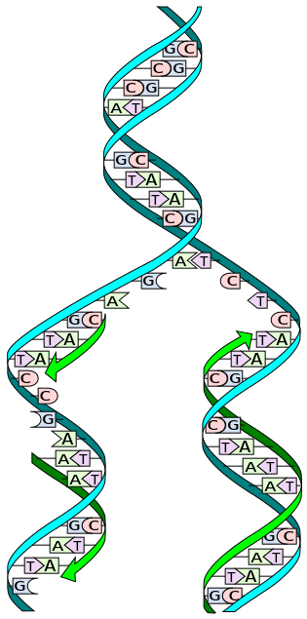
During replication, the two strands are separated. Each strand of the original DNA molecule then serves as a template for the production of its complementary counterpart. (Figure: Wikimedia Commons)

PCR
Replication may also be processed artificially. Sometimes called "molecular photocopying," the polymerase chain reaction (PCR) is a fast and relatively inexpensive technique used to amplify, or make many copies of, small segments of DNA. This is necessary because methods used for analyzing DNA or determining the DNA base pair sequence require more DNA than may be in a typical sample. Hence, the goal with PCR is to amplify a specific region of a DNA strand.
To perform PCR, the two strands of the DNA double helix are physically separated by applying high temperature (93-98 °C) in a process called DNA melting. In the second step, the temperature is lowered and the two DNA strands, now separated, become templates for so-called primers. Primers are short single stranded DNA molecules, complementary to the DNA region targeted for amplification. After lowering the temperature, the primers added to the PCR-process finds and binds to its specific target. An enzyme called DNA polymerase will elongate – or build - a new strand of DNA from the primer using the underlying single stranded DNA molecule as a template.
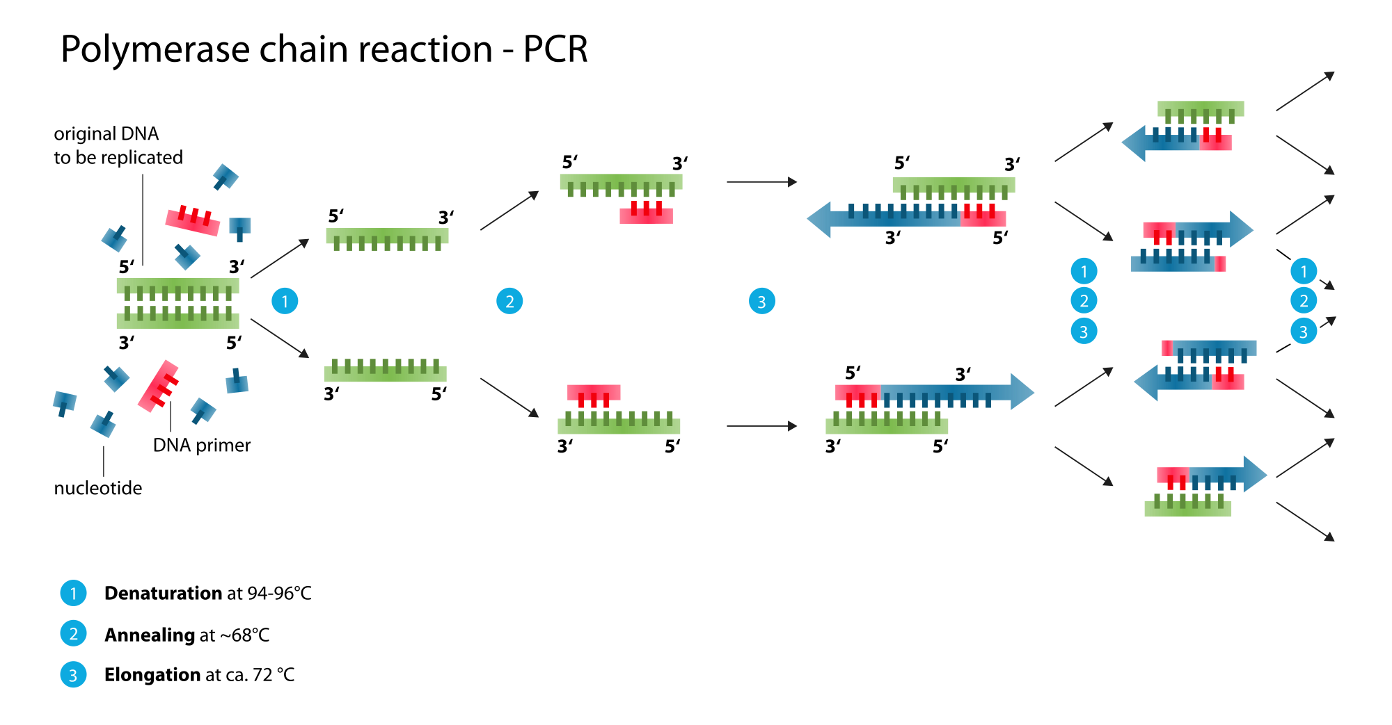
Polymerase chain reaction (PCR) (Figure: Wikimedia).
Building a ladder
As mentioned above, primers are short single stranded molecules of DNA. These are usually around 20 nucleotides long. This string of nucleotides, specifically attaches to the beginning of the template strand by base pairing – finding the complementary bases. DNA polymerase is then able to add the next complementary nucleotide. The polymerase continues adding more complementary nucleotides to the template DNA until a new double strand of DNA is completed, or to use the metaphor above; a new ladder is built, with one original side and one new side.
Dual primers make it possible to precisely define the area of a DNA molecule to be amplified by the PCR. These two flanking primers specify where the new chain should begin and end.
A small paradigm shift
A central rule strongly anchored in the mind of the molecular scientist is that primers should be complementary only to the target sequence, and not with each other. This to avoid primers using one another as templates and thus disabling further possible involvement in traditional target amplification.
In a recent study, published in the scientific journal PLOS One, Senior Research Scientist Marc Anglès d´Auriac with the Norwegian Institute for Water Research (NIVA) shows that it is possible to use highly complementary primers and yet avoid the unfortunate consequences mentioned above. The new method has been named COMPAS-PCR, short for COMplementary Primer Asymmetric PCR.
In short, Anglès d’Auriac observed that primers complementary between themselves and a target (triple overlay) could still define an amplification product when part of a repeated DNA motif or structure. This is shown in the figure below. Further, the physical hindrance of target amplification due to primer complementarity was alleviated by introducing asymmetric primer concentrations. Asymmetric in this respect means uneven numbers of molecules between the two primers. One primer consists of a low number of molecules, the other with a high number.
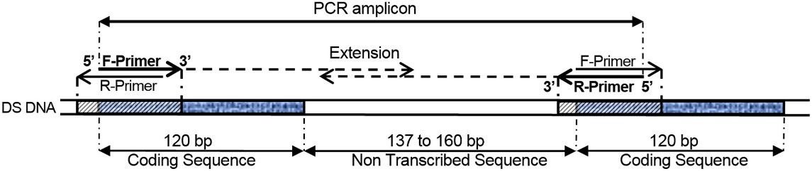
COMPAS-PCR using highly complementary primers applied to 5S ribosomal DNA direct repeat genes, as shown in this example. (Figure: From the publication).
- If using equal concentrations, as you usually do for PCR, the primers, present in equal amounts, will stick to each other, Anglès d’Auriac says.
- With asymmetric concentrations, the excess or high concentrated primer has a number of molecules not stuck with the limiting primer, and hence is available for target amplification.
Working alone
- This counterintuitive approach will isolate, but also protect, the low concentration primer, Anglès d’Auriac says.
With the limiting primer being stuck, and thus protected, it is possible for the high concentration primer to work alone, that is, make a single strand copy of the DNA-target. When sufficient single stranded amplicons are produced, they can serve as template material for the low concentration primer. The limiting primer is released, and the reaction switches to classical exponential PCR amplification.
- This enlarges PCR application possibilities for the scientist, Anglès d’Auriac elucidates.
Repetitive structures
In many organisms, a significant fraction of the genomic DNA is highly repetitive, with over half of the sequence consisting of repetitive elements in humans.
It was indeed a repetitive DNA structure that caused Anglès d’Auriac to think outside the box and put forward the COMPAS-PCR principle, a small paradigm shift within the field of molecular photocopying.
In the process of performing DNA based diagnosis for salmonids, in particular identification of the closely related brown trout (Salmo trutta) and Atlantic salmon (Salmo salar), Anglès d’Auriac struggled to separate these species – including hybrids between them. Rapid and accurate identification would help improve river ecosystem monitoring and studies, as identification of hybrids is important to estimate the ecological health of river basins. After using COMPAS-PCR, Anglès d’Auriac was able to apply a PCR product analysis method called high resolution melt analysis in identifying of brown trout, Atlantic salmon and their hybrids in one test as shown in the figure below.
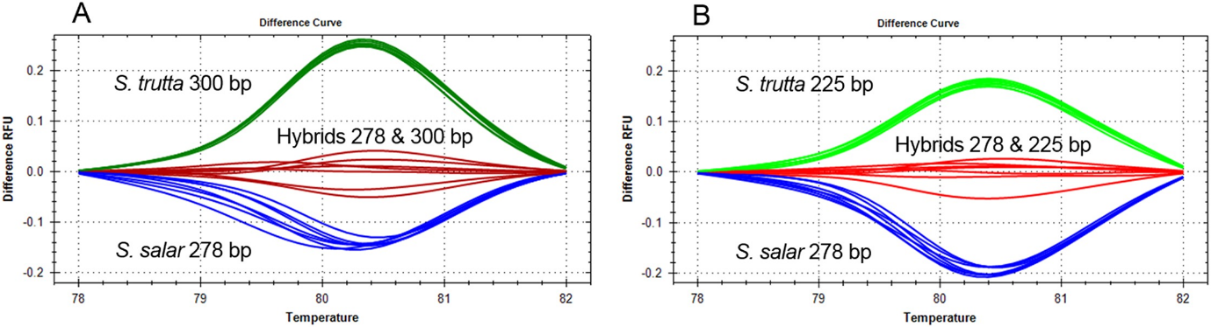
High resolution Melt analysis of two three-primer duplex COMPAS-PCR for the differentiation of S. salar, S. trutta and hybrids. (Figure: From the publication)

Anglès d’Auriac does however emphasize that the COMPAS-PCR principle is not restricted to the identification of fish species. Using almost fully complementary primers targeting the same sequence may apply to any copies which lie adjacent to each other, in DNA motifs of interest as target sequences.
- DNA repeat sequences are reported to comprise more than 50 % of the human genome and are present in many “housekeeping” gene families such as the 5S ribosomal gene used in this study. Hence, the general COMPAS-PCR principles will help develop new DNA amplification strategies taking advantage of these repeated DNA structures, Marc Anglès d’Auriac concludes.

References:
Marc Anglès d'Auriac (2016): “COMplementary Primer ASymmetric PCR (COMPAS-PCR) Applied to the Identification of Salmo salar, Salmo trutta and Their Hybrids” PLoS ONE 11(10): e0165468. doi:10.1371/journal.pone.0165468. In PLoS ONE journal, October 2016.
Marc Anglès d’Auriac (2016): “COMPAS-PCR fremgangsmåte og fremgangsmåter for påvisning, identifisering eller overvåking av laksearter, kit, samt anvendelse av metoden og kit” Norsk Patentstyre, Patent nr. 337188, granted 08/02/2016.

