Making teaching, studies, administration, and the region more international and sustainable: Kick-off of the "TH Wildau Sustainable Mobility Academy" on 26 January 2023
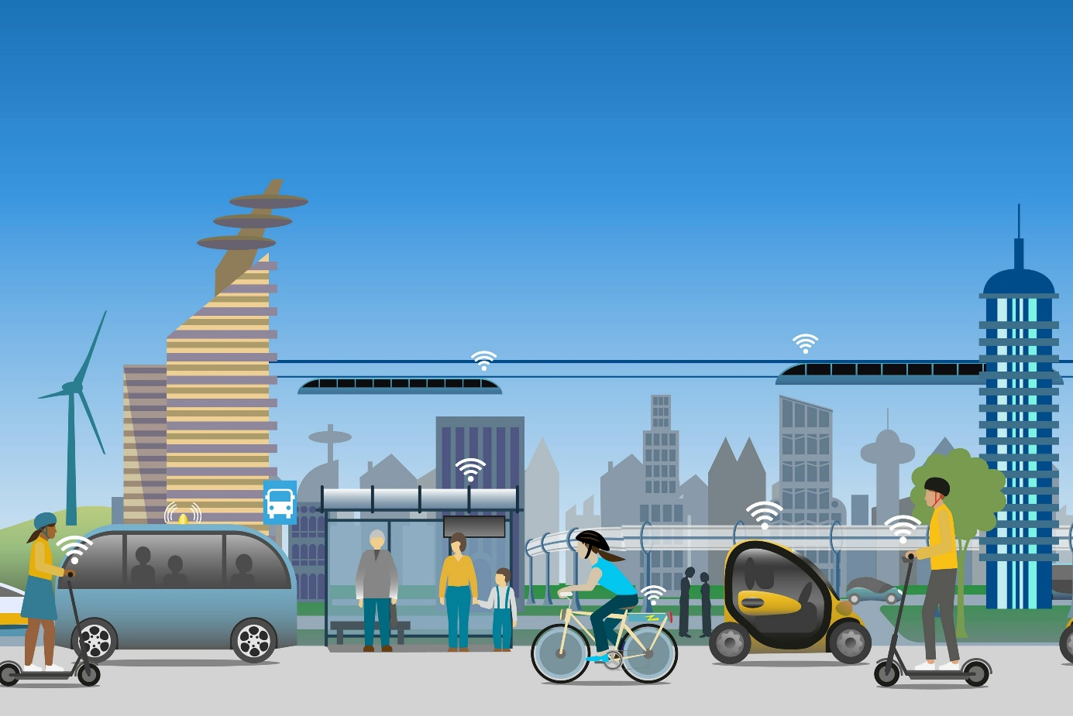
Caption: The launch of the new DAAD project "TH Wildau Sustainable Mobility Academy" will be celebrated on 26 January 2023.
Picture: Solveig – stock.adobe.com
Subheadline: TH Wildau International
Teaser:
The Technical University of Applied Sciences Wildau receives project funding from the DAAD for the establishment of the "TH Wildau Sustainable Mobility Academy". The project is intended to promote internationalisation at TH Wildau through stronger international networking in teaching, studies and administration. It also aims to raise awareness of the topic of sustainable mobility both on campus and in research and teaching. The university is one of only eleven universities of applied sciences in Germany to receive support under the DAAD HAW.International funding programme. The kick-off of the project will be celebrated on 26 January.
Text:
The Technical University of Applied Sciences Wildau (TH Wildau) has successfully applied for the latest round of the HAW.International funding programme of the German Academic Exchange Service (DAAD). As one of only eleven universities of applied sciences in Germany and the only one in Brandenburg to receive funding, the university will be supported through the DAAD programme to establish the "TH Wildau Sustainable Mobility Academy" (SMA).
The SMA is to become a flagship project of the TH Wildau for the implementation of the internationalisation strategy and supports the four central fields of the strategy, including campus, language, network and mobility. The start of the project will be celebrated on 26 January 2023 with a kick-off in the rooms of the Opportunity Lab (Opp:Lap) in Wildau, together with partners and supporters from science, business and the surrounding communities.
Establishment of the TH Wildau Sustainable Mobility Academy
What exactly is behind the "TH Wildau Sustainable Mobility Academy"? The core of the SMA project is an international and interdisciplinary Sustainable Mobility Summer Conference (SMSC), which will be held in English at the TH Wildau for a fortnight in 2023 and 2024. The SMSC brings together lecturers and students, researchers and administrative staff of both the TH Wildau and its international partner institutions, as well as employees of practice partners from the region, for lectures, seminars, projects, business games, workshops and excursions.
The conference is complemented by a Continuous Exchange Network (CEN), which runs throughout the year and supports not only incoming students, i.e. students coming to Wildau from abroad, but also outgoing students (TH Wildau students going abroad) in continuously promoting the topic of "sustainable mobility" together with international partners.
Making exchange mobility sustainable
During the project period, various activities on campus to promote sustainable mobility will be supported. This is done in close cooperation with the sustainability management of TH Wildau in order to create a stronger awareness of how issues of sustainable mobility affect us all and can be implemented, starting with everyday (international) campus life.
Sustainable mobility as an umbrella topic leads TH Wildau both back to its very own roots on the campus of a former railway factory and directly into the present and future of the surrounding, increasingly international Dahme-Spreewald and capital region. A number of practice partners of TH Wildau, for which sustainable mobility is one of their core economic and political concerns, have agreed to participate in the project, including the car manufacturer Tesla, the regional network dahme_innovation, the city of Wildau, but also other surrounding municipalities and companies.
Internationalise the new and the tried and tested
In addition to on-site activities, the SMA also includes digital offerings. This includes, for example, a virtual "appetiser" programme and an online portal that continuously expands the possibilities for international interaction beyond the in-person working meetings. The innovative digital platform, Wildauer Maschinen Werke (WMW), will be consistently internationalised in the course of the project. A special regional focus is on partner universities from the European Higher Education Area, with which the TH Wildau cooperates through its "European Neighbours Initiative" (ENI), started in 2021.
Medium and long-term goals
The model project is intended to have a broad impact on the university, in order to more strongly address other engineering, natural science and economic topics of the future. Furthermore, it is planned to expand the SMA into a certificate programme to create a permanent offer for the acquisition of micro-credentials in the field of sustainability. The project started on 1 January 2023 and ends on 31 December 2024, with a total funding volume of around 400,000 euros.
Further information
For more details on the project, see: www.th-wildau.de/sma
Professional contact TH Wildau:
Dr. Jeffrey Wolf
Project Coordinator
Centre for International Affairs
TH Wildau
Hochschulring 1, 15745 Wildau
Phone: +49 (0)3375 508 144 / -390
E-mail: jeffrey_charles.wolf@th-wildau.de
Contact persons External Communication TH Wildau:

Mike Lange / Mareike Rammelt
TH Wildau
Hochschulring 1, 15745 Wildau
Phone +49 (0)3375 508 211 / -669
E-mail: presse@th-wildau.de

