Publication from February 15, 2018
Consecutive No, Short Title Disto 02-2018, Leica Lino Series
The new Leica Lino series increases laser visibility, introduces an innovative Li-ion power concept and presents adapters designed for quick laser positioning

(Heerbrugg/Switzerland, 15 February 2018) – Leica Geosystems, industry leader in reality capture technology, announced today the new Leica Lino series, five cross-line and point lasers designed to deliver outstanding laser visibility. Its sophisticated adapters, based on strong magnets, allow for quick and easy laser positioning and the triple power concept, centred around rechargeable Li-ion batteries, allows for uninterrupted on-site working.

"In addition to precision, the most important features of an outstanding point or line laser are highly visible laser lines and practical adapters to allow the laser to be quickly and precisely positioned anywhere on the construction site," says Elvir Malkoc, Product Manager Lino. “The new Lino product range of five point and cross-line lasers fulfils these requirements excellently.”

Outstanding visibility of laser lines and points
All Leica Lino products combine decades of knowledge and experience in the fields of optics and electronics. The new green laser diodes are up to 4 times more visible to the human eye, meaning users can now work more efficiently, even in very bright lighting conditions. Vertical and horizontal alignment of the laser lines and points is quick and easy with these new self-levelling lasers.

Triple power concept based on Li-Ion technology
The Leica Lino cross-line and point lasers can be operated with rechargeable Li-ion batteries, alkaline batteries or they can be connected directly to the power supply. This allows for continuous on-site working.

Magnetic adapter concept for quick positioning
Leica Lino lasers easily connect to the precision-made adapters through use of strong magnets, thus ensuring precise set-up and positioning is done quickly. The rotating TWIST adapters can be attached to edges and profiles or fixed to tubes and rails and the setting wheel on the magnetic Leica UAL 130 wall bracket allows for precise height adjustments. This means that the new Leica Lino series is flexible and easily adapts to different construction site tasks.

Robustness
All lasers are made from high-quality materials and the optics are protected by a high-end aluminium frame and impact-absorbing rubber components. This makes them very suitable for construction site use. Each product is extensively tested to ensure it complies with the quality standards applied by Leica Geosystems.

Availability
The Leica Lino series is available from March 5st, 2018. All the details and ordering information can be obtained from any authorised Leica Geosystems sales partner.
Further information about the Leica Lino can be found at:
https://lasers.leica-geosystems.com/lino/L2P5G/
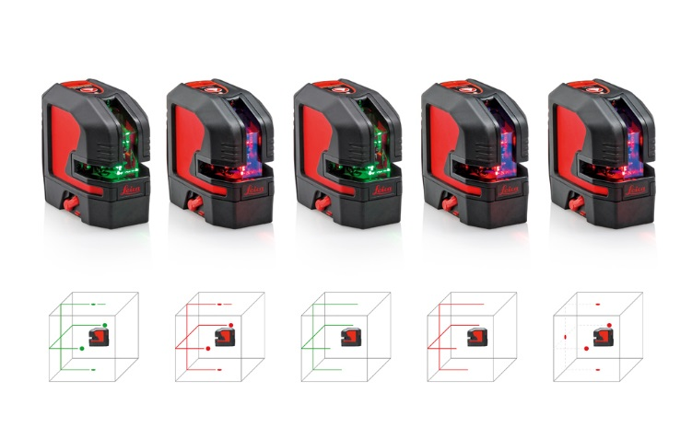

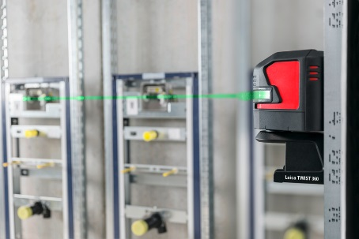

Leica Geosystems introduces the new Leica Lino series for best laser visibility

Leica Geosystems – when it has to be right
Revolutionising the world of measurement and survey for nearly 200 years, Leica Geosystems creates complete solutions for professionals across the planet. Known for premium products and innovative solution development, professionals in a diverse mix of industries, such as aerospace and defence, safety and security, construction, and manufacturing, trust Leica Geosystems for all their geospatial needs. With precise and accurate instruments, sophisticated software, and trusted services, Leica Geosystems delivers value every day to those shaping the future of our world.
Leica Geosystems is part of Hexagon (Nasdaq Stockholm: HEXA B; hexagon.com), a leading global provider of information technologies that drive quality and productivity improvements across geospatial and industrial enterprise applications.

For further information please contact:

Leica Geosystems AG
Susanne Haller
Heinrich-Wild-Strasse
CH-9435 Heerbrugg

Phone: +41 (0)71 727 3403
susanne.haller@leica-geosystems.com

www.leica-geosystems.com
www.disto.com

