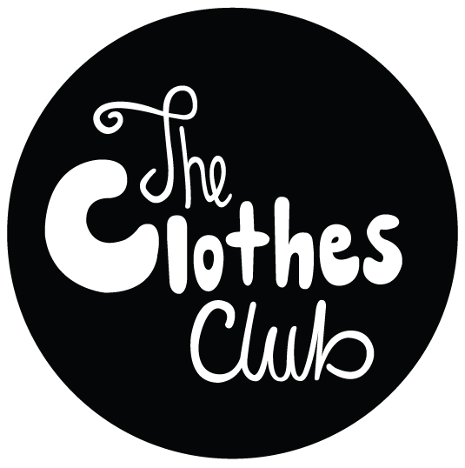

[The Clothes Club](http://www.facebook.com/theclothesclub) was launched by Emily de Groot to form a community of clothes swappers - with the aim of raising money for local social enterprises. Come and join them on Twitter @Clothes_Club_UK or Facebook www.facebook.com/theclothesclub

They're holding their first clothes swapping evening on Thursday April 25th from 7.30pm at Hackney Pirates 1-9 Downham Road, London N1 5AA.

It’s a great way to inject some new life into your wardrobe, without spending lots of money, whilst reducing the environmental effects of the fashion industry and raising money for good causes.

All profit from the first event will be supporting Hackney Pirates who help children with vital 1-1 attention after school hours.

Early bird tickets are just £8 (£10 after), and the money raised will be donated to social enterprises in London. You'll take home new items too!

http://www.tickettailor.com/checkout/view-event/id/8065/chk/8cc5

Come along, have a drink, have a dance, swap your clothes and network. Some amazing brands have donated items for the raffle including: [Mawi](http://www.mawi.co.uk), [Tokyo bike](http://www.tokyobike.co.uk), [Move Your Frame](http://www.moveyourframe.com) and [Orwell & Austen.](http://www.orwellausten.com)

7.30-8.30 - arrive with clothes & clothes organised

8.30-9.30 - clothes swap & raffle

8-10.30 - dj and networking

11 - close

Bring up to 3 items of quality clothing you no longer wear and swap them for someone else’s unwanted garments.

You'll be given tokens on the night for your items. If you really want an extra garment, you can always buy additional tokens.

Only bring clothes you are proud to pass on please; The Clothes Club want everyone to get back what they give.

They’re asking people to refrain from bringing underwear and jewellery for obvious reasons.

If you bring shoes, they’re allowing average sizes of 4-7 and please only bring 1 pair out of your 3 items, just so it's not a shoefest.

Lets help put some conscience into our closets!