www.thehappinesseffect.com

Press release

Can happiness spread online? The Happiness Effect movement seeks to find out on the International Day of Happiness.

SINGAPORE, 19 March 2013 – On the International Day of Happiness on 20 March 2013, The Happiness Effect (THE) movement will be launched. Over 100 days from 20 March to 27 June 2013, this global movement seeks to positively touch a million people by spreading happiness online.

Earlier studies suggest that happiness can spread amongst social networks up to 3 degrees of separation. Harvard social scientist Dr. Nicholas Christakis and political scientist James Fowler at the University of California at San Diego reported that emotions can pass among a network of people up to three degrees of separation away. This means that people who are surrounded by many happy people tend to be happier with time.

However, in a more recent study released in 2013, John F. Helliwell and Haifang Huang found that “real-life friends” have a much more significant impact than online friends on a person’s happiness levels. Specifically, they found that the number of real-life friends is positively correlated with subjective well-being (SWB). Doubling the number of friends in real life can increase well-being to the equivalent effect of a 50% increase in income. However, the size of one’s online networks was largely uncorrelated with SWB.

‘We do not believe that social media and online connections can, or should, replace real-life relationships. Studies however that suggest that focusing on positive events, people and solutions in life (rather than negatives and problems) can make people happier. The Happiness Effect (THE) movement explores the extent to which social media and technology can help to spread and amplify these positive emotions. We invite people to share their happy thoughts, feelings and moments through pictures, videos, and heart-felt comments,’ said Ms Angela Lam, founder of THE movement.

Over 100 days, THE movement invites the world to take 1 action a day to make someone happy, and to share these acts of happiness through videos, photos, tweets, and stories. The actions are selected from the free Happiness Manifesto or public suggestions. Happiness Angels are also nominated and voted by the public, to recognize the joy, happiness and positive contributions that they make to others. The objective of these actions is to increase consciousness of our options in daily lives. When a positive action is taken and shared online - such as an affirming word or a hug - another person is touched or affected.

‘Technology has become an integral part of our lives. We want to explore how we can use technology and social media to increase rather than decrease happiness and meaningful interaction’, said Ms Lam.

Here’s how you can participate and be a part of the movement:

- ‘Like’ and share the website and Facebook page at www.thehappinesseffect.com and www.facebook.com/thehappinesseffect.

- Follow the movement on Twitter at www.twitter.com/thehappinessef1.

- Download the free Happiness Manifesto at http://thehappinesseffect.com/book-videos, and offer your suggested ideas on actions that the world can take together to spread happiness.

- Tune in daily from 20 March 2013, do the selected happiness actions and upload your pictures, videos, ideas and comments on THE Facebook page or twitter. Start your tweets with the #TheHappinessEffect.

For more information, please visit www.thehappinesseffect.com.

END www.thehappinesseffect.com

MEDIA CONTACTS
Angela Lam angela.lam@thehappinesseffect.com, +65 9843 6993
Gareth Poh gareth.poh@thehappinesseffect.com, +65 8228 0302

THE MOVEMENT AND FOUNDERS
The Happiness Effect (THE) movement is a 100 day movement from 20 March to 27 June 2013. Over 100 days, THE unites the world in 1 action each day, focused at making someone happy. Actions are selected from the free Happiness Manifesto and public suggestions. Happiness Angels are also nominated and voted by you, to recognize the joy, happiness and positive contributions that they make to others.
THE aims touch 1 million people worldwide over 100 days and inspire positive action.
Here’s how you can participate and be a part of the movement:
1. ‘Like’ and share the website and Facebook page at www.thehappinesseffect.com and www.facebook.com/thehappinesseffect.
2. Follow the movement on Twitter at www.twitter.com/thehappinessef1.
3. Download the free Happiness Manifesto at http://thehappinesseffect.com/book-videos, and offer your suggested ideas on actions that the world can take together to spread happiness.
4. Tune in daily from 20 March 2013 to 27 June 2013, do the selected happiness actions and upload your pictures, videos, ideas and comments on THE Facebook or twitter pages. Start your tweets with the #TheHappinessEffect.
THE movement is a not-for-profit movement started as a personal initiative by Ms Angela Lam, Chief Happiness Officer of Skool of Happiness and several social entrepreneurs in Singapore. Skool of Happiness™ (SoH) betters lives by helping individuals to unlock their personal potential and live successful and fulfilled lives. SoH was founded by Ms Angela Lam. Angela started out with a high-flying corporate career in aviation, tourism and the hospitality industries. After more than 10 years in the corporate world, she gave up her title of Vice President with a multinational corporation to pursue her dreams and passions in bettering lives. Angela is known for her positive energy, bubbly nature, and “can-do” attitude. She loves music, dance, books, nature, and an occasional burst of spontaneity and madness. For more information, please visit www.skoolofhappiness.com.

PHOTOS

The following photos and captions may be used for visuals. The photos can be downloaded at this link: http://www.mynewsdesk.com/sg/pressroom/the-happiness-effect
 | A group of friends from different countries touching typhoon-hit villages in the Philippines with small gifts but big hearts.
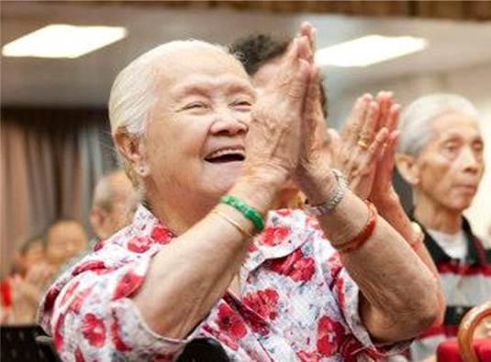 | Simple personal connections and great company can make the day for old folks. Sharing and giving at a charity event, Project 100 Smiles.
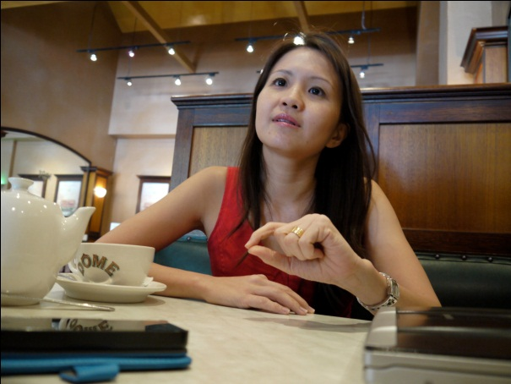 | Ms Angela Lam, founder of The Happiness Effect (THE) movement, speaking about her vision and objectives for THE movement.

