

**The Patient Status Engine - Moving higher acuity healthcare closer to home**

Almost everyday we hear yet another story of things going wrong in hospitals. Patients do not receive timely care, there are too many adverse events and avoidable deaths and hospital acquired infections are only too common. These are problems faced by all hospital operators in all countries worldwide and arise not because hospital staff are negligent or overworked, but essentially because hospitals in their current form are no longer fit for purpose.

Recognizing this and that hospitals are not only expensive but also dangerous, healthcare organisations worldwide are working on ways to make healthcare safer, better suited to the needs of patients and less expensive. Medical treatments that were once provided in hospital are being increasingly administered in the community As part of a renewed global focus on delivering general health care outside of the hospital, to improve safety and to free up beds on wards to provide more complex, specialised and emergency care.

This movement of care from acute hospitals to the community has become an international priority. Many countries acknowledge the need to improve productivity whilst reducing health care costs. Furthermore, global drivers for change such as rising patient need; an ageing population and workforce; demand for care to be delivered closer to the patient’s home; and reducing unscheduled health care use, are putting more pressure on health systems to deliver safe, timely and quality care for patients at home.

# Treating patients at home, even those who a few years ago may have been hospitalized leads to a number of benefits.

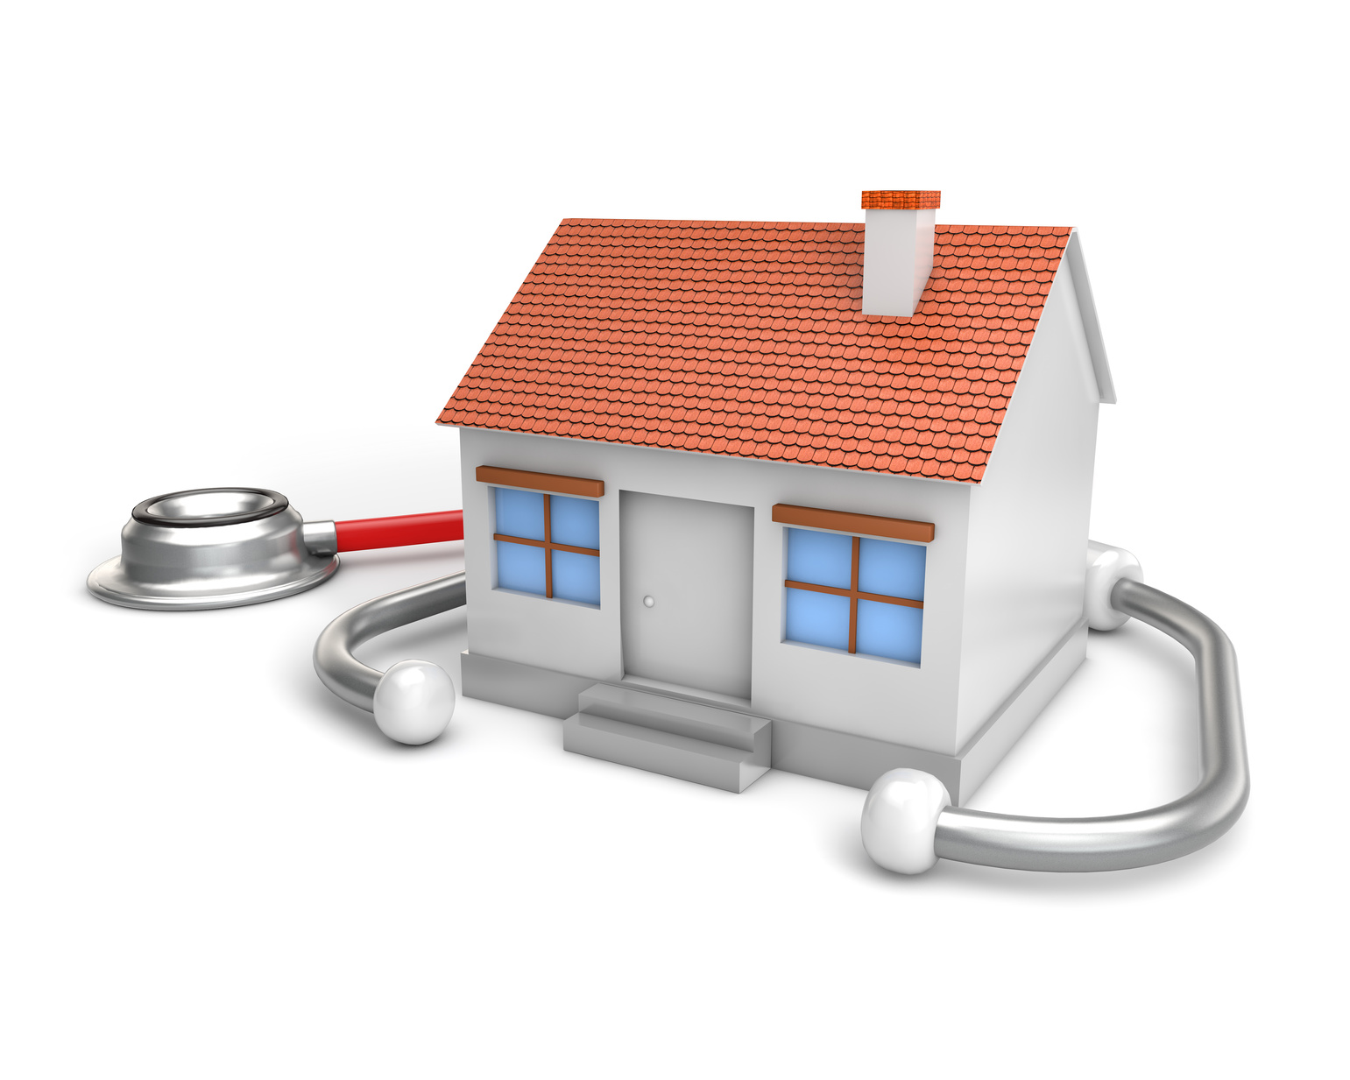

# Fewer hospitalisations and Emergency Department visits

# High patient satisfaction and acceptance

# Improved health

# Increased quality of life

# Improved hospital efficiencies

# Reductions in cost of care

# Reduction in the need to stop and start

There can, of course, be risks in treating patients in community-based settings:

* *Patients are not admitted to hospital early enough, or are discharged too early, without alternative services to address their needs*
* *If extra patients are treated in community-based settings, these services will require additional resources*
* *Patients may be at greater risk in community-based settings than in an acute hospital if their needs escalate quickly*
* *You need to have efficiency gains all the way through the care pathway. If you need someone to be with the patient 24/7 this negates many of the benefits of hospital at home.*

# To address these risks it is necessary to know the clinical status of these patients all times. For effective and affordable care of patients at home, you need a remote monitoring system that collects patient data automatically and continuously and which includes predictive elements so that any patient at risk of deteriorating is detected early and evasive action can be taken ro prevent things going badly wrong for the patient. Also any such monitoring system must be wireless in nature, since there are no nursing staff to fix and reset monitoing leads and cables giving patients the freedom to move around whilst their vital sign data is being collected continuously and in real-time.

# Higher acuity care at home that is supported by these medical devices and computer-based technologies that make up such a remote patient monitoring system is a big win-win for patients, healthcare providers and payers.

Isansys Lifecare in Oxford, has created the Patient Status Engine (PSE), a patient monitoring platform which collects and analyses patient’s vital signs and other relevant data continuously, alerting doctors and nurses if a person’s health is deteriorating and providing a robust and auditable record of the patient’s healthcare record.

The PSE is a complete end-to-end, CE marked, class IIa medical device, which uses wireless body-worn sensors to automatically collect and analyse six vital signs in real-time including heart rate, respiration rate, temperature, oxygen saturation, blood pressure and coma (or pain) score. The PSE is enabling clinicians and nurses to develop new methods to improve patient outcomes, reduce healthcare costs, shorten hospital stays and facilitate proactive care.

The wireless nature of the PSE means patients can also be monitored at home or in the community as well as in hospital.

  

***The Patient Status Engine provides freedom for patients whilst providing clinicians with data to make faster decisions***

Currently, nursing staff are not available 24 hours a day to continually watch a patient in their own home whilst they are in their care and therefore, can only monitor patients at various points of the day. This is timely, costly, and can put the patient at risk as deteriorations can occur quickly and in between observations.

Now, with the use of the PSE and its remote capabilities, patients can be monitored continuously and wirelessly from home, enhancing the level of medical support they receive without having to go into a hospital. The patients’ data is then streamed to a central server and delivered back to the patient’s care team.

This constant, highly accurate monitoring of patients at home will help clinicians identify potential indications of adverse events more quickly, improve the safety and care of patients while they recover at home, and reduce the number of readmissions into hospital.

In 2015, Isansys received £1 million funding from the Small Business Research Healthcare Initiative (SBRI) to carry out a study, with the [Queen Elizabeth Hospital](http://www.isansys.com/uploads/wysiwyg_editor/files/QEH-Case-Study.pdf) in Birmingham. Here, the clinical team are using data from the PSE to develop an early warning score for patients who are have just undergone chemotherapy and are recovering at home, but are at high risk of neutropenic sepsis.

*Results are due to be reported soon but there are already indications of:*

* Earlier, lower cost and less traumatic interventions
* Halting the progression of sepsis in its early stages, potentially allowing more patients to be successfully treated for neutropenic sepsis without requiring admission to hospital
* Presentation of early warnings to the patient and (remotely) to the care team
* Reducing hospital stays for those who are admitted, and significantly improving outcomes
* Empowering patients to be actively involved in the remote monitoring of their well-being at home
* Providing patients with better access to healthcare
* Improving quality of care
* Giving patients peace of mind and daily assurance

Isansys is also about to start work on a project with care of the elderly at home, with a view to reduced hospital admissions, and care of mentally ill and infirm patients in the community. These projects will, for the first time, show, evidence that clinical care in the home, at scale, is safe, patients like it, and it actually saves money.

## ARE YOU READY FOR HOSPITAL AT HOME?

If you are a healthcare organisations seeking to adopt innovative care models and are looking to take care into the community, please contact us about our Hospital at Home scheme to find out how we can help you. Please email [**info@isansys.com**](mailto:info@isansys.com) or call **01235 436225**.