PRESS RELEASE Stockholm 2/24/2014

Boats of the future with outriggers some of the highlights
of the Stockholm International Boat Show

The boats of tomorrow will have foils that lift them above the waves. Foils and outriggers also increase speed and can reduce fuel consumption by 75 percent. See the boats of the future first at the Stockholm International Boat Show! The Show also includes the speed-demon Zuperman, good for 180 knots. About 500 boats will be on display, several of which are world premiers. The Stockholm International Boat Show opens at Stockholmsmässan on March 1.
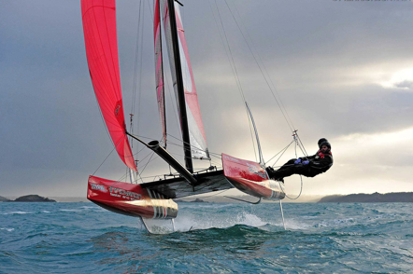
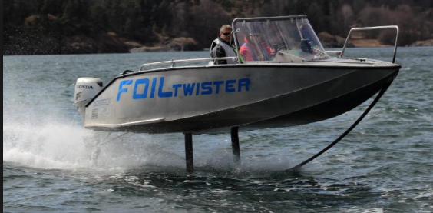

Foil Twister Flying Phanthom
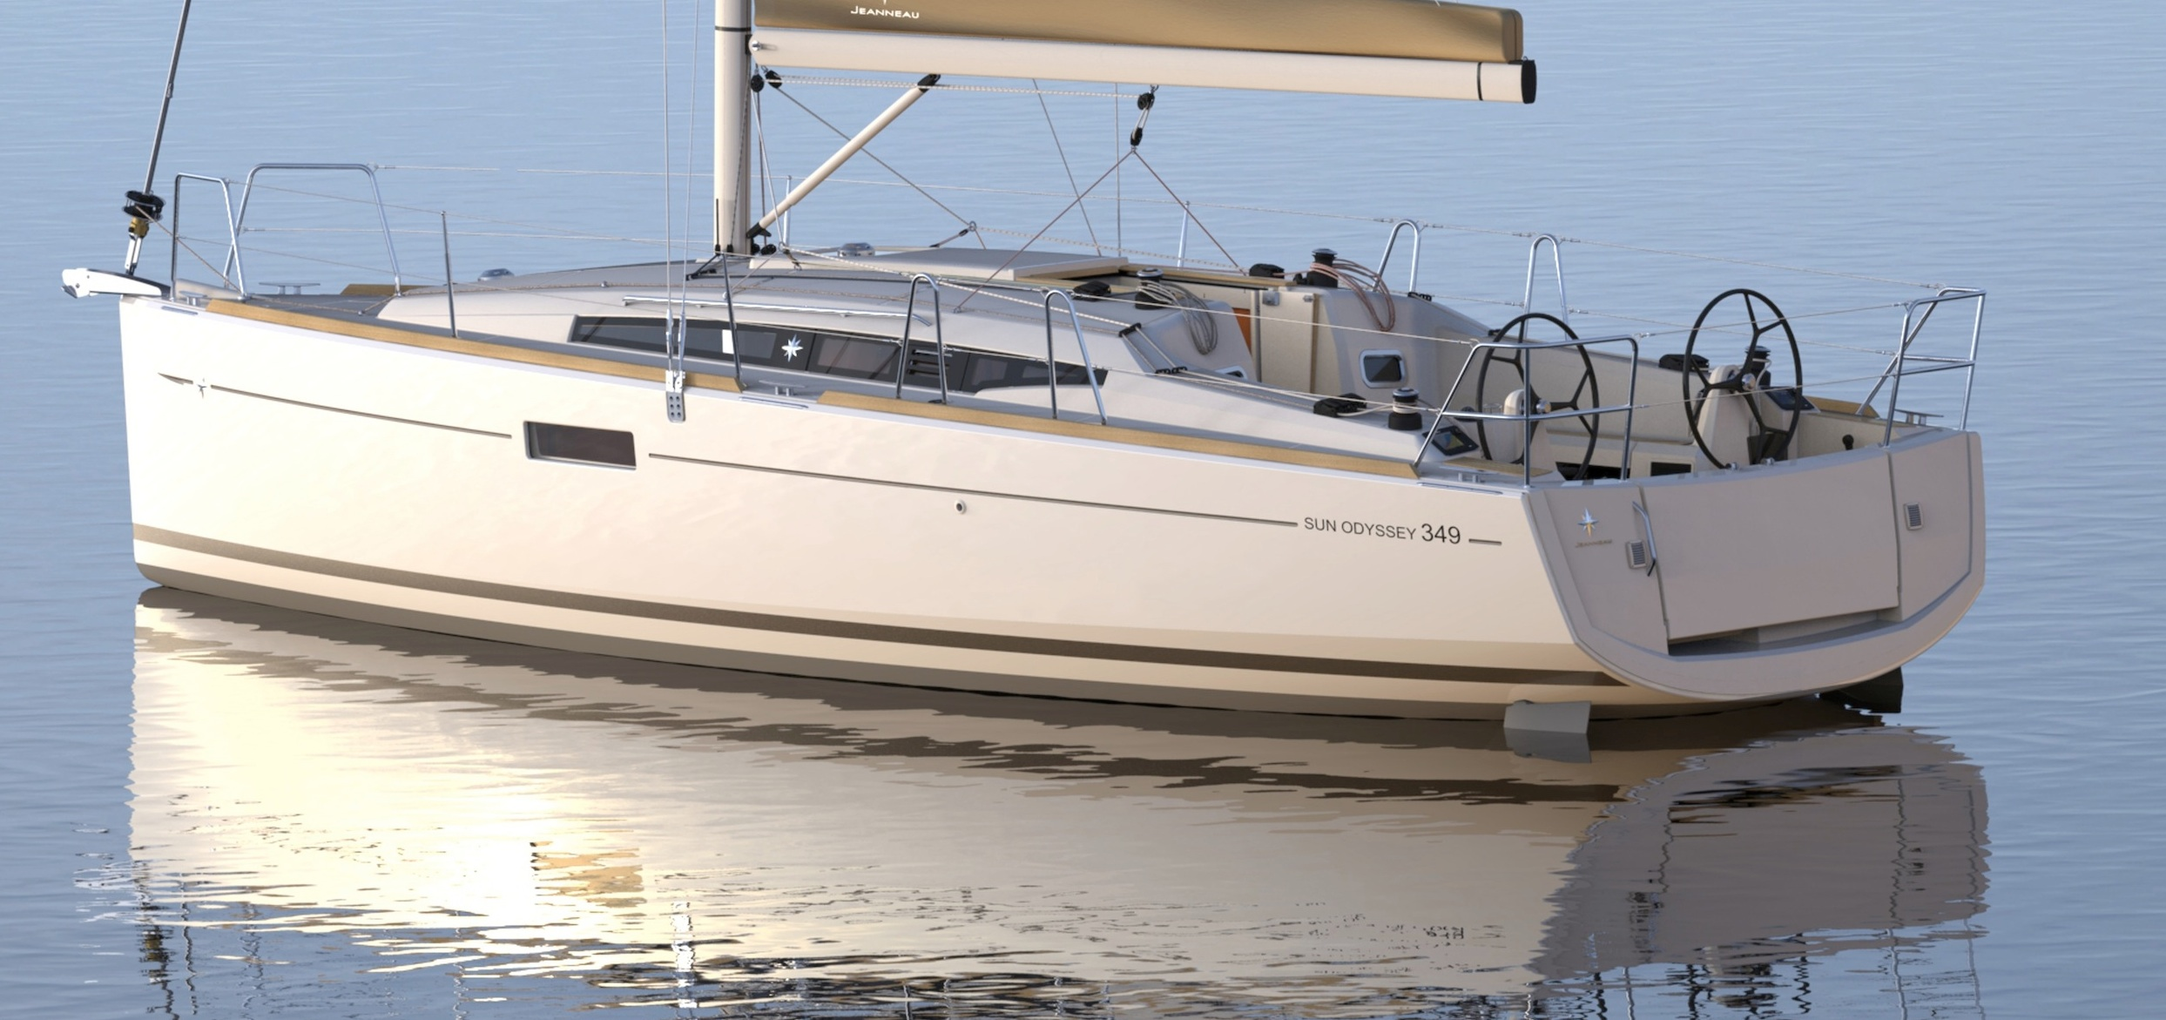
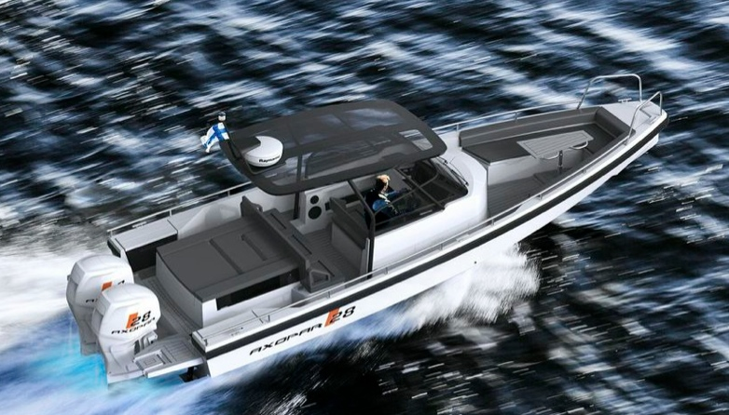
Axopar 28 Sun Odyssey 349

The Stockholm International Boat Show is the starting gun for the boating season. Around 100 000 visitors will get a taste of summer and plenty of opportunities to find boat and accessory bargains at the Show.

At the Stockholm International Boat Show, the Nordic region's largest, you will find a great many new boat models, thousands of new accessories and the latest sailing fashions. Among other things. For children there is a marine playground and many of the Show’s activities are for the whole family.

This year's Show is the meeting point of future, present and past. In contrast to the future’s flying boats, the Classic Boat Show section will feature examples of Swedish boat culture treasures. These are sleek wooden motor and sail boats from the turn of the last century, wafting the fragrance of tar and varnish. The Classic section’s theme this year is “The Beloved Gig". The gig (snipa) is the classic Swedish everyman's boat with roots stretching back to the Vikings’ boat-building techniques.

But it is surely all boat and accessory novelties that will arouse the most interest. And there will be plenty of new things to see, as this year’s Show is bigger than those of recent years. The industry is predicting an upturn in boating activity, which is reflected in the greater number exhibitors at this year’s Show.

“Yes, it was at least six or seven years ago that we had a Show that could match this year's. It’s exciting that this year we can also display so many new items. There are at least 40 boats that have never been seen here before, so it'll be a great Show this year”, said Thomas Sandberg, project manager for the Stockholm International Boat Show.

The 15-meter-long speed demon Zuperman, good for speeds just below 200 knots, will naturally be one of the major attractions. But there are also many other interesting new items. Among motor boats we find the Bavaria Virtess 420 Fly, the world-premiering Forbina 42 CC as well as the Axopar 28, which will appear in four different versions, among others. Other novelties include the Aquador 30 ST, Flipper 640 SC, Bella 630 RC, Jeanneau NC9, Sealine F380 Fly, Uttern, T52, Finnmaster T8, Cris Craft Carina 21 and Ryds F468 Sport.

The aluminum trend continues. New aluminum boats include the Swedish-made Viggo X8, making its world premier along with the Arronet 245 sxt. Buster is coming from Finland with four new Buster X models, and will also be showing aluminum-hulled rib boats.

Among the sail boats, of course, there are also many new items, for example the Dehler 38, Sun Odyssey 349, Hanse 385, Dufour 410, Seascape 27 and Finnflyer 34 GT. The Show’s largest boat this year is the Beneteau Sense 55

For the first time, this year the Show will comprise seven sections: Sailing, Grand Large/motor boats, Accessories, Environment/sustainable seas, Classic Boat Show, Life on Board and Little Stockholm International Boat Show.

The environment will be very much in focus at the Stockholm International Boat Show. This year the Show, along with the Hållbara Hav [Sustainable Sea] initiative, has created an extra, large section with many environmental exhibitors showing off their ideas and products for a cleaner Baltic Sea. In the environmental booth, visitors will get specific tips on how, as boat owners, they can help make the Baltic a cleaner sea.

At the Little Stockholm International Boat Show, children can explore and tinker in Engineer Lundström’s experiment booth. The Grand Large booth is home to the large motor boats. There is also a rosé-and-bubble bar where weary visitors can rest their feet and enjoy something refreshing and delicious.

To find out more:
- Thomas Sandberg, project manager, tel: +46-8-749 44 94, thomas.sandberg@stockholmsmassan.se
- Mats Hagman, Informedia, tel: +46-70-628 12 10, mats.hagman@informedia.se

