Contact:
Ovelin ltd.
+358407764954
media@ovelin.com

FOR IMMEDIATE RELEASE:

GUITARBOTS TURNS GUITAR PRACTICE
INTO SOCIAL GAMING

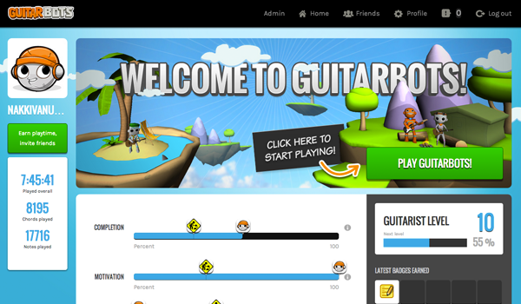

- OVELIN LTD. INTRODUCES GUITARBOTS -
THE SOCIAL GUITAR GAME PLAYED WITH A REAL GUITAR

New GuitarBots features available globally 29 April 2013.

SAN FRANCISCO – (April 29, 2013) – Ovelin ltd. announced today the release of GuitarBots social features to take its previously released guitar game title GuitarBots to the next level of development –turning guitar practice into a social online gaming experience.
The released GuitarBots now includes novel social features, making it possible for aspiring and experienced guitarists alike to invite friends from existing social networks (such as Facebook) and to compete with them on real-life guitar skills. The motivational aspects of GuitarBots game are also reinforced by introducing a novel set of challenges (achievements) to reward players to advance in certain areas of guitar playing – for example mastering a certain set of chords, playing certain amount of notes, practice frequency.
”Playing the guitar is a social activity – this is the missing aspect in the existing guitar learning products and services – games and educational packages alike” said Christoph Thür, the CEO and co-founder of Ovelin. “GuitarBots is the first service out there that combines guitar gaming, social networking and real-life guitar practice into one, fully featured package.”
The released GuitarBots social profile includes a range of new, exciting features including:
- Invite friends from different sources : Facebook, email, personal invite link
- Track your progress in the game (guitarist level), and earn achievements for improving in different areas of guitar skill
- Compete with your friends by completing new songs(completion), practicing more often for longer periods (motivation) and getting better at different areas (achievement)
GuitarBots is available online for Pc and Mac computers, at www.guitarbots.com. Mobile client versions are in development and will be released in the near future.
With a free GuitarBots account, the users can play for 5 minutes per day, up to 1 hour per day by inviting friends to join ( 5 minutes more per friend).
More playtime is available by purchasing a Premium account (priced at $9.99 /month).

For more information about GuitarBots visit : www.guitarbots.com
More information about Ovelin at: www.ovelin.com
Ovelin youtube channel : www.youtube.com/ovelinbird

For inquiries, contact:

US (San Francisco office)
Co-founder Christoph Thür, chris@ovelin.com, (+1 42 42 780 731 )

Europe (Helsinki office):
Marketing Manager Mika Jalonen, media@ovelin.com (+358 40 7764954)

About GuitarBots
GuitarBots is an innovative online guitar learning game played with any real guitar – acoustic or electric. GuitarBots turns real guitar practice into online gaming with social features, making it more motivating and fun to develop real life guitar skills.
Starting with GuitarBots is simple – you can play the game directly on your web browser. The game is played with a real guitar (acoustic or electric), using the computer’s microphone to “listen” to the chords and notes played.
GuitarBots is suitable for all ages and skill levels, featuring step-by-step tutorials, a built-in tuner and a variety of songs with both beginner and advanced difficulty levels.

About Ovelin ltd.
Ovelin is changing the way people learn to play musical instruments. Headquartered in Finland, the company is known as the creator of the popular guitar learning game WildChords for iPad. WildChords, played cord-free with a real guitar, has been the number 1 music app in 34 countries, featured in the Sunday Times ’World’s Best Apps 2012’ list, WIRED magazine and TechCrunch. It has also won several awards, the Best European Learning Game in 2011, and winner of SXSW 2012 and MIDEM 2012.

