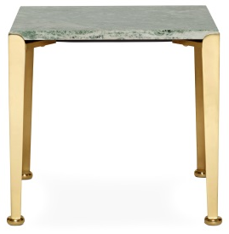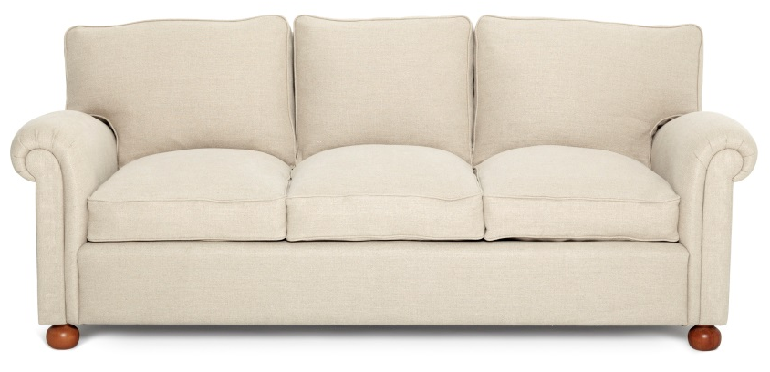
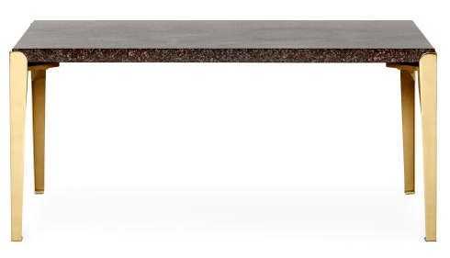 | 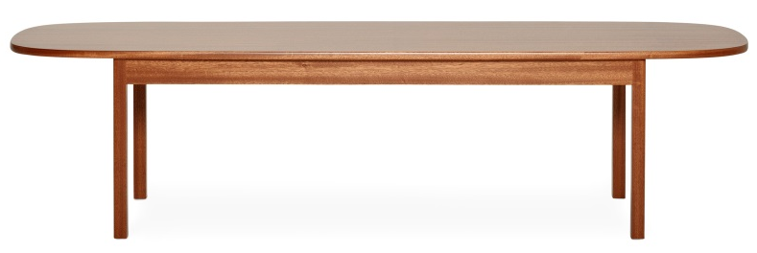

Above: Side table 764, SEK 15,900. Sofa 2080, SEK 40,500.
Coffee table porphyry SEK 19,500 and Coffee table L7, SEK 18,000.
Below: Chair 966, SEK 12,000, Desk 980, SEK 23,000.

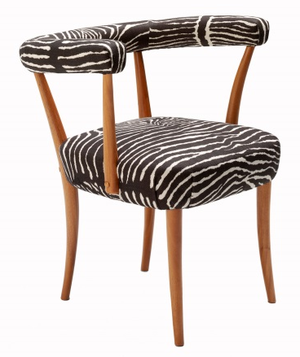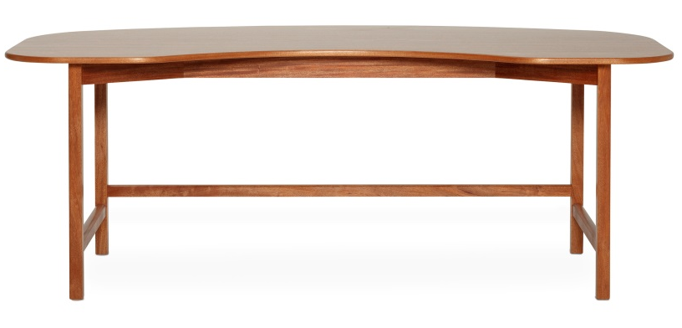

Sideboard 2137, SEK 90,000.  Armchair 2080, SEK 23,600. | 