Island Offshore secures a lean, clean future for its PSVs with hybrid power vessel conversions via KONGSBERG
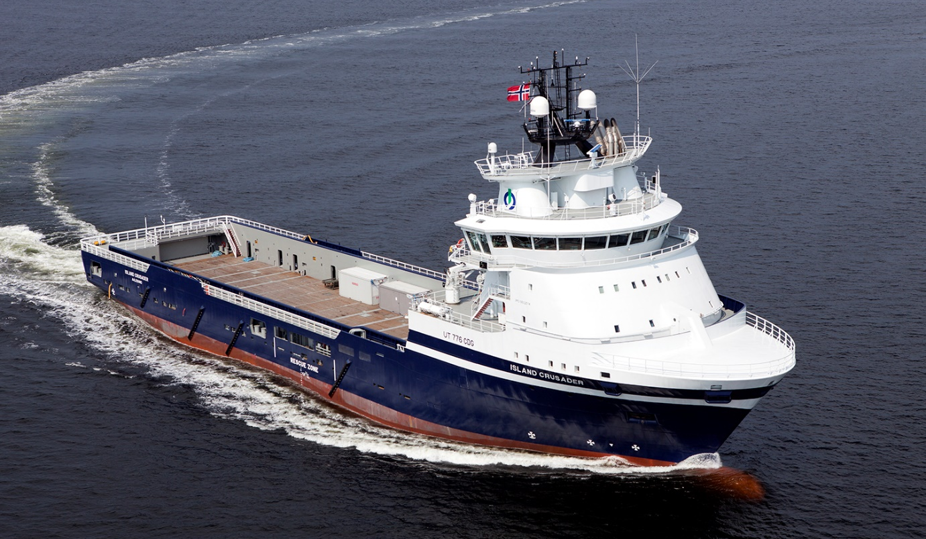
Photo: Gunder Tande Sandersen
The Norwegian oil-industry solutions provider Island Offshore has set a clear precedent in the market by contracting KONGSBERG to convert three of its Platform Supply Vessels to use hybrid power technology
Kongsberg, Norway, 17th August 2020 – Kongsberg Maritime is pleased to announce that it has been contracted by Island Offshore, a leading Norwegian provider of high-quality solutions for the offshore oil industry, to supply turnkey hybrid battery solutions for three of the firm’s UT 776 CD-design Platform Supply Vessels.
Two of the ships, Island Crusader and Island Contender, previously operated with a combination of Bergen LNG engines and Bergen Diesel engines, while the Island Commander deploys four diesels. The conversion of all three into hybrid craft not only represents a firm commitment on the part of Island Offshore to the principles of environmental responsibility, but also unlocks a wealth of potential for increased operational efficiency and a marked reduction in maintenance requirements. This in turn translates to significant cost savings for the company.
In the past, PSVs have typically run multiple engines to achieve redundancy, with consequent impacts on fuel performance, equipment health and emissions. However, combining conventional LNG or diesel engines with KONGSBERG’s SAVe Energy battery system – which has been validated by DNV-GL – produces instant benefits. The batteries allow for fewer engines to be running, thus improving efficiency by increasing the load on the remaining engines while also instantly delivering power on demand: ideal in the context of low-load operations such as Dynamic Positioning. Fuel consumption and running costs will also be reduced through conversion of the vessels to closed bus-tie operation.
The solution opted for by Island Offshore will operate via a single feed from the ESS (Energy Storage System) to the main switchboard – with manual changeover that will enable the operators to balance out running hours on generators – and a 600kW dual shore connection. Kongsberg Maritime’s 8m/26ft ESS 896kWh deckhouse will encompass a standard, type-approved, liquid-cooled container solution with air-cooled SAVe Energy batteries. The extensive scope of supply will also involve modifications to each vessel’s main switchboard and K-Power EMS energy management system, as well as an upgrade of the Acon automation and alarm system.
“We are pleased to be working with Kongsberg Maritime on this endeavour, as a leading supplier and strategic partner to our business,” says Tommy Walaunet, Managing Director, Island Offshore Management AS. “By making this investment despite challenging market conditions, we underline our commitment to continue reducing our vessels’ environmental footprints, and our strong belief in a sustainable future for our business.”
“The operational, financial and ecological benefits of hybridisation based on our lithium-ion SAVe Energy modular energy storage system speak for themselves,” adds Gaute Aasen Augestad, Regional Sales Manager (EMEA), Kongsberg Maritime. “Applying this concept to the PSV market sets an important precedent for the industry, and we’re pleased to have been entrusted with delivering this integrated technology package for these Island Offshore vessels.”
Ends

For further information, please contact:
Gunvor Hatling Midtbø, VP Communication
Kongsberg Maritime
Tel: +47 9921 4209
gunvor.hatling.midtbo@km.kongsberg.com
David Pugh
Saltwater Stone
Tel: +44 (0)1202 669244
d.pugh@saltwater-stone.com

About Kongsberg Maritime
Kongsberg Maritime is a global marine technology company providing innovative and reliable ‘Full Picture’ technology solutions for all marine industry sectors including merchant, offshore, cruise, subsea and naval. Headquartered in Kongsberg, Norway, Kongsberg Maritime has manufacturing, sales and service facilities in 34 countries.
Kongsberg Maritime solutions cover all aspects of marine automation, safety, manoeuvring, navigation, and dynamic positioning as well as energy management, deck handling and propulsion systems, and ship design services. Subsea solutions include single and multibeam echo sounders, sonars, AUV and USV, underwater navigation and communication systems.
Training courses at locations globally, LNG solutions, information management, position reference systems and technology for seismic and drilling operations are also part of the company’s diverse technology portfolio. Additionally, Kongsberg Maritime provides services within EIT (Electro, Instrument & Telecom) engineering and system integration, on an EPC (Engineering, Procurement & Construction) basis.
Kongsberg Maritime is part of Kongsberg Gruppen (KONGSBERG), an international, knowledge-based group that celebrated 200 years in business during 2014. KONGSBERG supplies high-technology systems and solutions to customers in the oil and gas industry, the merchant marine, and the defence and aerospace industries.
Web: Kongsberg Gruppen | Kongsberg Maritime
Social media: LinkedIn | Twitter | Facebook

