**Epson launches new portable scanner, WorkForce DS-310 and DS-360W**

First portable scanner with ADF in SE Asia

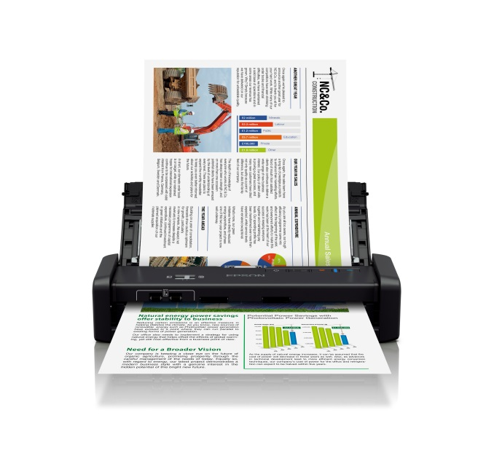

**Epson’s WorkForce DS-360W**

**Malaysia, July 18, 2017** – Epson has launched its new portable scanners, the WorkForce DS-310 and DS-360W, for convenient scanning on-the-go. One of the fastest portable business scanners on the market, the WorkForce DS-310 and DS-360W scanners are the first portable scanners with an Automatic Document Feeder in SE Asia, enabling speedy scanning and archiving of documents for the mobile workforce.

The WorkForce DS-310 and DS-360W scanners scan at fast speeds of 25ppm or 50ipm, at up to 300dpi resolution for efficient and fast document archival. The compact and lightweight scanners weigh at 1.1kg and 1.3kg respectively, and can be carried around easily in bags and briefcases.

Both the scanners provide convenient scanning with connectivity options while on the move, and can easily be charged via USB 3.0 without the need for an AC adaptor. Additionally, the DS-360W has a built-in battery which can be charged directly with a USB cable connected to a PC or laptop. With the DS-360W, users can connect via Wi-Fi. The device can also be used as an access point for devices to connect directly to the scanner.

The versatile scanners scan a wide variety of media, from 52 to 230gsm in thickness, including business cards and plastic cards, as well as different paper sizes of up to 1.1m in length.

The scanners come with advanced software that allow for text enhancement for improved text recognition when scanning. Its auto area segmentation feature automatically detects and scans text and images separately, while the document skew correction feature automatically adjusts and straightens scanned images.

Epson document scanners come bundled with document management software that allows users to easily manage their scanned files.

“The new portable WorkForce DS-310 and DS-360W scanners are power packed with features in a compact and lightweight body, and are well-suited for the busy road warrior. With the Automatic Document Feeder, scanning while on the move can be done more quickly with greater convenience,” said Danny Lee, General Manager, Sales & Marketing, Epson Malaysia.

***

**About Epson**

Epson is a global technology leader dedicated to connecting people, things and information with its original efficient, compact and precision technologies. With a lineup that ranges from inkjet printers and digital printing systems to 3LCD projectors, smart glasses, sensing systems and industrial robots, the company is focused on driving innovations and exceeding customer expectations in inkjet, visual communications, wearables and robotics.

Led by the Japan-based Seiko Epson Corporation, the Epson Group comprises more than 72,000 employees in 91 companies around the world, and is proud of its contributions to the communities in which it operates and its ongoing efforts to reduce environmental impacts.

<http://global.epson.com/>

**About Epson Southeast Asia**

Since 1982, Epson has developed a strong presence across major markets in Southeast Asia. Led by the regional headquarters Epson Singapore, Epson’s business in Southeast Asia spans an extensive network of 11 countries with a comprehensive infrastructure of close to 500 service outlets, 7 Epson solution centres and 7 manufacturing facilities. <http://www.epson.com.sg>

**About Epson Malaysia**

Epson Malaysia Sdn Bhd was established in Malaysia in 1991 as Epson Trading (M) Sdn Bhd, a sales company of the Seiko Epson Corporation, Japan. The company has exclusive rights to market, distribute and support a complete range of leading-edge Epson consumer and business digital imaging products in Malaysia and Brunei. Today, Epson Malaysia has 84 employees and an extensive network of 59 authorised service outlets nationwide. For more info, please visit [www.epson.com.my](http://www.epson.com.my/) or connect with us at [www.facebook.com.my/EpsonMalaysia](http://www.facebook.com.my/EpsonMalaysia)

.

**Media Enquiries:**

|  |  |
| --- | --- |
| Epson Malaysia Sdn Bhd  Chua Li Tinn  Manager – Marketing Communications  Tel: (03) 5628 8288 Ext 274  Email: [ltchua@emsb.epson.com.my](mailto:ltchua@emsb.epson.com.my) | SWOT Communications Sdn Bhd  Edina Manuel  Tel: 012 2500142  Email: [edina@swotcommunications.com](mailto:edina@swotcommunications.com) |