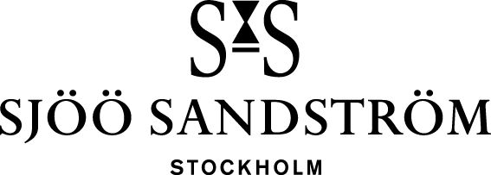

Press release, Stockholm, 2022

Annual Edition 2022: The girl who keeps on giving

Swedish watch manufacturer Sjöö Sandström was established in 1986 and is the only Swedish watch brand in the luxury segment. Each year the company launches a unique and limited edition of the iconic model Royal Steel Classic. This exclusive edition, available only in 86 pieces, celebrates Sjöö Sandström’s legacy as well as the irresistible passage of time.

Just as the number of available pieces stems from the company’s founding year, so does the design of the Royal Steel Classic Annual Edition – spiked with a contemporary touch. This year’s edition is a sequel to 2021’s successful tribute to Pippi: the strongest girl in the world.

- Although we were quite certain that last year's Annual Edition was destined for success, we could never have dreamt of the overwhelming response. Watch-aficionados and Pippi-fans from all over the world instantly signed up to get a watch, but as the Annual Edition concept goes, only 86 timepieces were manufactured and delivered, says Kristofer Johansson, Partner at Sjöö Sandström.

Inspired by the enduring power of Pippi, the Swedish watch manufacturer now launches Annual Edition 22 featuring 2021’s stunning design and details, but with a black, timeless dial. Just like its predecessor, the exclusive watch comes with an elegant dial that features a subtle interpretation of Pippi's iconic braids; a unique tactile pattern that comes alive through light and shades and which provides depth and detail for a profound experience. In addition, the second hand and the year 2022 boast an orange color that reflects the girl’s vibrant personality. Engraved on the caseback is also one of Ingrid Vang Nyman's classic Pippi illustrations.

- We’re happy to offer yet another timepiece which celebrates our Swedish heritage and this iconic Astrid Lindgren-character. We expect it to sell our as quickly as previous, temporary collections. Due to the massive interest in our Annual Editions, we invite our customers to already sign up for 2023’s edition by sending an email to sjoosandstrom@sjoosandstrom.se, continues Kristofer Johansson.

Royal Steel Classic Annual Edition 22 comes in three sizes – 32, 36 and 41mm – offering optimal fit for both ladies and gents and is available in a total of only 86 pieces. The timepiece is presented in an exclusive box featuring classic Pippi Långstrump illustrations.

Specifications
CASE: Stainless steel Ø32, Ø36 & Ø41 mm.
CASE-BACK: Unique “annual 2022” closed case-back
GLASS: Scratch resistant sapphire crystal with anti-reflective coating.
DIAL AND HANDS: Dial with white super luminova index marks and hands with super luminova.
DIAL: Pippi inspired pattern
BEZEL: Stainless steel
BRACELET: Ø32 & Ø36 Stainless steel, with an engraved logotype on end piece. Ø41 Stainless steel.
WATER RESISTANCE: 10ATM (100 meters)
MOVEMENT: Ø32 Electronic movement SS L1 Ø36 & Ø41 SS G7 Automatic movement (Swiss Made)
RRP: Ø32 17.800 SEK Ø36 25.800 SEK Ø41 25.800

For more information, please contact:
Felix Formark
Press contact, Sjöö Sandström AB
felix.formark@sjoosandstrom.se
Telephone: +46 760 06 82 90

Annual Edition 2022 Pippi x Sjöö Sandström

