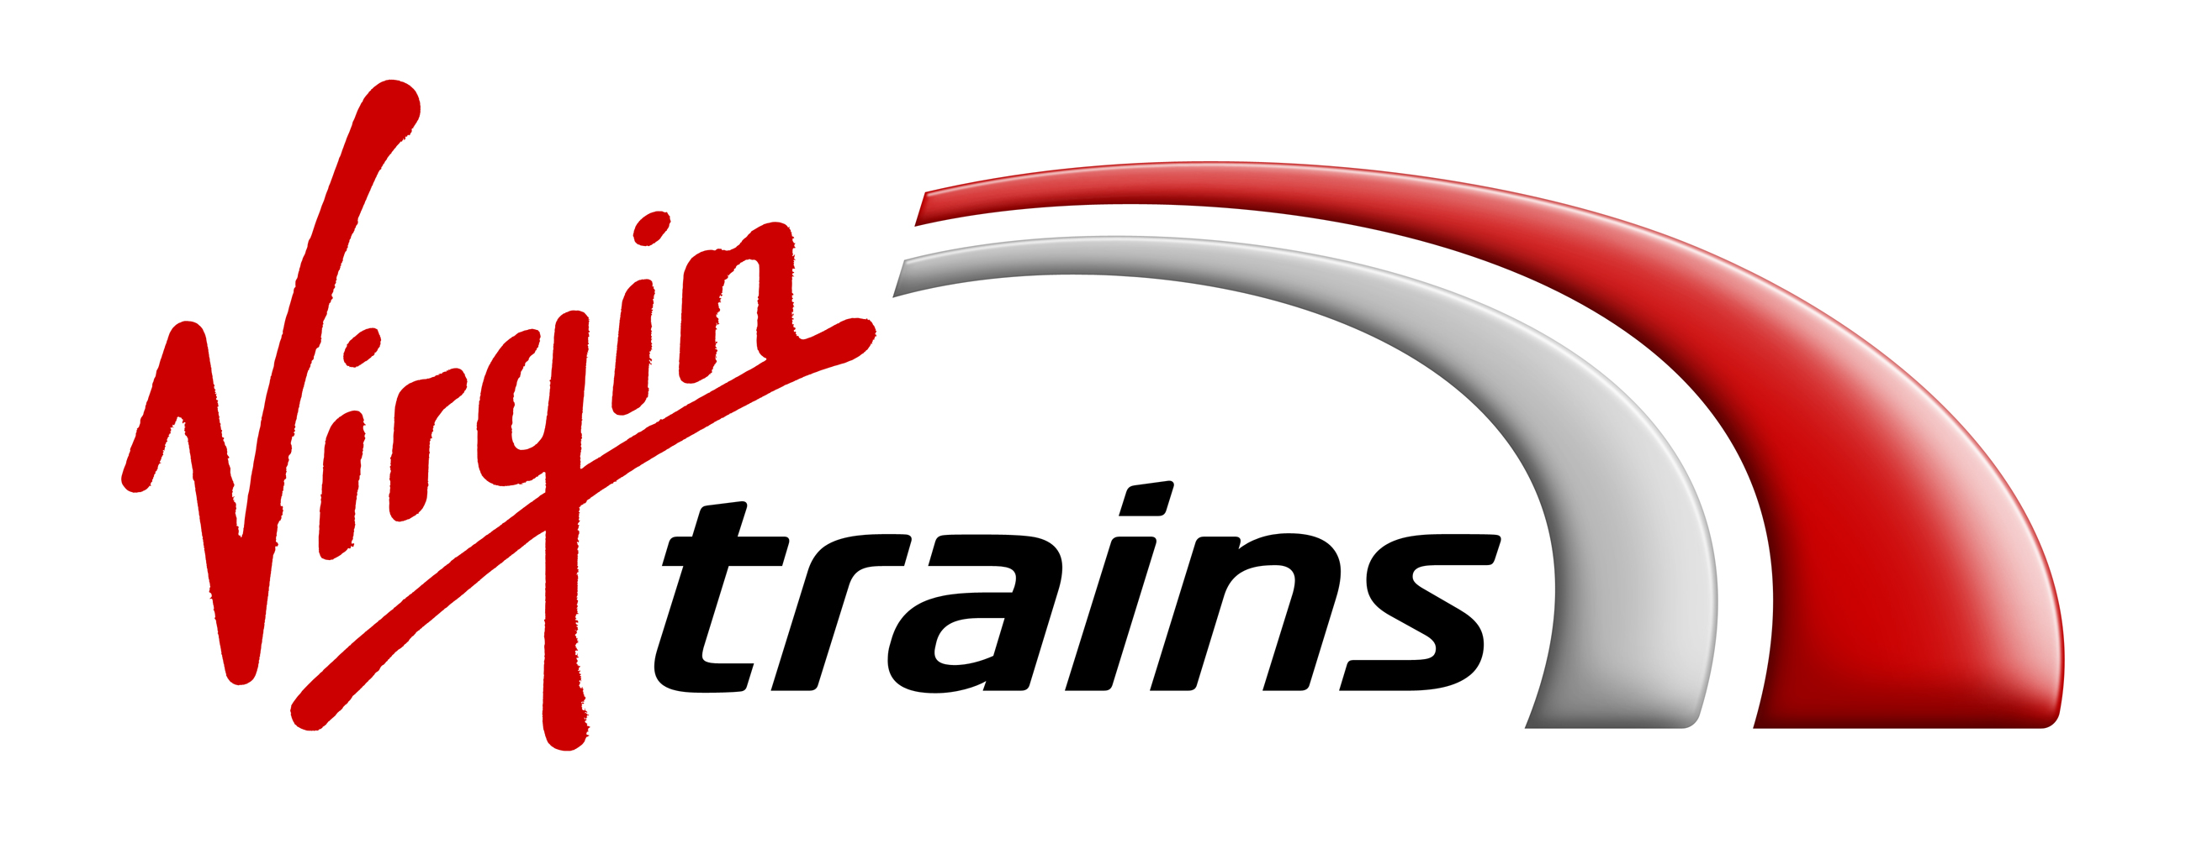

Press Release
LIFE IS SHORT: THE AVERAGE BRIT HAS JUST 17 DAYS OF FREE TIME EACH YEAR
- We value free time more than money, careers and success
- Sleep, sex and socialising are the top things we miss out on
- Find out how much free time you have each year with the Virgin Trains Free Me Calculator

London, 14 August, 2017: The average Brit has just 17 days of free time a year, including weekends, according to a new study from Virgin Trains. That’s just over two weeks across the entire year to spend doing the things we really want to do.

A third of us (32%) feel we have less time than we did five years ago, and nearly half of us (46%) wish we had more free time. In fact, Brits actually value free time more than money, material possessions and even career success.

More than half of Brits (51%) would go travelling if they had more time, over a third (34%) would catch up with friends and family and 16% of us would like to learn a new language. Interestingly, the top things people think they miss out on because they don’t have enough free time, are socialising (35%), weekend and day trips (35%), sleep (33%) and sex (20%).

If we’re not doing the things we really want to do, then what is taking up all of our precious time?
- 103 days a year sleeping
- 9 days a year on social media
- 11 days of the year cooking and eating
- 8 days a year doing housework
- 7 days a year doing exercise
- 5 days a year in the bathroom

Virgin Trains Free Me
With just 17 days to play with, there’s no time to waste. That’s why Virgin Trains has launched Free Me, an inspiring campaign to encourage people to make the most of their free time this Summer, whether that’s visiting a new city, taking up a new hobby, or watching that film you’ve always wanted to watch.

The research reveals the top 10 things we’d love to do with our free time are:
- Travelling (51%)
- Visiting friends and family (34%)
- Walking (32%)
- Going to the cinema and theatre (24%)
- Visiting museums (20%)
- Cooking (20%)
- Gardening (20%)
- Sleeping (19%)
- Learning a new language (16%)
- Volunteering at charities (14%)

With the majority of Brits longing to travel more, almost 70% of us would explore more of Great Britain if we had the time. The top destinations we’d visit if we had the chance include Edinburgh (51%); York (48%); Oxford (43%); Bath (40%) and London (37%).

Almost half of Brits (47%) agree it’s relaxing to travel by train, and a third (33%) agree it gives them extra time for themselves. Apart from the time you physically save while travelling on a train, Brits use the journey itself to admire the view outside (60%), listen to music (25%) and get lost in a day dream (17%).

Find out exactly how much free time you have this year with the Virgin Trains Free Me Calculator, available online at https://goo.gl/TdoLba. Just put in your details, see how many days it gives you and then grab the opportunity to make the most of it!

Patrick McCall, Co-Chairman, Virgin Trains, said of the new Free Me campaign; “When we look back at our lives, it’s the time spent with the people we love that we’ll remember and the experiences we’ve had along the way. It won’t be about the stuff we buy, or the next stage in our career. Whether you’re on a journey to pursue a dream you’ve always had or you simply want to use the time on your train to unwind and relax. Free Me is about inspiring people to get out there, see more of Great Britain and make the most of those 17 days of precious free time.”

Virgin Trains is running a summer family promotion* on its East Coast route, with 50 per cent off family travel up to September 10. Selected stations include Newcastle, London King’s Cross, Leeds, York and Durham for journeys booked before September 2. More information on this can be found at www.virgintrainseastcoast.com/family-promo using the offer code FM50. On the West Coast, Virgin Trains’ family ticket** is super flexible, (outward journeys must be reserved, return journeys anytime within a month) that can be booked for as little as £99 for journeys such as London to Manchester or Liverpool for a family of six (up to two adults and four children). If you want to treat yourself, Virgin Trains also offers a First Class family ticket - for the same London to Manchester or Liverpool journey, it will cost just £198 for a family of six (up to two adults and four children).

– ENDS –

For further information on Virgin Trains on the west coast, please contact Chloe Morris at Kaper,
020 3301 2338 / chloe@kaper.uk.com

For further information on Virgin Trains on the east coast, please contact Dana Leigh at Kaper,
020 3301 2210 / dana@kaper.uk.com

Notes to Editors
Research compiled by One Poll on behalf of Virgin Trains in July 2017, of 2000 respondents.
* Free time calculator assumes 5 weeks of holiday for those in work and 12 weeks of holiday each year for those studying.

About Virgin Trains:
Stagecoach and Virgin are working in partnership to operate the East Coast and West Coast inter-city routes under the Virgin Trains brand. Together, they are on track to revolutionise rail travel across the UK.

The combined network connects some of the nation’s most iconic destinations including Glasgow, Liverpool, Birmingham, Manchester, Edinburgh, Newcastle, Leeds, York and London.

Virgin Trains is committed to delivering a high speed, high frequency service, offering shorter journey times, more comfortable travel and excellent customer service. Customers consistently rate Virgin Trains as one of the top long-distance rail franchise operators in the National Rail Passenger Survey (NRPS) commissioned by industry watchdog, Transport Focus.

On the East Coast route, £140m is being invested to create a more personalised travel experience. We have already invested over £40m in our existing fleet, including £21m refurbishing the interiors and £16m towards improving the engines of our trains. Customers can now benefit from 42 additional services between Edinburgh and London every week, and an extra 22 Saturday services between Leeds and London – a total of 1.74 million additional seats since May 2016. 2018 will see the introduction of completely new Azuma trains being built in the UK by Hitachi.

The West Coast route has a proud record of challenging the status quo - from introducing tilting Pendolino trains, to a pioneering automated delay repay scheme and becoming the first franchised rail operator to offer m-Tickets for all ticket types.

Visit the Virgin Trains Media Room - virgintrains.co.uk/about/media-room - for the latest news, images and videos. Subscribe here for regular news from Virgin Trains.
Press Office: 0845 000 3333.

Terms and Conditions:

*FAMILY PROMOTION (Virgin Trains on the east coast)
- 50% discount applies to lowest Virgin Trains East Coast Standard Advance and First Advance tickets only, booked between 31 July and 2 September 2017 inclusive, for travel between 7 August and 10 September 2017 inclusive (excluding 25 to 28 August inclusive), on selected Virgin Trains East Coast services.
- At least one child (age 5-15) must be travelling with the group.
- The 50% discount is valid for Virgin Trains East Coast train services only for journeys (in both directions) between the following stations Newcastle, Durham, Darlington, York, Doncaster, Retford, Newark Northgate, Harrogate, Skipton, Wakefield Westgate, Leeds, Grantham, Peterborough and London King’s Cross
- 50% discount can only be used when booked through the promotional link www.virgintrainseastcoast.com/family-promo and entering the offer code FM50.
- The code is valid for one transaction for up to eight Passengers with a combination of adults and children. At least one child (age 5-15) must be travelling with the group (each way) to qualify for the discount.
- 50% discount code can only be used once.
- Tickets must be booked by 23.59 on 2 Sep 2017 and are valid on booked date and train only.
- This discount is not valid for Virgin Trains services on the west coast route.
- Discount is not valid in conjunction with any other offers, discounts or Railcards and eVouchers.
- Tickets are subject to availability and there is very limited availability at peak times.
- Usual Advance terms and conditions apply. Please click here <https://www.virgintrainseastcoast.com/rail-travel/your-ticket/train-ticket-options/advance-tickets/#Tab_436

** FAMILY TICKET (Virgin Trains on the West Coast)

- These terms and conditions (“terms”) apply to the discounted fares offered by Virgin Trains for Families travelling into and out of London during the Promotion Period (the “promotional fares”). These terms apply in addition to Virgin Trains' full ticket terms and conditions, available at www.virgintrains.com/terms-conditions or by calling 0344 556 5650, and in the event of any conflict between any of these terms and the full ticket terms and conditions these terms will prevail.
- The 'Family ticket' promotional fares are available for purchase all year round (inclusive).
- The 'Family ticket' promotional fares are available for travel at anytime for destinations along the West Coast Mainline (subject to planned engineering works taking place), view https://www.virgintrains.co.uk/travel-updates/planned-improvements.
- The return leg of the journey is flexible and must be used within 1 month of the outward travel date, travelling at any time, on any Virgin Train along the West Coast Mainline.
- The 'Family ticket' promotional fares are available on all routes on the Virgin Trains network along the West Coast Mainline, as long as the journey is from or to London Euston.
- The 'Family ticket' promotional fares only apply to a Family purchasing all tickets required for travel at the same time. For the purpose of the promotional fares, a 'Family 'is defined as: minimum 1 adult and 1 child; maximum 2 adults, 4 children.
- The 'Family ticket' promotional fares are only available on services operated by Virgin Trains. If you are in any doubt as to whether a certain train is run by Virgin Trains, you should check with the staff before boarding.
- The promotional fares are available in Standard class only.
- The promotional fares are available for purchase on www.virgintrains.com and at stations.
- The promotional fares are available for purchase during the promotion Period until 23:59 on the day before travel.
- Seat reservations are compulsory and free of charge for the outward journey only. Customers must travel on the trains and seats that they reserve. If customers travel on different dates or trains to those reserved, they will have to purchase a new ticket at the full fare.
- Other discounts including Railcards and Group discounts do not apply to the Promotional fares.
- The promotional fares are subject to availability and requested journeys cannot be guaranteed.
- Tickets purchased on the promotional fares are non-refundable.
- Tickets can be collected at FastTicket machines at the relevant stations or sent via post only.
- If you have specific needs or require journey assistance when travelling by train, please contact Journey Care on 08000 158 123 at least 24 hours before your journey.
- All travel is subject to The National Conditions of Carriage, copies of which may be obtained from ticket offices.
- In the event of unforeseen circumstances, Virgin Trains reserves the right to cancel the promotion without prior notice.
- Virgin Trains reserves the right to revise the terms and conditions, information materials and notices on this website from time to time or to temporarily or permanently discontinue the website or any part of it from time to time without prior notice should circumstances make such action reasonably necessary. You should review the terms and conditions each time you visit this website.
- Virgin Trains endeavours to ensure that the information on this website is accurate but makes no representations or warranties as to accuracy and accepts no liability for the same.
- Personal information provided by you to the site will be used in accordance with the laws enforced under the Data Protection Virgin Trains Privacy Policy, available at www.virgintrains.co.uk/privacy-policy.
- This promotion is run by West Coast Trains Limited: Registered in England and Wales No. 3007940. Registered office: The Battleship Building, 179 Harrow Road, London W2 6NB.

