Alina Lazăr
Tel: +40 749 129 063
alina.lazar@grayling.com

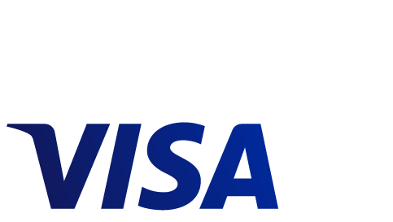
Alexandra Chelu
Tel: +40 749 088 409
alexandra.chelu@grayling.com

Website: www.visa.ro

Visa europe │ COMUNICAT DE PRESĂ
Visa takes you to Rio 2016 Olympic Games

Bucharest, 15th of March 2016: Romanians who pay with their Visa cards between 15th of March and 30th of April 2016 for purchases in stores or online are automatically registered in the race for winning a trip to Rio 2016 Olympic Games.

Visa Europe and member banks in Romania unroll the promotional campaign “Pay with any Visa card and you can win a trip to Rio 2016 Olympic Games”, whereby all payments made with any type of Visa cards issued by one of the 18 banks participating at the campaign are accepted.

Individuals and companies that want to participate at the promotion only need to use their Visa cards for shopping during the mentioned period and they are automatically registered when making the transaction. More payments bring cardholders additional chances to win a trip to Brazil, while contactless transactions have double chances at the lucky draw.

The winning transaction will bring the cardholder a VIP journey for two to the Rio 2016 Olympic Games between 18 and 22 August 2016. The prize includes airplane tickets, accommodation at a minimum 4 star hotel, tickets for two at three pre-selected competitions and the closing ceremony, transportation during the stay and a touristic tour of Rio de Janeiro. Total costs paid by Visa amount to around EUR 24,000.

The lucky draw will take place by mid-May and the winner will be announced afterwards by the issuing bank in 10 working days at the most. More details about the campaign and the regulation are available on www.visa.ro.

Even if foreign tourists do not need a visa for the Summer Olympic Games in Brazil, they will definitely need their Visa card in order to pay for products and services in the Olympics premises.
In 2016, Visa celebrates 30 years as the official sponsor for payment services of the Olympic Games worldwide.

About Visa Europe
Visa Europe is a payments technology business owned and operated by member banks and other payment service providers from 38 countries.
Visa Europe is at the heart of the payments ecosystem providing the services and infrastructure to enable millions of European consumers, businesses and governments to make electronic payments. Its members are responsible for issuing cards, signing up retailers and deciding cardholder and retailer fees. Visa Europe is also the largest transaction processor in Europe, responsible for processing more than 18 billion transactions annually.
There are more than 500m Visa cards in Europe, while €1 in every €6 spent in Europe is on a Visa card. Total expenditure on Visa cards exceeds €2 trillion annually, with €1.5 trillion spent at point-of-sale.
Visa Europe is an independent business with an exclusive, irrevocable and perpetual licence to use the Visa brand in Europe. Visa Europe works in partnership with Visa Inc. to enable global Visa payments in more than 200 countries and territories.
For more information, visit our website (www.visaeurope.com), the Visa Vision blog (vision.visaeurope.com), and @VisaEuropeNews

