

Stewart Anderson is crowned ‘Fred. Olsen Cruise Lines World Indoor Bowls Champion 2013’.

29th January 2013

Stewart Anderson from Scotland was crowned as the new singles champion, in the finals of the Fred. Olsen Cruise Lines World Indoor Bowls Championship 2013, on Sunday 27th January 2013.

The 27-year-old ninth seed celebrated an epic 10-10, 10-9 victory at Potters Leisure Resort over fellow Scot Paul Foster, taking the coveted championship and a prize pot of £45,000.

The trophy was presented to Stewart by Nathan Philpot, Sales & Marketing Director of title sponsors, Fred. Olsen Cruise Lines, who said: “Congratulations to Stewart on a fantastic win. The standard of play has been very high this year and we have enjoyed some fantastic bowls. We are delighted to be title sponsors of this prestigious championship for the second year running and greatly value our close partnership with Potters Leisure Resort and its specialist company No Fly Cruising.com.

“The extensive coverage on BBC2 television, as well as on Eurosport and Sky TV, gave our cruise guests the chance to keep up-to-date with all the excitement of this championship.”
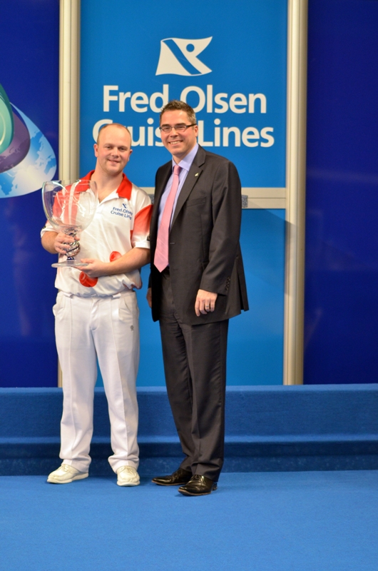

Nathan Philpot, Sales & Marketing Director, Fred. Olsen Cruise Lines
presenting the trophy to Stewart Anderson, Indoor Bowls Champion 2013

For media enquiries, please contact:
Rachael Jackson  Public Relations Manager, Fred. Olsen Cruise Lines  Tel: 01473 292233  E-mail: rachael.jackson@fredolsen.co.uk | Jill Channing  Bugsgang & Associates  Tel: 01795 518200  E-mail: jill.channing@bugsgang.co.uk

