**Isansys’ patient monitoring platform featured on Channel 4**

**show ‘24 Hours Inside Your Body’**

Isansys Lifecare’s new generation patient monitoring technology has today been featured in a Channel 4 programme which sees the implementation of the first “full-body rig” – a network of monitors that track the body’s inner-workings in forensic detail.

The Patient Status Engine, a wireless, real-time monitoring platform, was used in the programme called 24 Hours Inside Your Body. Along with other high-tech, non-invasive monitoring devices usually found within hospitals, the Patient Status Engine was used to monitor two ordinary people in real-time to see how the stress of daily life can take its toll on the body.

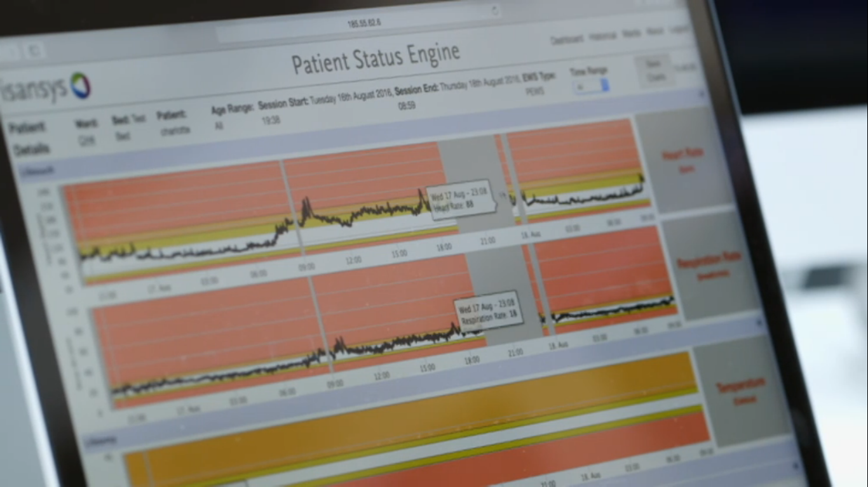

**The Patient Status Engine featuring on Channel 4**

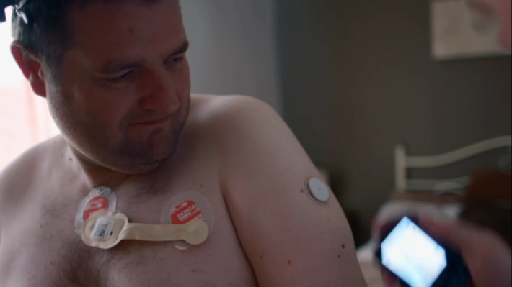Dave, an owner of a courier business who lost three stone in weight, and Charlotte, mum of one and the owner of a hairdressing salon, were fitted with the Isansys Lifetouch wireless body-worn cardiac sensor and wireless blood-pressure cuff to monitor their heart rate, respiration rate and blood pressure in real-time and continuously for 24 hours. They were then fitted with other biometric devices including electrodes, glucose monitors, posture monitors and tracking glasses.

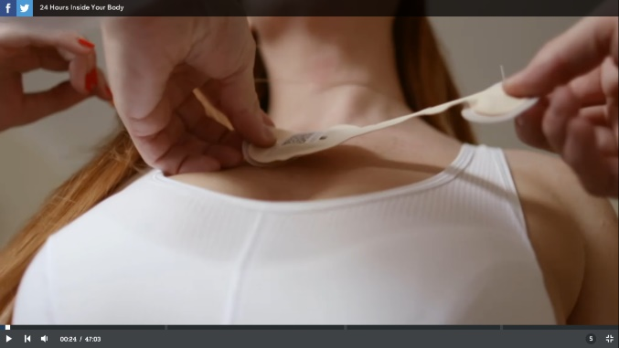

***Dave and Charlotte were fitted with the Lifetouch***

***and other biometric devices for 24 hours***

As the participants went about their normal days, leading experts watched them from a medical laboratory to assess how everything they did, how they slept, what they ate, and the jobs they did, impacted upon their bodies and long-term health. This gave them a unique opportunity to match every change in the medical data to a precise time and activity.

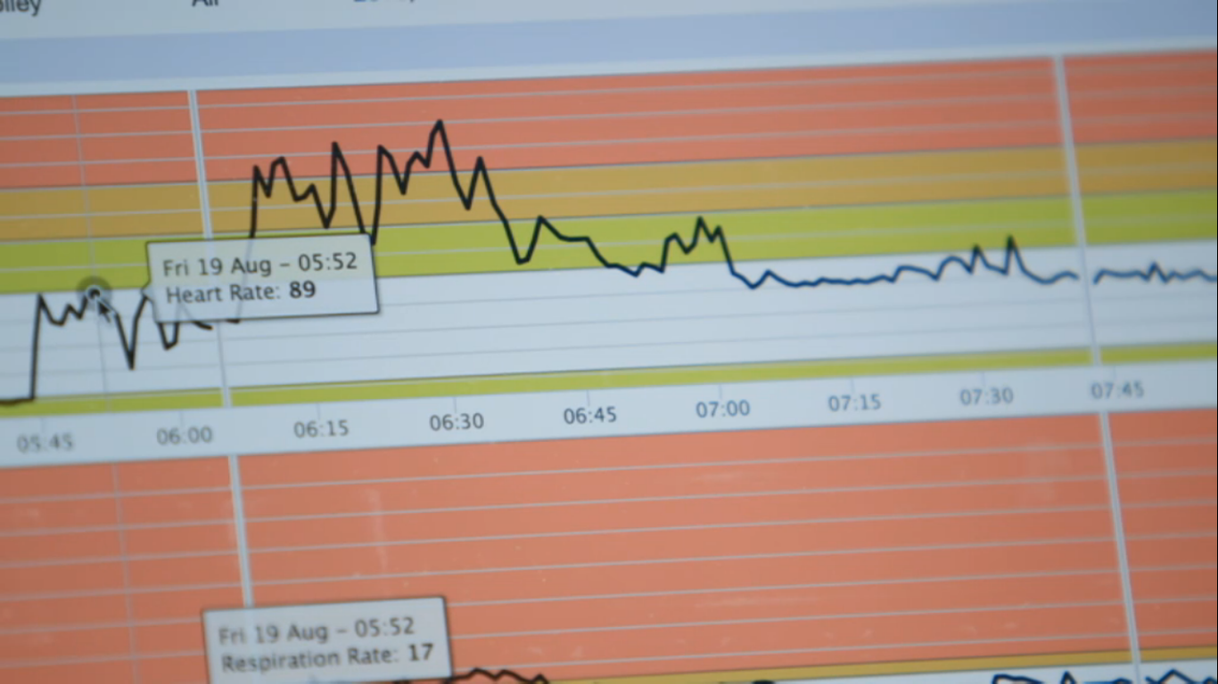

**Data collected showed Dave stopped breathing whilst he slept and**

**he suffered extreme stress levels whilst at work**

The results from the data collected were staggering….

Dave, who is at high risk of a heart attack because he suffers from high blood pressure, was informed that he stopped breathing completely for several seconds while he slept and this happened frequently throughout the night. This resulted in him waking up seven times every hour because he was suffering periods of sleep apnoea. 1 in 25 people in the UK suffer broken sleep because of sleep apnoea.

The Patient Status Engine detected extreme stress levels in Dave when a problem suddenly occurred at work. His heart rate escalated by 25bpm when an urgent phone call came into his office.

However, despite this, the Patient Status Engine highlighted that Dave’s blood pressure dropped dramatically when he exercised and that he usually remained relaxed and was fit and healthy.

Charlotte however was told that although she was on her feet most of the day, she was not as active as she first thought. This was due to a problem with her posture for which she is now seeking support from a physiotherapist.

Paul Kittel, a producer of FullFat TV which produced the show for Channel 4, says: “The Patient Status Engine was our most reliable piece of equipment during filming. It was easy and simple to use.”

You can watch the PSE in action [on Channel 4.](http://www.channel4.com/programmes/24-hours-inside-your-body/on-demand/64420-001)