

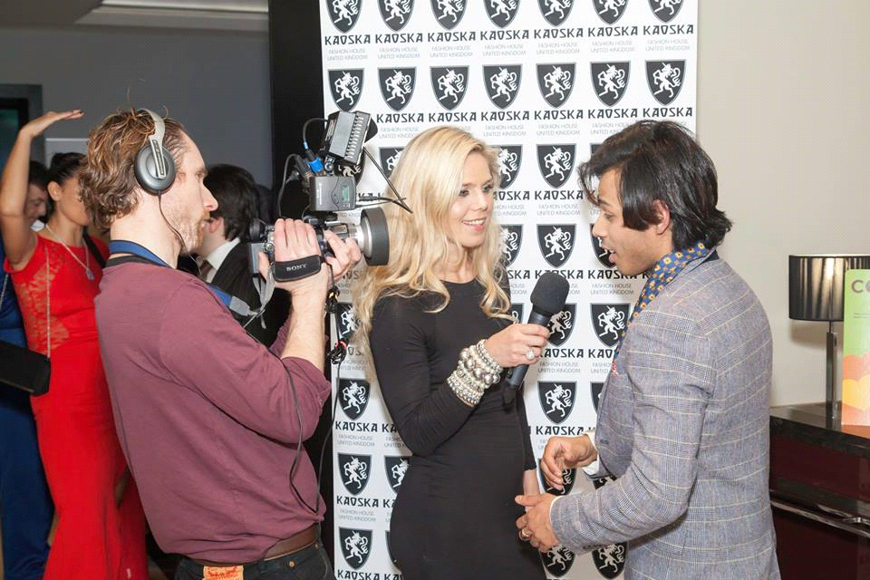
PRESS RELEASE

Target: Editors
Date: 22 / 09 / 2015
Page: 1 of 3
Photograph: Nomy Khan of Kaoska Fashion House UK Ltd being interviewed at last year’s Fashion show.

Headline: Kaoska Annual Fashion Show

The exclusive fashion show plans to bring together up-and-coming new stars to the fashion world and provide them with a platform of exposure to move into business. With an exclusive invite Only VIP Guest List including celebrities from movies, TV and sport are coming together with key investment and corporate firms to celebrate fashion. The event takes place on 24th of September 2015, from 18:00 to 23:00 at the DoubleTree by Hilton London-Marble Arch Hotel.

Designers will offer VIP and Celebrity guests the opportunity to wear their designs so they are captured by the press and TV channels in attendance. In addition to the celebrity guest list, personal invites have also been made to the key high street buyer groups and selected independent boutique buyers. In the aftermath of London Fashion Week the event’s key aim is to promote local business, to assist with expansion of their market and make essential business networking introductions available to them through our prestige VIP guest event.

Managing Director, and founder of Kaoska Fashion House UK Ltd, Nomy Khan explains. “I am so pleased to be hosting this event, it is truly inspirational to see young designers having their first opportunity on the London stage. It’s great to have so many industry professionals involved in the event though, I simply could not do it without them. We have a great team on this event. I’m also especially pleased this year to be fundraising at the event for Variety, the children’s charity. The work they do has such a positive impact on children’s lives and I’m delighted to be supporting them.”

Kaoska unites designers across the wide spectrum of fashion industry, from the established couturier like Nico Didonna with his femme fatal dresses collection, effortlessly stylish Aftershock women’s fashion, trendy ‘London style’ jackets collection by Joe Alvarez, Marria Rosa and Ray Stower of Stowers of London. A hand tailored bespoke garment remains the ultimate in luxury clothing and Stowers pride themselves in upholding the traditional values of Savile Row and hand crafted bespoke tailoring.

Celebrity event organiser Jay Hofman of Hous of Hofman added “It is so important to help the emerging artists and designers to step up to the next level and this annual event certainly does that. It’s one I’m delighted to be so heavily involved in.”

Kaoska events attract attention from the celebrity world, names like British actors Craig Conway, Kevin Leslie, Winston Ellis, Samuel Anderson as well as media people like well-acclaimed author & social media strategist Elise Quevedo with a half a million Twitter followers and TV & Radio presenter Lizzie Cundy will be in attendance.
This event is not without the extravagant fashionistas and popular socialites like international catwalk choreographers Barbod Mayriz and Evrin Bashak.

A special thanks goes to the Double Tree Hilton Hotel Marble Arch and sponsors DrinksMotion, Alchemedia, OrangeTree Wine, WildCat Energy Drinks, Greenginger Living, Pedini London, Equity Proudction, Mayfair New Media, Lisser Moi, Reeta Hair and Make Up Academy. Also the entire team of Kasoka Fashion show 2015 for their support.

“What I like about the fashion designers at Kaoska – it’s all about the strong individuals and personal style. It brings together high-end, low-end, avant-garde and classic style labels of up-and-coming designers. It’s a true celebration of creative mind!” says well-known fashion TV presenter and blogger Diana Ellis Jones.

--------ENDS-------
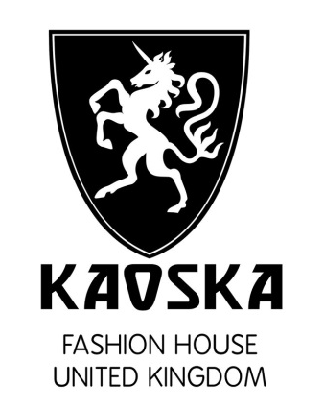

Media Contact: David Jones
Managing Director
Thirty 30 Media Ltd
M: +44 (0)7813 291216
E: david@thirty30media.co.uk
W: www.thirty30media.co.uk

Notes to Editors:

COMPANY OVERVIEW
KAOSKA Fashion House UK is an organization focusing on providing opportunities for upcoming new designers, students and creative talents to explore their interest in fashion while showcasing their artistic talents in our Exclusive Fashion Shows.
Our fashion shows bring together key industry professionals to provide an exclusive platform for up-and-coming talents. These opportunities provide up-and-coming designers with rich learning experiences outside the classroom as well as a chance to participate in socially beneficial activities in support of the global fashion world.
We offer our experience in guiding each designer on the path to success through discussions about their collection; from designing to production and from marketing research to target clientele. Designers bring their creative minds but also need skilled business people who also have an understanding of the fashion industry to provide the necessary exposure once the fashion line has been produced. We offer these introductions and connections through these opportunities.

ABOUT NOMY KHAN

Nomy Khan started his career as a model and supporting artist. He then worked with many different brands until he decided to launch Kaoska Fashion. Nomy has always been keen to support charities. His entrepreneurship career focuses on fashion and the media industry.

OUR AIM
The program we have developed aims to introduce new designers and provide fashion and creative students with quality fashion education to help them shape their future.
By organising successful events and receiving the support of sponsors, our aim is to raise sufficient funds for which we will build a new fashion platform to help new up-and-coming design students to introduce them into the international business world of fashion.

CHARITY
Our nominated charity is Variety, the children’s charity. Variety was one of the UK’s first charities to be founded especially for children and young people. They believe that all children should have an equal opportunity to reach their potential, regardless of their circumstances. All their programmes are designed to help less fortunate children to achieve precisely that.

They improve those young lives by providing practical help (such as Sunshine Coaches, wheelchairs and specialist equipment) and memorable childhood experiences. The charity’s practical help makes an immediate difference. It means that children have fewer bad days and more great days. With independence, freedom and dignity they are able to make the most of their childhood. Variety, the children’s charity play a key role in building the self-esteem of children who are disadvantaged and in making them the people who they become. KAOSKA is committed to raise funds to support Variety, the children’s charity at this year’s sparkling event.

COMPANY DETAILS
Nomy Khan
Mobile Number: 07415098476
Kaoska Fashion House UK Ltd
WWW.KAOSKA.COM
INFO@KAOSKA.COM
Registered Company Number: 08448345

