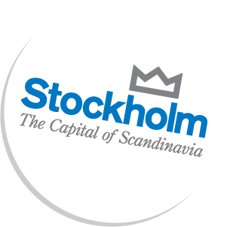
Pressrelease 2010-08-26
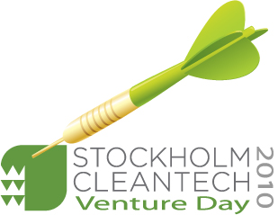

Full programme and the keynote speakers for Stockholm Cleantech Venture Day 2010
The Key note speakers at the conference - with their in depth know-how and interesting topics - are some of the most prominent within the sectors cleantech, climate, entrepreneurship and venture capital. Along with pitch presentations of the 25 hot cleantech companies, panel discussions and business speed dating the venture day will be the most promising so far since the start in 2007.

The organisers and sponsors of Stockholm Cleantech Venture Day 2010 are proud to present the full programme (which still could be subject to change) and keynote speakers for the conference that takes place on September the 30th in Kista Science City/Stockholm.

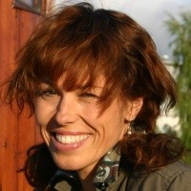
The moderator of the day is the well known meteorologist Madeleine Westin, from TV4.

She is also a researcher, author and a captain in the Swedish Defence, and noted for her work with climate change.

- It will be a pleasure to present InnoEnergy –Europe’s contribution to world leading innovation in the sustainable energy society of the future - from source to consumer, says Magnus Callavik at ABB, one of the InnoEnergy partners. We believe in the potential of InnoEnergy as a platform for pushing new technologies in the field of energy to the market. We are particularly happy to present InnoEnergy at Stockholm Cleantech Venture Day 2010, as we believe the future for startups and collaboration within the knowledge triangle starts with financing and investments in these companies.

- Stockholm Cleantech Venture Day is one of the most important arenas for support and intelligent marketing of innovation, says Anette Scheibe, CEO of the Electrum Foundation/Kista Science City AB. Emerging markets and new technology goes hand in hand, and combining them in a serious effort to support growth is bound for success. For this reason we are extra proud to host the Stockholm Cleantech Venture Day 2010 in Kista Science City.

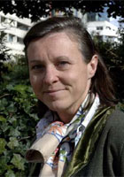
Keynote speaker Ms. Véronique Hervouet, Senior VP Investments, Total Energy Ventures
Leveraging on more than twenty years of experience in the oil & gas industry for Elf & Total (Exploration & Production, Refining & Marketing, Petrochemicals, Chemicals) with responsibilities in the areas of Buisness, Strategy, R&D, Sustainable Development and Environment, Véronique has been shaping and initiating the corporate venturing activity of Total. (for complete BIO see www.stockholmcleantech.com)
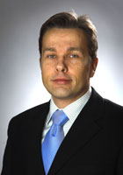
Keynote speaker Dr. Magnus Callavik, ABB AB
Dr. Magnus Callavik, MBA, PMP is working at ABB as the HVDC Grids Program Manager focusing on development of development of the future high voltage supergrid. (for complete BIO see www.stockholmcleantech.com)

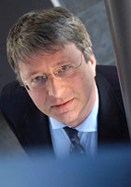
Keynote speaker Dr. Marc Lambrechts, Capricorn Venture partners NV
Dr Marc Lambrechts (49), is Senior Investment Manager at Capricorn Venture Partners NV. Marc’s investment interests are related to technology fusion and more specifically cleantech, ICT, advanced materials and nanotechnology.

(for complete BIO see www.stockholmcleantech.com)

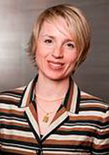
Keynote speaker Dr. TATAJ Daria, EIT Executive Committee
Dr. Tataj is currently a Managing Partner at EMF (Enterprise Management & Finance) and Assistant Professor of management and block co-ordinator at the Warsaw University of Technology Business School, teaching Organisational Behaviour, Leadership and Change Management. (for complete BIO see www.stockholmcleantech.com)

Panel discussions
Three different funding alternatives for Cleantech companies:
Peter Räke (RWE Innogy GmbH), Susanne Haefeli-Hestvik (Tricorona), Johan Gorecki (Globe Forum).

Reinventing the city:
Magnus Emfel (WWF), Mats Lindgren (NordIQ), Vivek Tandon (Aloe Private Equity (TBC))

Full programme:
http://www.stockholmcleantechventureday.com/Programme/Cleantech/2010.html?Idother=122

…………………………………………………………………………………………………………….

STING (Stockholm Innovation and Growth) and Kista Science City AB powered by KIC InnoEnergy have joined forces to co-organise Stockholm Cleantech Venture Day 2010, which will be held in Kista Science City on September 30th .

For more information contact the organisers:
Magnus Rehn, STING (Stockholm Innovation & Growth, +46 705 12 05 48
magnus.rehn@stockholminnovation.com
Press and accreditations:
Annica Englund, Media & Press at Stockholm Cleantech Venture Day
annica.englund@kista.com
Phone: +46 707 71 92 04
Application for accreditation required no later than September 23.

More about the event and registration:
http://www.stockholmcleantechventureday.com


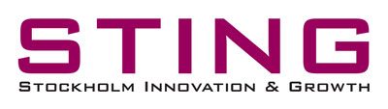
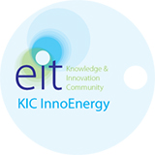
Organisers:

Partners/Sponsors:
VINNOVA, Bird & Bird, PricewaterhouseCoopers, SBRD, WWF, Bornicon & Salming

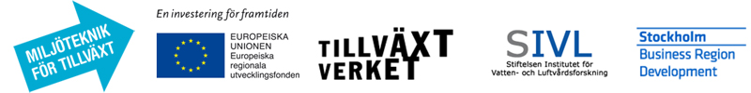

Official Media partner:
Metro Teknik

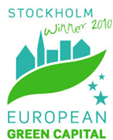
Official event of:

