Press release
Düsseldorf, 20/09/2023
Myth or reality: Why are all excavators yellow?
Most manufacturers colour their construction equipment yellow. Over three-quarters of all excavators worldwide wear this colour. But why? The reasons range from safety concerns to historical developments, all the way to deeply ingrained cultural and psychological associations.
Imagine you have a pack of crayons, and someone asks you to draw an excavator. What colour would it wear? Most likely, it would be yellow. Even as children, many of us played with yellow toy excavators. And at the construction site at the end of our street, we often see yellow machines. But why does this colour so strongly dominate the world of construction equipment? Here are the reasons.
Reason 1: Safety through visibility
A construction site poses inherent risks, and unfortunately, accidents there are all too common. Yellow is one of the most visible colours. Both during the day and at night, the colour provides sufficient contrast – even under the dusty conditions on a construction site. As such, it serves excellently as a warning colour that signifies hazards. Both workers and bystanders are more likely to recognise the machinery on the site, helping to avoid accidents.
Reason 2: Who starts it?
Caterpillar was the pioneer in adopting yellow as the colour for construction machinery. In the early 20th century, their equipment was grey, influenced by military usage. However, it was recognised that for increased safety on roads and at construction sites, these vehicles needed to sport a high-visibility colour. Thus, in 1931, the company opted for a yellow hue. An unintended consequence was branding: The yellow machines drew attention, stood out, and helped people remember the manufacturer. So, it was not long before other companies followed suit.
Caterpillar used their Hi-Way Yellow until 1979. Since then, their construction machines have been driving around in a more subdued, yet visually appealing, Caterpillar Yellow. And of course, this colour is legally protected as a trademark. Since 1989, the colours black and Caterpillar Yellow have also been integrated into the modern Cat logo.
Reason 3: Culture and psychology
For decades, yellow has been the standard colour for construction machinery, and people often associate the colour with the construction industry. This is why there are also cultural reasons for painting excavators yellow. Even children are conditioned to this colour scheme. Or have you ever seen a non-yellow toy excavator?
Additionally, psychology plays a trick on us so that we hardly notice non-yellow excavators. The psychological phenomenon responsible for this is called “selective perception”, in which we only notice certain aspects of our environment while ignoring others. This is a result of our cognitive capacity limits, as we simply cannot process all information simultaneously. This can be further reinforced by our past experiences and psychological effects such as confirmation bias or self-fulfilling prophecies. Humans tend to perceive things in a way that confirms their existing beliefs, while at the same time ignoring contradictory information. This combination of cultural influences, early childhood experiences, and our psychological wiring makes us firmly believe: An excavator must be yellow.
Reason 4: More than three-quarters of all excavators are yellow.
The colour of the construction machine depends mainly on the manufacturer. For the sake of selective perception, we will ignore the fact that some construction companies have their machines specially made in their corporate design of their company.
Those familiar with the construction industry know about the Yellow Table by KHL Group. Every year in the May/June issue of International Construction, the 50 largest construction machinery manufacturers – defined by their turnover from the previous year – are listed. And yes, this data collection is called the Yellow Table … again, the colour yellow!
If we focus solely on the manufacturers of excavators and filter the Yellow Table by companies making mini and midi excavators up to 13 tons as well as large excavators over 13 tons, then 28 out of the 50 companies fall into this category. If we combine the individual market shares with the corporate colour of the construction machinery company, it turns out that more than three-quarters of all excavators sold in 2022 were yellow. To be exact: 76.2%. The second most common colour by a wide margin was orange or red (11.9%), followed by white or grey (6.2%) and green or blue tones (5.8%). These trends are also reflected in the used machinery market. At Surplex, in the year 2022, 71% of the sold used excavators were also yellow, coming from top manufacturers.
Conclusion
So, it is both myth and reality. Not all excavators are yellow, but the majority are, and for good reasons. This ensures safety on construction sites, and from a young age and for generations, we have been conditioned to associate yellow with excavators.

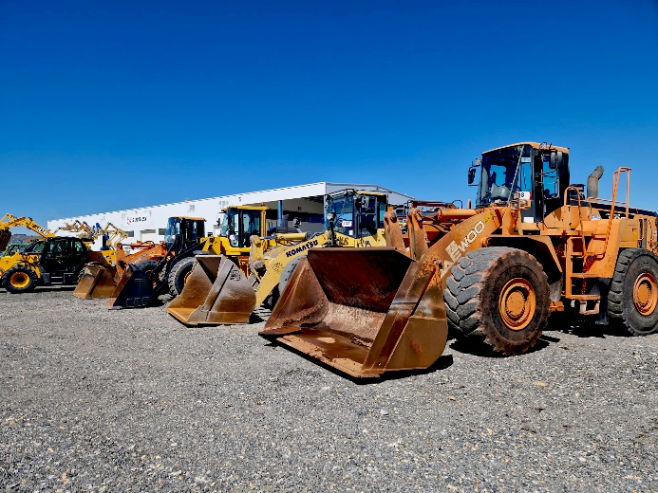 | Photo 1  Whether orange or yellow: Used excavators and construction machinery can be found at the industrial auction house Surplex.  (© Surplex).
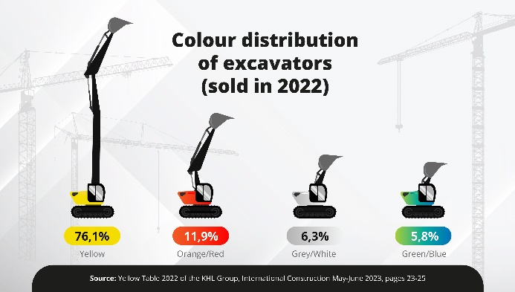 | Photo 2  The dominance of yellow in an infographic: More than three-quarters of all excavators sold in 2022 are in this striking signal colour. The other colours follow in far smaller numbers.
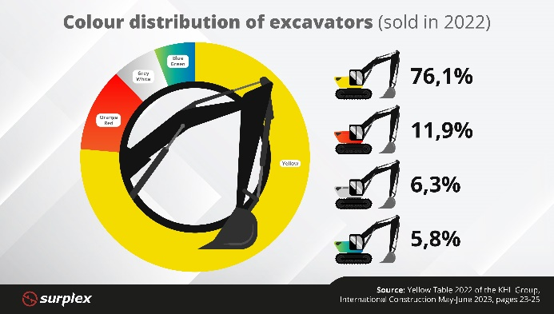 | Photo 3  An overview as a diagram of the colour distribution of excavators: In 2022, the colour yellow dominated the excavator market. The shades orange/red, white/grey, and green or blue are far less common.

