PRESS RELEASE

Pan Pacific Hotels Group Gains Greater Momentum with First Footprint in Europe in 2020 and Leads the Way with Sustainable Hospitality

21st May 2019, Singapore – Pan Pacific Hotels Group, twice-winner of “Best Regional Hotel Chain”, will debut its first Pan Pacific hotel in London in 2020 and relaunch Pan Pacific Orchard in 2021 as its next sustainable hotel in Singapore.
Debuting sincere brand of hospitality in Europe
Pan Pacific Hotels Group will introduce its signature Pan Pacific brand into Europe next year with the opening of Pan Pacific London in the United Kingdom. Designed by international design firm Yabu Pushelberg, Pan Pacific London will offer 237 keys in the heart of London’s financial district at One Bishopsgate Plaza, a five-minute walk from Liverpool Street station, a major railway and underground station in central London.
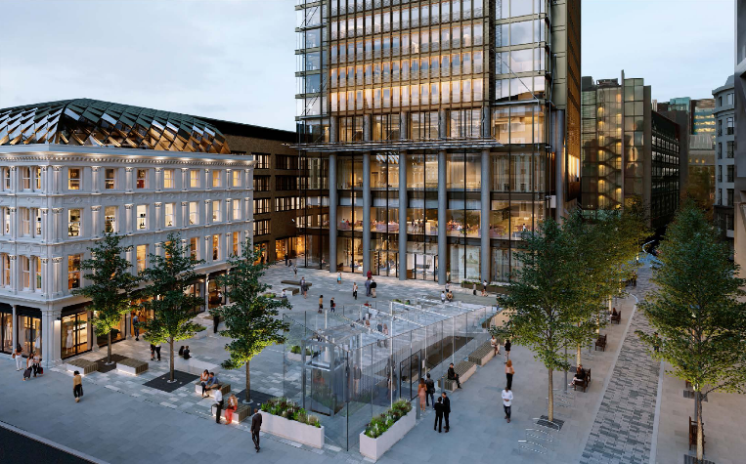
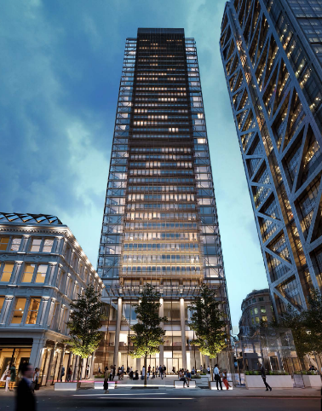

Pan Pacific London opens next year in the heart of London’s financial district
With this flagship opening in London, Pan Pacific Hotels Group will join a select handful of Asia-based hotel companies to enter the Europe luxury hotel space, and introduce its brand of sincere hospitality for the first time to a mature and sophisticated market.
Pan Pacific London will provide unmatched scale and quality in the area. The Signature Suite of the hotel on the 19th floor is an epitome of luxury complete with spectacular views of city landmark, The Gherkin. Housed within the luxurious Pan Pacific London will be the Square Mile’s first smart ballroom, capable of accommodating up to 370 guests in a banquet seating along with six meeting venues. An indoor lap pool with views of the street, calming spa treatment rooms and a modern fitness centre make up this sanctuary, while a dedicated Studio Lounge provides a comfortable space for early arrivals and late departures.
Leading the way in sustainable hospitality
Pan Pacific Hotels Group is dedicated to operating with sincerity and integrity as its core values. Beyond the adoption of earth-friendly practices, it is designing and building green hotels right in the heart of cities – and stamping its mark as a leader in sustainable hospitality in Singapore and across Asia. Pan Pacific Hotels Group has been recognised with the “World’s Leading Green City Hotel”, awarded to PARKROYAL on Pickering, a flagship of its PARKROYAL brand in Singapore, thereby showing that sustainability can go hand-in-hand with luxury through innovative design. Building on PARKROYAL on Pickering’s success as the greenest city hotel in the world, the Group will be launching Pan Pacific Orchard in 2021, offering an unprecedented level of sustainable hospitality in Singapore.
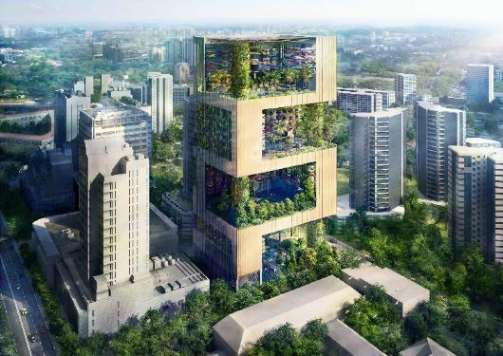

Pan Pacific Orchard will be relaunched in Singapore’s Orchard Road in 2021
In a repeat collaboration with WOHA, the award-winning firm behind PARKROYAL on Pickering, Pan Pacific Orchard will feature three levels of experiential sky gardens with foliage that comprises three times its total land area— a scale that is unprecedented in a built-up city centre – and offer true resort living in the heart of urban Singapore. Located along the Orchard Road shopping and lifestyle district, this architectural stunner will be the Group’s first zero-waste hotel— featuring a rainwater harvesting system, a recyclable water system, and a compactor that transforms food waste into compost, amongst other innovative elements.
In preference for more environmentally sustainable alternatives, Pan Pacific Hotels Group has eliminated plastic straws across all hotels, resorts and serviced suites globally since 2018. In line with the Group’s commitment to be free of single-use plastics by the end of this year, the properties will be opting for greener alternatives for in-room amenities, meetings, and more, while expanding recycling efforts for non-plastic items such as bottles and soap.
Ms Cinn Tan, Chief Sales & Marketing Officer, Pan Pacific Hotels Group, says, “We are defined by our core values of sincerity and integrity, and are committed to caring for the environment and operating in a sustainable manner across our portfolio of 40 hotels, resorts and serviced suites globally. We’re proud to be leading the way in sustainable hospitality with jewels such as PARKROYAL on Pickering, the “World’s Leading Green City Hotel”, and will up the ante with the launch of Pan Pacific Orchard, our first zero-waste hotel, in 2021. Pan Pacific Hotels Group is deeply invested in the cause for sustainability and we have plans to expand our footprint of experiential green hotels, each one to surprise and delight our guests. With their unique eco-architecture, our green jewels will redefine not just the landscape they are in, but the very concept of sustainable hospitality.”
Sustained growth in Asia with new openings and refurbishments
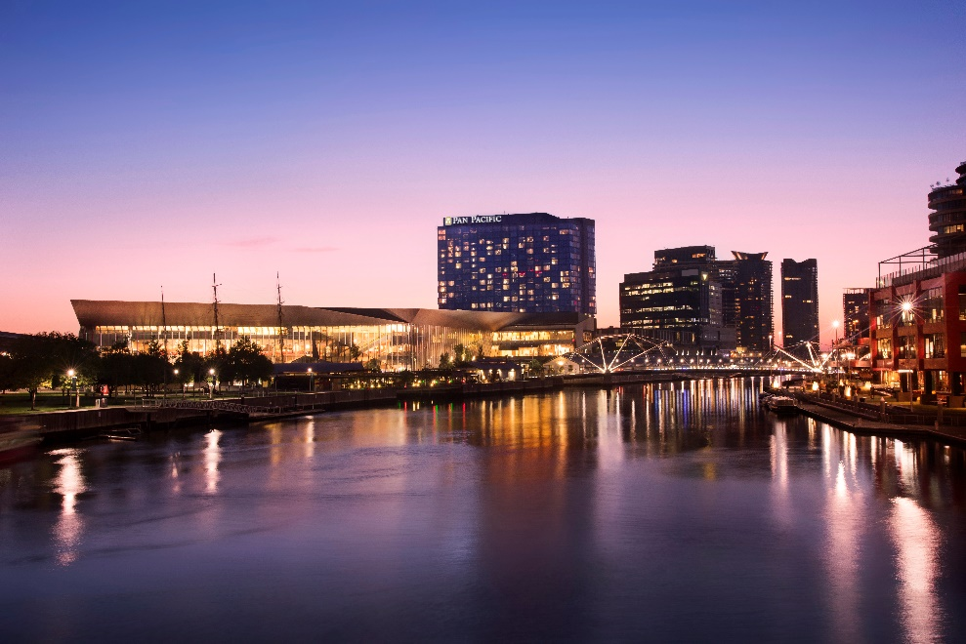

Pan Pacific Melbourne on Yarra River, directly connected to Melbourne Convention Centre
As the owner of more than half of all properties it manages, Pan Pacific Hotels Group recognises its ability to deeply impact the guest experience. The Group is committed to the success of its properties and demonstrates this through investments in regular upgrades and refreshments. In the last two years, the Group has undertaken multi-million dollar refurbishments across the region for properties including Pan Pacific Melbourne and Pan Pacific Perth in Australia, PARKROYAL Penang Resort in Malaysia, PARKROYAL on Beach Road and PARKROYAL on Kitchener in Singapore.
With more than 80 per cent of its hotels, resorts and serviced suites in Asia Pacific, Pan Pacific Hotels Group will remain focused on this region for its sustained growth. To cater to multi-generational and leisure travel, the Group is strengthening its serviced suites portfolio with the opening of Pan Pacific Serviced Suites Puteri Harbour in Johor, Malaysia and PARKROYAL Suites Bangkok in Thailand by the end of this year. Fans of the energetic PARKROYAL brand can look forward to new openings in Malaysia as Pan Pacific Hotels Group will be expanding its resort offerings with PARKROYAL A’Famosa Resort (2020) and PARKROYAL Langkawi Resort (2021).
-ENDS-
Media Contact
Cuili NG
Director, Brand & Corporate Communications
Pan Pacific Hotels Group
Mobile: +65 9634 4425
Email: ng.cuili@pphg.com

About Pan Pacific Hotels Group
Pan Pacific Hotels Group is a wholly-owned hotel subsidiary of Singapore-listed UOL Group Limited, one of Asia’s most established hotel and property companies with an outstanding portfolio of investment and development properties.
Based in Singapore, Pan Pacific Hotels Group owns and/or manages more than 40 hotels, resorts and serviced suites including those under development in 24 cities across Asia, Oceania, North America and Europe.
Voted “Best Regional Hotel Chain” by readers in Asia-Pacific in 2017 and 2018, Pan Pacific Hotels Group comprises two acclaimed brands: its signature brand, Pan Pacific and its deluxe brand, PARKROYAL.
Sincerity is the hallmark of Pan Pacific Hotels Group. The Group is known to its guests, partners, associates and owners for its sincerity in people and the sense of confidence which alleviates the stresses of today’s complex world.
Visit us at www.panpacific.com.
Pan Pacific Hotels and Resorts
With hotels, resorts and serviced suites across Asia, Oceania and North America, Pan Pacific provides a safe harbour in an ever-changing world. Places with less to worry about because, when you stay with us, rest assured that all will be taken care of. For this is where you will find your balance.
PARKROYAL Hotels & Resorts
A big city or cosy enclave – where there is a PARKROYAL hotel, resort or serviced suite, there is a celebration of people. Our passion for creating real connections and joyous moments can be felt when you enter any of our properties across Asia and Australia. After all, this is the place to bring out the best of you, by us.

The hotel features 15,000 square metres – double its total land area – of hanging gardens comprising 50 varieties of plants spread across 16 storeys with sunlit rooms accessed by open corridors. The hotel harvests rainwater and solar power and uses automatic sensors to regulate energy and water.

