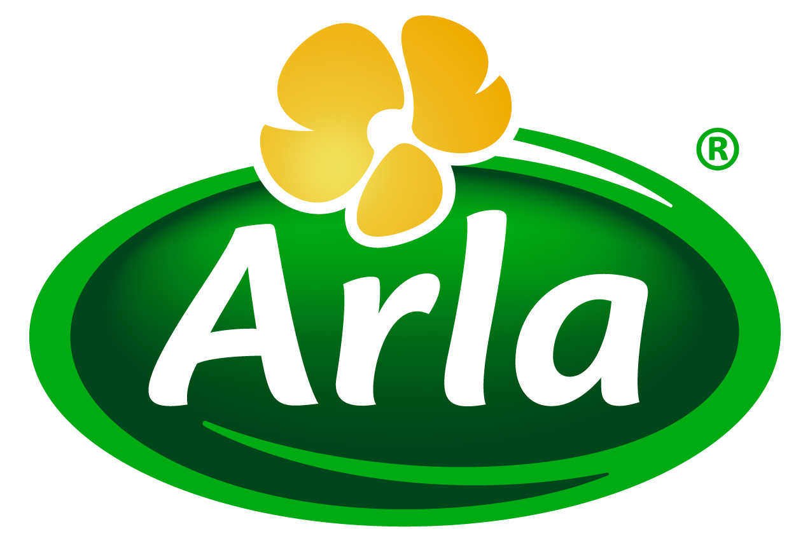
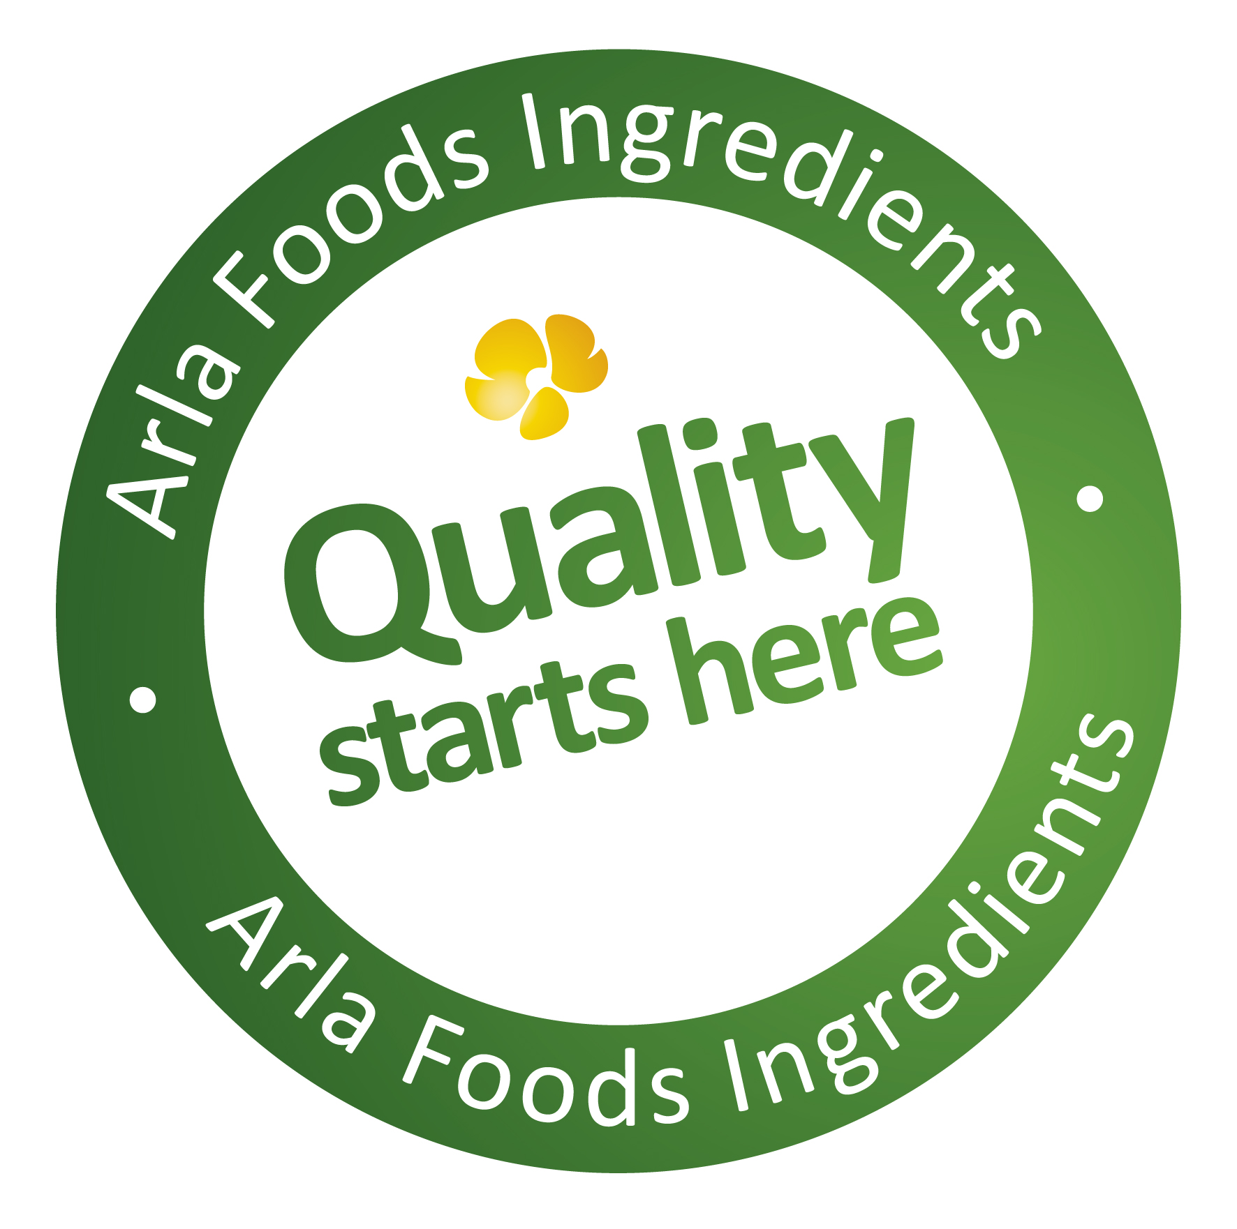

10 September 2014
PRESS RELEASE

Arla Foods Ingredients reboots smoothies
with new Greek-style yoghurt concept

Arla Foods Ingredients has launched a new ingredient concept that makes it easy to produce delicious, healthy, convenient and environmentally friendly Greek-style yoghurt smoothies that are rich in both protein and real fruit.

Nutrilac® YO-8075 is a natural whey protein, derived from cow’s milk. It gives manufacturers the ability to use their existing equipment to formulate a fat-free smoothie that is 50% Greek yoghurt, 50% fruit and which has a protein content as high as 7.5%.

Greek yoghurt continues to captivate consumers for its combination of great taste, texture and high protein content. Per capita consumption has doubled in the past decade according to NPD Group data, and US sales are set to hit $9.3 billion by 2017, up from $7.3 billion in 2012 (Packaged Facts) – demonstrating that this is a trend that is here to stay. Fruit also continues to enjoy enduring popularity as an ingredient that adds a ‘health halo’ to a product, making it the perfect partner to protein.

Using the new Nutrilac® protein to make Greek-style yoghurt smoothies is very cost-effective and ‘green’ because the process generates high yields and zero acid whey, which is the controversial waste product associated with traditional Greek yogurt making. The protein is supplied by Arla Foods Ingredients ready to produce a Greek-style yoghurt base that can be combined with a wide range of fruit ingredients – or even vegetables – in one straightforward step.

Torben Jensen, Category Manager for Functional Dairy Proteins at Arla Foods Ingredients, said: “Dairy and fruit smoothies are really popular with busy consumers because they’re tasty, filling and healthy. However, the products on the market today typically offer a protein content of about 1%, which is too low for the growing number of people who are keen to add more protein to their diet for health reasons. This means there is a significant opportunity in the marketplace to offer next-generation smoothies that are also very high in protein. The launch of this new Nutrilac® protein means companies can now create 7.5%-protein Greek-style yoghurt smoothies that taste great and are easy to drink on the go – tapping into the trends that really make modern-day consumers tick.”

ENDS

For more information, please contact:

Miranda Mills, Ingredient Communications
Tel: +44 207 193 4167
Email: Miranda.mills@ingredientcommunications.com

About Arla Foods Ingredients
Quality starts here: Arla Foods Ingredients is a global leader in natural whey ingredients for products in a range of categories – from bakery, beverages, dairy and ice cream to clinical, infant and sports nutrition.
The cornerstones of our business are innovative ingredients, world-class facilities and a staff of dedicated experts. Drawing on our portfolio of functional and nutritional whey proteins, milk minerals, lactose and permeate, our expert team delivers solutions that bring new food products quickly and efficiently to market. Our application centres run hundreds of customer product trials every week. All ingredients are produced using state-of-the-art processing technology at our plant in Denmark, or by one of our joint ventures in Argentina, Germany and the UK.
Arla Foods Ingredients Group P/S is a 100% owned subsidiary of Arla Foods, a global dairy company and cooperative owned by dairy farmers in Denmark, Sweden, the UK, Germany, the Netherlands, Belgium and Luxemburg.

RSS Feed
Visit our website at http://www.mynewsdesk.com/arla-foods-ingredients and sign up to our News RSS feed for all the latest developments – updated regularly.

Twitter
Follow us on twitter for all the latest updates @ArlaIngredients

