**Bäckman siblings joins TCR Europe SIM Racing Series**

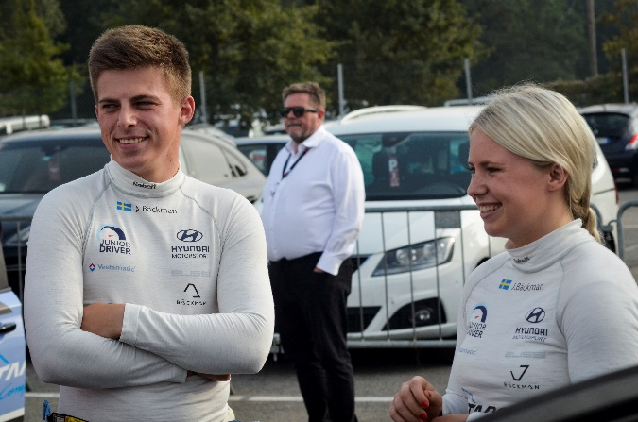Andreas and Jessica Bäckman joins TCR Europe SIM Racing.  
Photo: Racers - Behind the helmet

**The Swedish racing siblings Andreas and Jessica Bäckman are still waiting to start their racing season. As a complement to the wait, TCR Europe launched a brand-new e-sport racing series. The siblings were today presented as two of the drivers joining the series.  
– We are very excited to be competing in sim-racing. It will be a new challenge to being able to race virtually, says Jessica Bäckman.**

Today, the Bäckman siblings from the North of Sweden are announcing their participation in TCR Europe SIM Racing. This series is for the real-world drivers to compete against each other in a seven-event sim racing calendar in virtual e-sport racing. The drivers will race virtually at the same tracks as they will face in the real-life racing later this year.

– E-sports and Sim-Racing has been getting a lot of attention lately, so it’s nice that TCR Europe is jumping on the Sim-Racing trend. Both for the fans and the drivers it’s great opportunity to enjoy some racing during these difficult times right now in the world, says Andreas Bäckman.

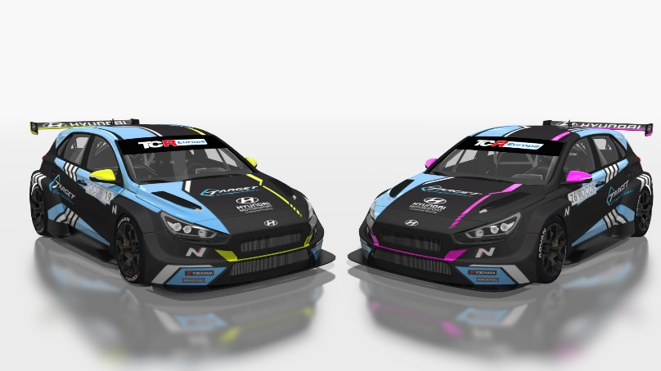Andreas’ and Jessica’s virtual Hyundai i30 N TCR cars for the TCR Europe SIM Racing Series.   
Photo: WSC Group/TCR Europe

**Same tracks, same cars**The first event of the Sim Racing series kicks off this weekend on Saturday (May 2nd) at the virtual Spa-Francorchamps circuit in Belgium. All the track layouts in the series will be identical to the real-world tracks. The tracks are scanned with precision to simulate all the details to make it as realistic as possible.

When it comes to the cars, all current TCR Europe cars will be available for the drivers to choose from. Andreas and Jessica will be driving the same cars as they did last year, Hyundai i30 N TCR, but now in a brand-new livery and the same design that they will be using on track later on this year when the season starts.

– One cool thing about the sim-racing is that it’s possible to design the cars so they look very realistic and almost identical to the real car, says Jessica Bäckman.

**Follow the action LIVE on TCR Social Media platforms**The first Sim-Racing event this weekend will be live-streamed at TCR’s social media platforms [Facebook](https://www.facebook.com/TCREurope/), [YouTube](https://www.youtube.com/channel/UCoSlmLSprEnTz7HjmMb7HBw) and [Twitch](https://www.twitch.tv/tcr_series), as well as on the [TCR TV website](http://www.tcr-series.tv/). The format will be very similar to the usual TCR Europe format, with one Qualifying session and two races, where Race 2 has a reverse-grid order for the Top 10 finishers from Race 1.

**Here is the time-schedule for this weekend’s first event on Saturday May 2nd:**18:55 Live Streaming Starts  
19:00 Qualifying  
19:24 Race 1  
19:58 Race 2  
20:25 Interviews with the drivers