**Andreas Bäckman clinched the pole-position and a new track record in STCC at Mantorp Park**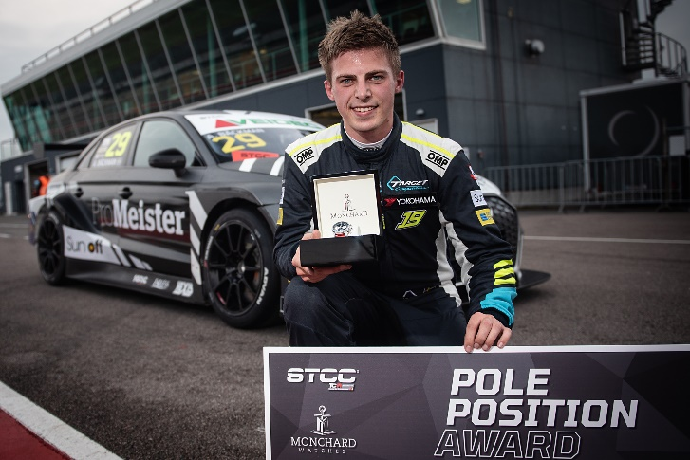Andreas Bäckman clinched the pole-position and a new track record for TCR cars at Mantorp Park in his STCC one-off appearance for Brink Motorsport in an Audi RS 3 LMS TCR car.  
Photo: Anders Helgesson (Free rights to use the images)

**This weekend, Andreas Bäckman, made a one-off appearance in STCC (Scandinavian Touring Car Championship) at Mantorp Park together with Brink Motorsport. Already in the Qualifying, Andreas showed the speed by taking home the pole-position and set a new track record for TCR cars at Mantorp Park.  
- So happy to show my capacity and speed after a tough year in WTCR, says Andreas Bäckman.**

STCC is Sweden's most prestigious motorsport championship and is today the leading class for Touring Car Racing. The cars are built according to the global TCR regulations, which means that the cars used in STCC are the same as those in the other TCR series around the world. The series consists of six race weekends held on different Swedish tracks.

Last weekend, October 2nd-3rd, the FIA WTCR driver Andreas Bäckman made a one-off appearance in the fifth round of the championship at Mantorp Park, Sweden. He competed for the first time in an Audi RS 3 LMS TCR car for Brink Motorsport. Mantorp Park, which is located near Linköping, is one of Sweden's top motorsport facilities and a large number of motor events are arranged here every year, some of which are among the largest in Sweden and Europe.

**Pole-position and a new track record in the new car**  
The weekend started well as Andreas was immediately the fastest of all in the first free practice. Then in the Qualifying, in the first qualifying round Q1, it was a Safety Car period at the wrong moment, and he was thus not allowed to put his best qualifying lap when the tires were at their best condition. Then in Q2, it worked out better and was then the fastest of all drivers in the field and clinched the pole-position and the first starting position for Race 2. The lap time was also the fastest lap driven around Mantorp Park and thus also a new track record for TCR cars.

With his pole-position, Andreas was also the first driver this year to break the championship winner Robert Dahlgren's record suite with nine consecutive pole-positions.

- So happy to show my capacity and speed after a tough year in WTCR, where we have not gotten the car to work and thus not been able to show what I can do as a driver. The qualifying lap was not perfect but I’m happy that it was enough all the way to pole-position and it was extra fun to drive the fastest TCR lap ever around Mantorp Park in my first competition in both the car and the team, **Andreas Bäckman** says.

**Good speed but a lot of misfortune in Race 1 and 2**In Race 1 on Sunday, it was raining and thus it was completely new conditions compared to earlier in the weekend. Andreas started 4th in the race but had a bad start and lost some places in the beginning. Then on lap 5, an incident caused him to be hit and came out on the track again as the penultimate car on track. After this, he drove up to a 10th place with the second fastest lap time and showed that he and the car had the speed in the wet conditions as well.

For Race 2, the track dried up so that it was a dry line on the track but still wet outside of the ideal racing line. Andreas started at the front in pole-position but thus also on the wet side of the track, which made it a challenge in the start, and he got a lot of wheel spin and lost a lot of positions. Later in the race, he was fastest on the track and picked up positions until a technical problem forced him to retire the race and he lost the control and went off the track as a result.

**Strong comeback from last on the grid in Race 3**In the last and final race of the day, Race 3, the Brink Motorsport driver was forced to start at the back because of the retirement in Race 2. There Andreas made a lot of overtakes and drove all the way up to a 5th place and caught up to the leaders with several laps left.

- Fun to end the weekend with a race where it went my way a little more. I felt that I really had the car with me and I could quite easily catch up with the cars in front of me. The Safety Car came out in the middle of the race which meant that we lost some race laps, otherwise I think that with more laps I could probably have been able to reach the podium, **Andreas Bäckman** says.

- To sum up the weekend, I think the car has felt good all weekend and I have enjoyed both the team and the car all weekend. I had problems getting good starts in the races and it prevented me from being able to fight for the wins and podium positions, which I felt was definitely possible with the speed we showed in all conditions. Big thanks to Brink Motorsport for the opportunity to jump in their car this weekend. It was great fun to be back in STCC, **Andreas Bäckman** says.

**Andreas’ results:**Free Practice 1 (Test 1): 1st place  
Free Practice 2 (Test 2): 4th place  
Qualifying 1 (Q1): 4th place

Qualifying 2 (Q2): 1st place  
Race 1: 10th place  
Race 2: Retired (DNF)

Race 3: 5th place

***Free rights to use the images.***

***Download press-photos here:***[***http://bit.ly/jabaeckman-photos***](http://bit.ly/jabaeckman-photos)[***https://www.mynewsdesk.com/se/ja-backman/images***](https://www.mynewsdesk.com/se/ja-backman/images)

