

**PRESS RELEASE STOCKHOLM, 19-01-2021**

PRE SPRING COLLECTION ON NEW DAILY SPORTS WEBSITE

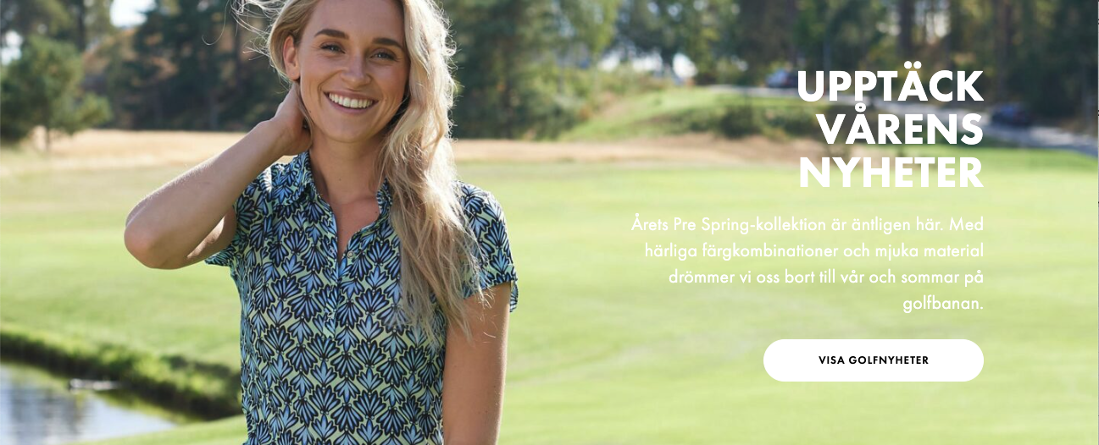

**As their new website goes live, Daily Sports is taking the opportunity to launch a fresh new Pre Spring 2021 collection that’s bursting with crisp colours.**

It’s an early taste of the coming summer from a wintry Sweden. Daily Sports has produced   
a Pre Spring 2021 collection that simply breathes light, crispness and hopes for the summer.   
It’s bursting with colours that evoke the feel of spring and deliver a boost of energy. We’ve checked out their new collection on their updated website, which feels equally fresh.

“We’ve been working on changing our platform and redesigning our website for some time. First we had to choose the people to work with, and then came the job of actually bringing   
it all together. It feels absolutely wonderful to be going live now,” says Ulrika Skoghag,   
CEO of Daily Sports.

“Our partnership with the design agency Stök and the new platform Centra have run very smoothly,” adds Matilda Landhör, E-commerce Manager at Daily Sports.

Daily Sports has taken yet another step forwards, and it's great to see a family business keeping up with development in this way.

See the new collection at [www.dailysports.com](http://www.dailysports.com/)

**FOR MORE INFORMATION CONTACT:**

Tina Lindkvist

Marketing Project Manager

Tel: +46 722-51 62 30

Email: [tina.lindkvist@dailysports.se](mailto:tina.lindkvist@dailysports.se)

Daily Sports is today one of Sweden’s biggest suppliers of golf clothes for women. We sell our golf and active wear in 26   
countries. Daily Sports clothing is famed for its feminine fit, focus on function and attractive details.   
Featuring designed patterns and matching combinations, the clothing is for both leisure and at work.

The company was founded in Sweden in 1995 with the aspiration to make women want to be active. Our current turnover   
is about SEK 80 million, of which the Swedish market accounts for about SEK 25 million.

Tulegatan 47 T +46 8 120 105 00

SE-113 53 Stockholm, Sweden

info@dailysports.se www.dailysports.com