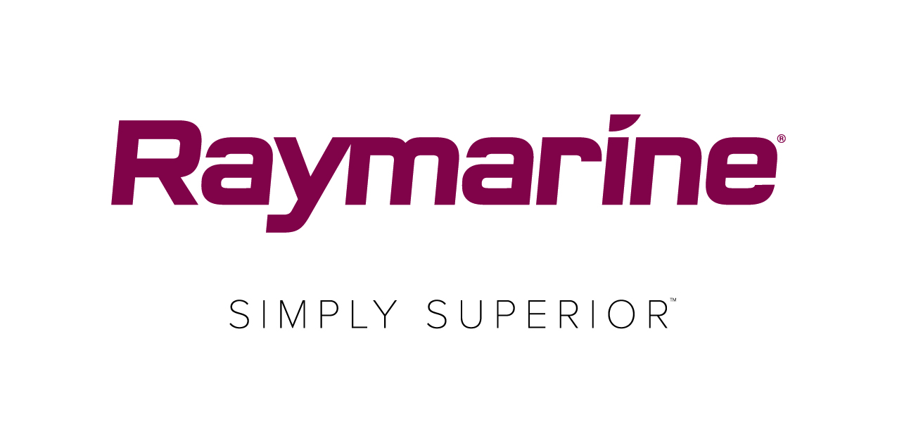
Raymarine returns to Cowes to host Live Weather Briefing
Raymarine teams with meteorologist, Simon Rowell for the pre-race weather briefing on the eve of the 2018 Round the Island Race in association with Cloudy Bay

Top marine meteorologist Simon Rowell will deliver the all-important pre-race weather briefing for the 2018 Round the Island Race in association with Cloudy Bay. Hosted by the Race’s official Technical Partner, Raymarine, competitors will get the most up-to-date forecast and tidal information ahead of the Race. During the briefing, which can also be watched online, Simon will also reveal how this year’s competitors could win over £2000s of Raymarine equipment.

The Events Centre, Cowes Yacht Haven has been named as the new venue for this year’s briefing which takes place at 18.00 Friday 6th July. Simon will be presenting data taken from the Theyr high-precision weather and ocean forecasting software app amongst other sources. This is Raymarine’s global weather forecasting app powered by the company’s LightHouse operating system and available on Raymarine’s Axiom® family of MFDs. In addition to weather, tide and sea state information, Simon will also run through the course, giving vital information about exclusion zones and anticipated conditions at the main areas of concern.

Simon has a string of high-profile yachting achievements under his belt including skippering the winning boat in the 2002 Clipper Round the World Race and acting as assistant race director for the same contest in 2005-6. After 12 years in the yachting industry, he enrolled at Reading University and gained a master’s degree in meteorology with distinction. Since 2015 he has been employed as meteorologist for the British Sailing Team.

The Round the Island Race Raymarine Weather Briefing has become a must-attend event for competitors and is the culmination of a series of daily weather reports shared in the run up to the race. The reports will be available daily at www.raymarine.co.uk/events/RTIR where you can also register for a reminder to watch the live Weather Briefing and post briefing, be able to replay and watch again.

Watch the live briefing at 18:00 on Friday 6th July at the Events Centre, Cowes Yacht Haven and you could be in with a chance to win one of Raymarine’s Axiom multifunction navigation systems as well as a top-of-the-range Raymarine AIS700 Class B transceiver – with a combined value of £2,390.

To register for the weather briefing visit http://www.raymarine.co.uk/events/rtir/

###

About FLIR Systems
Founded in 1978 and headquartered in Wilsonville, Oregon, FLIR Systems is a world-leading maker of sensor systems that enhance perception and heighten awareness, helping to save lives, improve productivity, and protect the environment. Through its nearly 3,500 employees, FLIR's vision is to be "The World's Sixth Sense" by leveraging thermal imaging and adjacent technologies to provide innovative, intelligent solutions for security and surveillance, environmental and condition monitoring, outdoor recreation, machine vision, navigation, and advanced threat detection. For more information, please visit www.flir.com and follow @flir.

About Raymarine:
Raymarine, a world leader in marine electronics, develops and manufactures the most comprehensive range of electronic equipment for the recreational boating and light commercial marine markets. Designed for high performance and ease of use, the award-winning products are available through a global network of dealers and distributors. The Raymarine-branded product lines include radar, autopilots, GPS, instruments, fishfinders, communications, and integrated systems. Raymarine is a brand of FLIR Systems, a world leader in thermal imaging. For more information about Raymarine please go to www.raymarine.com.

Media contact:
Karen Bartlett
Saltwater Stone
+44 (0) 1202 669 244
k.bartlett@saltwater-stone.com

