KONGSBERG technology is integral as Damen signs up
to build the world’s first fully-electric ship-handling tug
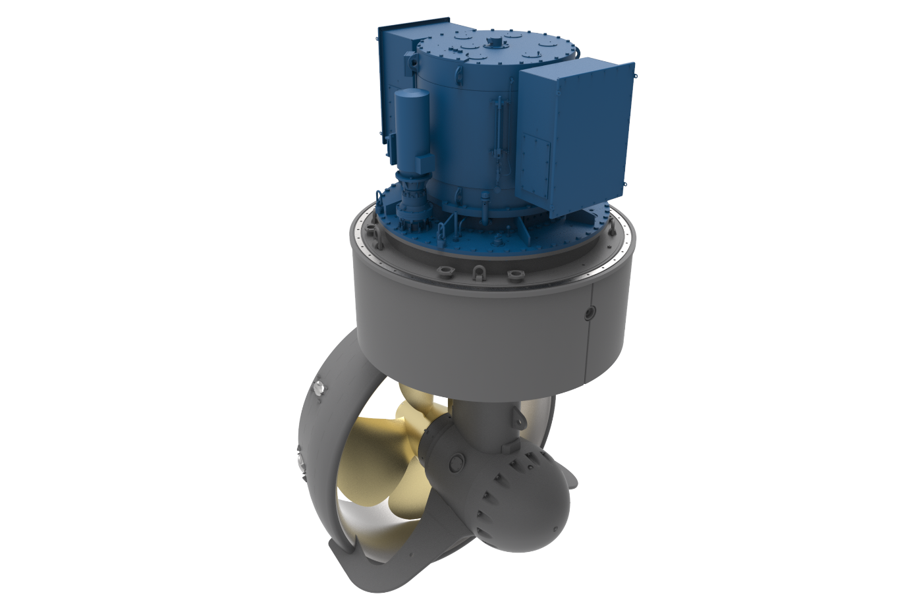
Two Kongsberg Maritime US255 L PM FP azimuth thrusters will provide unrivalled manoeuvrability
Kongsberg, Norway, 2nd April 2020 – Kongsberg Maritime has taken another bold step in the implementation of its market-leading strategies for autonomous, sustainable shipping thanks to the company’s involvement in an ambitious new tugboat project.
In a groundbreaking enterprise, Ports of Auckland Limited (POAL) in New Zealand has entered into a partnership with the Damen Shipyards Group in the Netherlands to develop a fully-electric ship-handling tug – the first of its kind in the world – and Kongsberg Maritime’s advanced technology will be an integral element of the delivery.
Having declared the intention of conducting completely emission-free operations by 2040, POAL needed to drive the development of a fully-electric tug, and approached Damen as a trusted, progressive yard with a pioneering reputation for fuel-efficient hybrid tug design. The result of this joint initiative will be the RSD-E Tug 2513, a zero-emissions derivation of the IMO Tier III-ready RSD Tug 2513, introduced by Damen in 2018.
The radical new tug will be equipped with two KONGSBERG US255 L PM FP azimuth thrusters, supplied from Kongsberg Maritime’s facility in Rauma, Finland and providing a bollard pull capability of 70 tonnes. With their integrated PM electric motors, unrivalled manoeuvrability, tough modular construction and proven reliability, these thrusters combine minimal running costs with impeccable environmental credentials.
The latest delivery continues a mutually fruitful working relationship which dates back to 1983, when KONGSBERG first supplied Damen with its UL801 retractable azimuth thrusters. In the intervening years, the productive alliance between the two companies has notched up many significant successes. KONGSBERG celebrated the delivery of its 1,000th thruster to Damen in 2017 – the same year that the company first provided Damen’s ASD 2811 tugs with thrusters featuring an integrated HD (Heavy Duty) slipping clutch – and that figure has now risen to nearly 1,300.
“With sustainability as an ongoing watchword, both KONGSBERG and Damen are of a like mind in encouraging the spread of remote and autonomous processes across the marine industry,” says Bård Bjørløw, EVP Global Sales and Marketing, Kongsberg Maritime. “Equipped with our state-of-the-art thrusters, the RSD-E Tug 2513 is destined for recognition as a benchmark concept in the development of zero-emissions, fully-electric vessels; and we commend Ports of Auckland in setting this inspiring example for eco-friendly port operations.
“As the demand grows to mitigate environmental impacts and slash emissions throughout entire supply chains, we at KONGSBERG are pleased to be able to assist our customers in choosing innovative and dependable solutions for efficient, green and safe global maritime working practices.”
Ends

For further information, please contact:

Gunvor Hatling Midtbø, VP Communication
Kongsberg Maritime
Tel: +47 9921 4209
gunvor.hatling.midtbo@km.kongsberg.com

David Pugh
Saltwater Stone
Tel: +44 (0)1202 669244
d.pugh@saltwater-stone.com

About Kongsberg Maritime
Kongsberg Maritime is a global marine technology company providing innovative and reliable ‘Full Picture’ technology solutions for all marine industry sectors including merchant, offshore, cruise, subsea and naval. Headquartered in Kongsberg, Norway, Kongsberg Maritime has manufacturing, sales and service facilities in 34 countries.
Kongsberg Maritime solutions cover all aspects of marine automation, safety, manoeuvring, navigation, and dynamic positioning as well as energy management, deck handling and propulsion systems, and ship design services. Subsea solutions include single and multibeam echo sounders, sonars, AUV and USV, underwater navigation and communication systems.
Training courses at locations globally, LNG solutions, information management, position reference systems and technology for seismic and drilling operations are also part of the company’s diverse technology portfolio. Additionally, Kongsberg Maritime provides services within EIT (Electro, Instrument & Telecom) engineering and system integration, on an EPC (Engineering, Procurement & Construction) basis.
Kongsberg Maritime is part of Kongsberg Gruppen (KONGSBERG), an international, knowledge-based group that celebrated 200 years in business during 2014. KONGSBERG supplies high-technology systems and solutions to customers in the oil and gas industry, the merchant marine, and the defence and aerospace industries.
Web: Kongsberg Gruppen | Kongsberg Maritime
Social media: LinkedIn | Twitter | Facebook

