Kongsberg Digital and SeaCross team up to deliver
end-to-end solution for high-speed navigation and simulator training
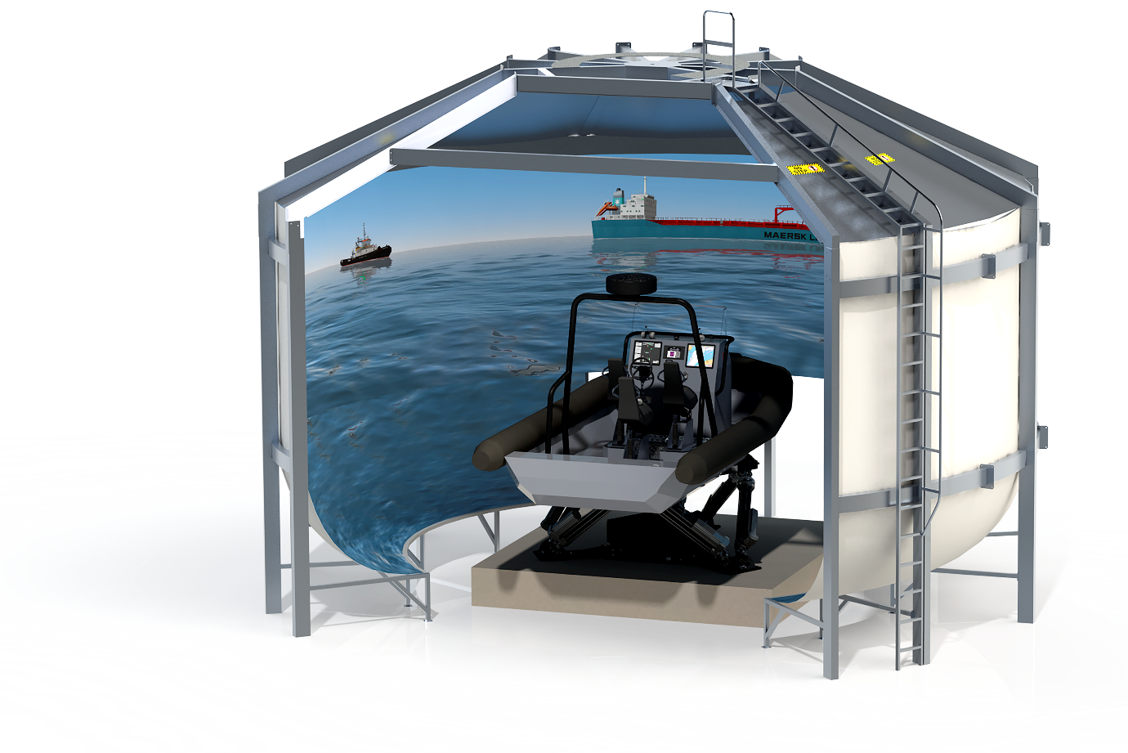 Kongsberg Digital’s K-Sim Fast Craft Simulator

Asker, September 10th, 2019: Kongsberg Digital, the global innovator of maritime simulation technology and SeaCross, the company behind the advanced SeaCross navigation system for safe and effective high-speed craft operation have announced a new partnership at the DSEI (Defence & Security Equipment International) exhibition and conference in London today.
The pairing forms the basis for the coming together of two cutting-edge technical innovations, with the focus to develop unique and effective products and end-to-end solutions for high-speed navigation and fast craft simulation by utilizing the joint strength of the two companies.
The training aspect is comprehensively covered by Kongsberg Digital’s K-Sim Fast Craft Simulator technology. Designed to provide trainees with a realistic perception of operating in a real-life environment, the simulator utilizes an advanced physics engine, motion system and hydrodynamic vessel modelling capabilities to replicate the behavior of high-speed vessels in various sea states and at all speeds. This allows military and professional fast craft operators to perform efficient, safe and repeatable training in tactical scenarios, that would be dangerous, expensive and resource-demanding to do in real life.

The K-Sim Fast Craft layout is configurable to mirror onboard operator positions of specific craft, allowing real controllers, indicators and displays to be integrated, while a low-radius, cylindrical visual projection system provides a greater vertical field of view. The training objectives met exceed boat handling and high-speed navigation to include full-scale tactical scenarios, with the system’s capability to incorporate firing of multiple weapon types. The entire training process is overseen by a leading-edge instructor, monitoring and assessment system.
The SeaCross navigation system has been developed for use in craft which can attain speeds of up to 100 knots in the challenging environments of littoral waters or open seas. The SeaCross system has been developed based on experience and knowledge derived from operating high-speed craft in this exceptionally demanding navigational environment. The SeaCross navigation system is a modular, scalable and fully integrated system, specifically designed to meet the requirements for high-speed operations and includes unique capabilities that are specific to operators of high-speed interceptors, SAR vessels, patrol vessels, or any operator requiring accurate real-time data they can trust.
Since the first product launch in 2006, SeaCross has evolved into a platform with unique functionality, specifically designed for the most demanding environments and end users. The navigation system is currently in use on a large number of vessels around the world. The primary customers are Special Forces, Police, Firefighting vessels, Coastguard, SAR, and Naval Forces.
“KONGSBERG and SeaCross have already been co-operating with common clients including police, naval and special forces,” says Lars Klemmetsby, VP Business & Development Defense, Kongsberg Digital, “and this exciting new partnership arrangement further strengthens our co-operation and allows us to benefit from SeaCross’ vast knowledge and experience within high-speed navigation and fast craft operations. Jointly we are able to offer the highest quality solutions for navigation and simulator training within this segment.”
“KONGSBERG’s K-Sim Fast Craft simulator technology offers a unique addition in the training programs our customers conduct to secure safety and effectiveness when using the SeaCross navigation system,” adds Axel Törneman, SeaCross Marine AB. “By combining our expertise and technology, users will be able to leverage the power of the SeaCross system when they come to deploy it in real-life situations.”

ends

For further information, please contact:

Anne Voith
Kongsberg Digital
Maritime Simulation
Tel: +47 48084640
Email: anne.voith@kdi.kongsberg.com

Anne.voith@kdi.kongsberg.com

About Kongsberg Digital
Kongsberg Digital is a provider of next-generation software and digital solutions to customers within maritime, oil and gas, and renewables and utilities. The company consists of more than 500 software experts with leading competence within the internet of things, smart data, artificial intelligence, maritime simulation, automation and autonomous operations. Kongsberg Digital is one of three business areas of KONGSBERG, an international, knowledge-based group delivering high technology systems and solutions to clients within the oil and gas industry, merchant marine, defense and aerospace, renewable energy and the utility industry. KONGSBERG has 7,000 employees located in more than 25 countries and total revenues of NOK 14.5 billion in 2017. Follow us on Twitter: @kongsbergasa.
www.kongsberg.com/en/kongsberg-digital/
www.kongsberg.com

