MEDIA RELEASE

Lights Out at Pan Pacific Hotels Group in support of Earth Hour 2019

29 March 2019, Singapore – At Pan Pacific Hotels Group, we care for our environment by operating with integrity, which means means adopting sustainable practices which protect the world around us. This year, our hotels, resorts and serviced suites globally are switching off or dimming non-essential lights in support of Earth Hour, which takes place on 30th March 2019, 8.30pm to 9.30pm (local time). This includes the building façade and public areas such as the lobby, driveway and guest corridors.

Besides joining in a plethora of activities organised by the hotels, we urge our guests to reduce the use of lighting and energy in their rooms during Earth Hour, as we join millions around the world to pledge our commitment toward a more sustainable planet.

Fund-raising campaign in collaboration with WWF Singapore

In an inaugural collaboration with WWF Singapore, four hotels including the eco-chic PARKROYAL on Pickering and three serviced suites are doing a little more with a fund raising campaign from 25 March to 15 April. Guests are invited to pledge a donation of SGD1 (or any amount) on top of their room bills towards WWF Singapore’s efforts against climate change.

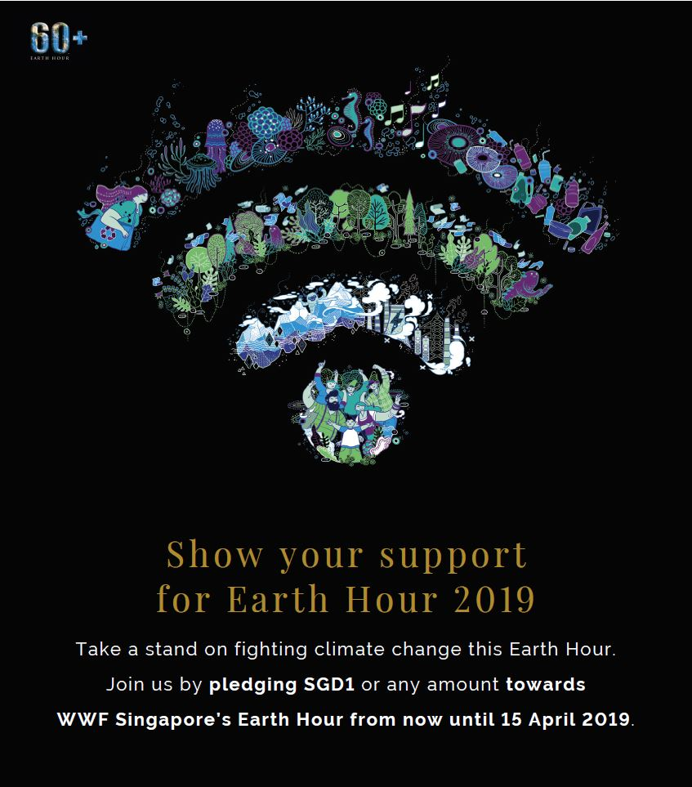

Themed Dining and Curated Drinks

Pan Pacific and PARKROYAL hotels are getting creative with their F&B offerings for Earth Hour, with an Opera Buffet in the Candlelight at Pan Pacific Vancouver; a BBQ Cookout by the Poolside at PARKROYAL Saigon; and a Salad Buffet to promote sustainable eating at Pan Pacific Beijing (with part of the proceeds going towards WWF Beijing) amongst other dining promotions for Earth Hour.

Guests can also look forward to post-dinner activities such unplugged performances and flash mobs at various hotels including PARKROYAL Kuala Lumpur and PARKROYAL Penang Resort, which will also be offering Earth Hour-themed cocktails and welcome drinks to raise awareness amongst their guests. To promote conscious eating, PARKROYAL on Pickering will be setting up a pop-up stall to sell the wildly popular Beyond Burgers®, which feature delicious plant-based (gluten and soy-free!) patties, to the CBD lunch crowd for a limited period.

Rewarding Plastic-Free Efforts

The hotels are also rewarding guests who are taking action for this green cause. PARKROYAL on Pickering will be giving out complimentary servings of their signature Limenade to customers who bring their own reusable cups, while Pan Pacific Ningbo is serving free coffee and bento meals to guests who bring their own mugs and food containers. This year, the hotel is also incentivising guests to reduce the use of disposables by offering a discount of RMB50 on their room rate if they opt out of the in-room toiletries, slippers and bottled water.

PARKROYAL Serviced Suites in Singapore will be gifting all in-house guests reusable bamboo straws which are eco-friendly and organic as a friendly reminder to reduce the use of disposable straws. At Pan Pacific Serviced Suites Beach Road, every guest who makes a written pledge towards a sustainable act will receive a bag of vegan cookies.

Ms Cinn Tan, Chief Sales & Marketing Officer, Pan Pacific Hotels Group, says, “We care for the environment and actively collaborate with partners such as WWF to send a strong message about sustainability. As an operator of more than 40 hotels, resorts and serviced suites globally, including the World’s Leading Green City Hotel, we’re deeply conscious about our carbon footprint. We also believe in engaging our guests in our efforts to protect our planet, be it reducing the use of single-use plastics to harvesting rainwater and investing in food compactors. Most importantly, we are leading the way in designing and building green hotels which are truly zero-impact and zero-waste.”

-ENDS-

Media Contact
Cuili NG
Director, Brand & Corporate Communications
Pan Pacific Hotels Group
Mobile: +65 9634 4425
Email: ng.cuili@pphg.com

About Pan Pacific Hotels Group

Pan Pacific Hotels Group is a wholly-owned hotel subsidiary of Singapore-listed UOL Group Limited, one of Asia’s most established hotel and property companies with an outstanding portfolio of investment and development properties.

Based in Singapore, Pan Pacific Hotels Group owns and/or manages more than 40 hotels, resorts and serviced suites including those under development in 24 cities across Asia, Oceania, North America and Europe.

Voted “Best Regional Hotel Chain” by readers in Asia-Pacific in 2017 and 2018, Pan Pacific Hotels Group comprises two acclaimed brands: its signature brand, Pan Pacific and its deluxe brand, PARKROYAL.

Sincerity is the hallmark of Pan Pacific Hotels Group. The Group is known to its guests, partners, associates and owners for its sincerity in people and the sense of confidence which alleviates the stresses of today’s complex world.

Visit us at www.panpacific.com.

Pan Pacific Hotels and Resorts
With hotels, resorts and serviced suites across Asia, Oceania and North America, Pan Pacific provides a safe harbour in an ever-changing world. Places with less to worry about because, when you stay with us, rest assured that all will be taken care of. For this is where you will find your balance.
PARKROYAL Hotels & Resorts
A big city or cosy enclave – where there is a PARKROYAL hotel, resort or serviced suite, there is a celebration of people. Our passion for creating real connections and joyous moments can be felt when you enter any of our properties across Asia and Australia. After all, this is the place to bring out the best of you, by us.

About DISCOVERY Loyalty
A memorable trip demands more than a comfortable stay. DISCOVERY, an award-winning global loyalty programme, provides 14 million members recognition and perks across over 550 hotels, resorts and palaces in 75 countries. Elite members have the opportunity to immerse themselves in local culture through Local Experiences, distinctive activities that capture an authentic taste of each destination. For more information, visit discoveryloyalty.com

Pan Pacific Singapore, PARKROYAL on Pickering, PARKROYAL on Beach Road, PARKROYAL on Kitchener Road
Pan Pacific Serviced Suites Orchard, Pan Pacific Serviced Suites Beach Road, PARKROYAL Serviced Suites
Available for take-away between 11:30am and 2:30pm on weekdays from 29 March to 12 April 2019, and Saturday, 30 March 2019.
First 30 guests for coffee, and first 10 guests for bento

