Media Release

EmTech Singapore gathers local, international innovators to discuss the future of technological innovation

21 November 2014 – SINGAPORE – The second edition of EmTech Singapore, hosted by MIT Technology Review magazine and co-organized and managed by Koelnmesse Pte Ltd will occur 27-28 January, 2015 at Sands Expo and Convention Centre in Singapore. The event brings over 500 local and international business leaders to share and understand new technologies that are being created and how they will change the face of business and drive the new global economy.

EmTech Singapore is hosted by the Infocomm Development Authority of Singapore (IDA) and one focal point of the conference will be to discuss the latest innovations that assist in the building of a ‘smart nation’. Steve Leonard, IDA’s Executive Deputy Chairman will give the opening address.

"Singapore has outlined an ambitious vision to be a Smart Nation. As global trends of an ageing population and urban density also affect us, we know that new approaches to healthcare, mobility and resource-management will be needed in the years ahead,” said Mr Leonard. “These new approaches will rely heavily on exciting new advances in technology, but with the purpose of improving vital services to people of all ages."

Supported by the Singapore MIT Alliance for Research and Technology (SMART), the event has also become a meeting place for other R&D institutes like A*STAR, who sent 40 of their top researchers to attend the conference. Dr Tan Geok Leng, Executive Director for the Science and Engineering Research Council at A*STAR commented about EmTech Singapore 2014, “We are always on the lookout for very interesting things. I came to this place to get our people inspired, look for new ideas. We bring some of our researchers here so that they can see what is going on.”

In 2015, EmTech Singapore will explore the key themes of Digital Life; Healthcare & Life Sciences; Space 3.0; along with the Next Frontier of Sustainable Innovations, addressing real world challenges. Among others, some of the international speakers at EmTech Singapore include:
- Kai Yu, Deputy Director of IDL / Distinguished Scientist, Baidu
- Steve Isakowitz, President, Virgin Galactic
- Scott Farquhar, Co-Founder and Co-CEO, Atlassian
- Li Yingrui, CEO, BGI Tech
- Guyue Zhou, Director of New Technology, DJI
- Alex Dickinson, Senior Vice President of Strategic Initiatives, Illumina
- Steven Feiner, Professor at Columbia University & Lead Advisor at META
- Rudy A. Mazzocchi, CEO, PULSE BioLogic
- Sumeet Jain, Investment Director, Intel Capital
- Carlo Ratti, Director, SENSEable City Laboratory, MIT

In 2015, a well rounded programme is being developed, with emphasis given to building a content-driven program in collaboration with MIT Technology Review’s editorial team. Rarely are such a diverse group of game-changing innovators brought together in Asia. For example’:
- An ‘Investors Roundtable’ will be held within the conference, which is geared towards matchmaking the innovators with investors and the Venture Capital community
- The use of an onsite mobile networking app will better enable opportunities for interested parties to meet at social functions
- Focused themes of Space Technology, Smart Nations and Genomics with world leading technologists and innovators participating in the conference
- Spotlight on Wearables, Robotics and Drones with world leading technology companies Rolls Royce, DJI, Misfit Wearables and META speaking at the conference

The event also recognizes the top 10 Innovators under 35, from around the region that qualifies them to be considered for MIT Technology Review’s TR35 List, to be announced in October 2015.

– ENDS –

MEDIA CONTACT
Illka Gobius
PINPOINT Public Relations
M: +65 9769 8370
E: illka.gobius@pinpoint-pr.net

Image and Caption
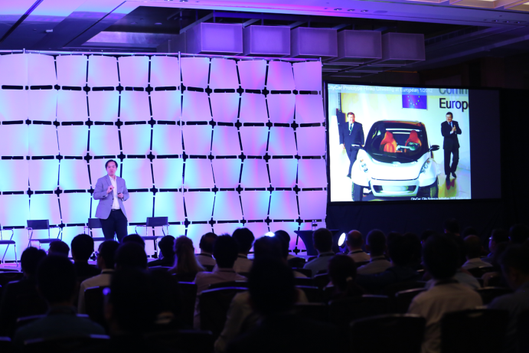
Caption – Ryan Chin, Research Scientist at MIT Media Lab presents at the inaugural EmTech Singapore conference on 20 Jan 2014.
Photo credit – Koelnmesse Pte Ltd

Download high resolution image

About EmTech Singapore
EmTech Singapore in 2015 is organized by by MIT Technology Review and Koelnmesse Pte Ltd. This year’s host partner is the Infocomm Development Authority of Singapore (IDA). Key partners also include SMART and The Indus Entrepreneurs. The official broadcast partner is CNBC. The press room is sponsored by Mynewsdesk.

About EmTech
EmTech Singapore is where technology, business, and culture converge. It’s the showcase for emerging technologies with the greatest potential to change our lives. It’s an access point to the most innovative people and companies in the world. Most of all, it is a place of inspiration — an opportunity to glimpse the future and begin to understand the technologies that matter and how they’ll change the face of business and drive the new global economy. www.emtechsingapore.com

About MIT Technology Review:
MIT Technology Review leads the global conversation about technologies that matter. An independent media company owned by MIT, it produces publications read by millions of business leaders, innovators, and thought leaders around the globe, in six languages and on a variety of platforms. The company publishes MIT Technology Review, the world′s most respected technology magazine; daily news features, analysis, and opinion; and Business Reports, which explain how technologies are transforming industries. It produces live events such as the annual EmTech MIT, international EmTech conferences, Summits, and Salons. The company’s entrepreneurial community organization, MIT Enterprise Forum, hosts 400+ events a year around the world.

Media Contact:
David Sweeney
T: +1 617-475-8018
mediarelations@technologyreview.com

About Koelnmesse:
Koelnmesse Pte Ltd is one of the world's largest trade fair companies. Its more than 70 trade fairs and exhibitions have the broadest international scope in the industry, as 60 percent of the exhibitors and 40 percent of the visitors come from outside Germany. The Koelnmesse events include the leading global trade fairs for 25 sectors, such as imm cologne, Anuga, IDS, INTERMOT, interzum cologne, photokina, Gamescom, and the International Hardware Fair Cologne.

IDA Media Release: Singapore Unveils Building Blocks of Smart Nation Vision
Video: Tan Geok Leng, Executive Director for the Science and Engineering Research Council at A*STAR comments about EmTech Singapore 2014
Media Release - 4 Sept 2014 EmTech Singapore Opens for Registration with an Outstanding Line Up of Speakers
Media Release – Innovators in Singapore Blaze on EmTech Singapore’s 2015 Innovators Under 35 Regional List

