Drainage screed against flood damages - Floors permanently secured with lightweight screed drainage system against flood damages
Extreme floods in recent past have necessitated the costly and time-consuming renovation and rehabilitation of numerous buildings worldwide. The German companies eSKa-Drain and Dennert Poraver have developed a permanent protection for floors in flood-prone buildings. The water permeable system contains out of gravel, expanded glass granulate, and VOC-free resin. In the flood area Radebeul near Dresden owner of a family house chose this innovative system for the lasting protecting of their indoor floors. The cement-free system is easy to use, provides thermal insulation, and protects against new water damage
The extreme floods in the summers 2002 and 2013 have caused enormous damage in Central Europe. Especially the floors of the affected building suffered during this floods considerable damage and had to be renovated extensively and costly.
Quick and easy processing guaranteed
The floors of the exemplary building project also had to be replaced several times at great cost after the floods. For this reason the owners opted for the permanent solution with eSKa-Drain and Poraver. The contractor Bau-Schulze from Dresden installed the user-friendly two-component system over 65 m² of the residential property. Due to the screed's short curing time of 24 hours, the construction project can be completed in only one week. The base drainage layer consists of thermally insulating Poraver expanded glass granulate, bonded with VOC-free resin from eSKa-Drain. On this particularly lightweight insulating layer an underfloor heating system is installed and covered with eSKa-Drain leveling screed. In addition 150 holes are drilled into the concrete floor and provided with special plugs. In the case of flooding, the plugs are easy to open and the water drains through the water-permeable screed and insulation layer into the basement. The floor and the underfloor heating will not be damaged.
Water permeable, cement-free and thermal insulating properties
The cement-free system is easy to use, provides thermal insulation, and protects against new water damage. In addition the system is very lightweight. Poraver is a health-friendly and recommended insulation material made of 100% glass. The expanded glass granulate is extremely resistant against temperature, moisture or mould and provides excellent thermal conductivity of 0.07 W/(m∙K).
A building material of the future
The eSKa-Drain screed has been used as an efficient drainage system for balconies and terraces for many years. The reference project shows that the system is a particularly efficient interior solution and provides continuous protection against water damage in flood areas. Civil engineer Achim Uhlig from Bau-Schulze GmbH considers the system as a pioneering solution: “Industrial companies are completely paralyzed during floods. Everything has to be rebuilt, renovated and renewed. The eSKa-Drain system with Poraver expanded glass would prevent against production downtime or significantly reduce it. Operations and equipment would quickly be ready for use again!”

(approx. 3200 characters)
With production sites in Postbauer-Heng, Germany and Innisfil, Canada, Dennert Poraver GmbH has been the leader in the production of expanded glass granulate for 30 years. Developed by Dennert Poraver GmbH, Poraver is a lightweight aggregate made from recycled glass that has established itself in many different areas of application due to its versatility and outstanding features. With planned production capacity of 500,000 m³ per year, the Poraver company is the world's largest manufacturer of expanded glass granulate.

Photos | File | Caption
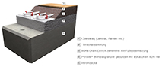 | eSKa_Poraver01.jpg | Constructive protection against flood damage: The floor structure consists of gravel, Poraver expanded glass granulate and VOC-free resin.  Visualization: Dennert Poraver GmbH
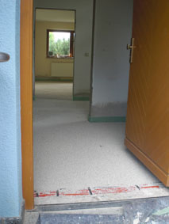 | eSKa_Poraver02.jpg | The floor of the family house in Radebeul is now protected from future flood damage by using the system of eSKa-Drain and Poraver  Photo: Dennert Poraver GmbH
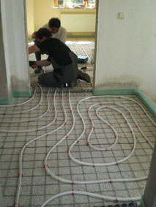 | eSKa_Poraver03.jpg | The resin-bound Poraver expanded glass granulate forms a water-permeable and thermal insulating layer for the installation of the underfloor heating.  Photo: Dennert Poraver GmbH
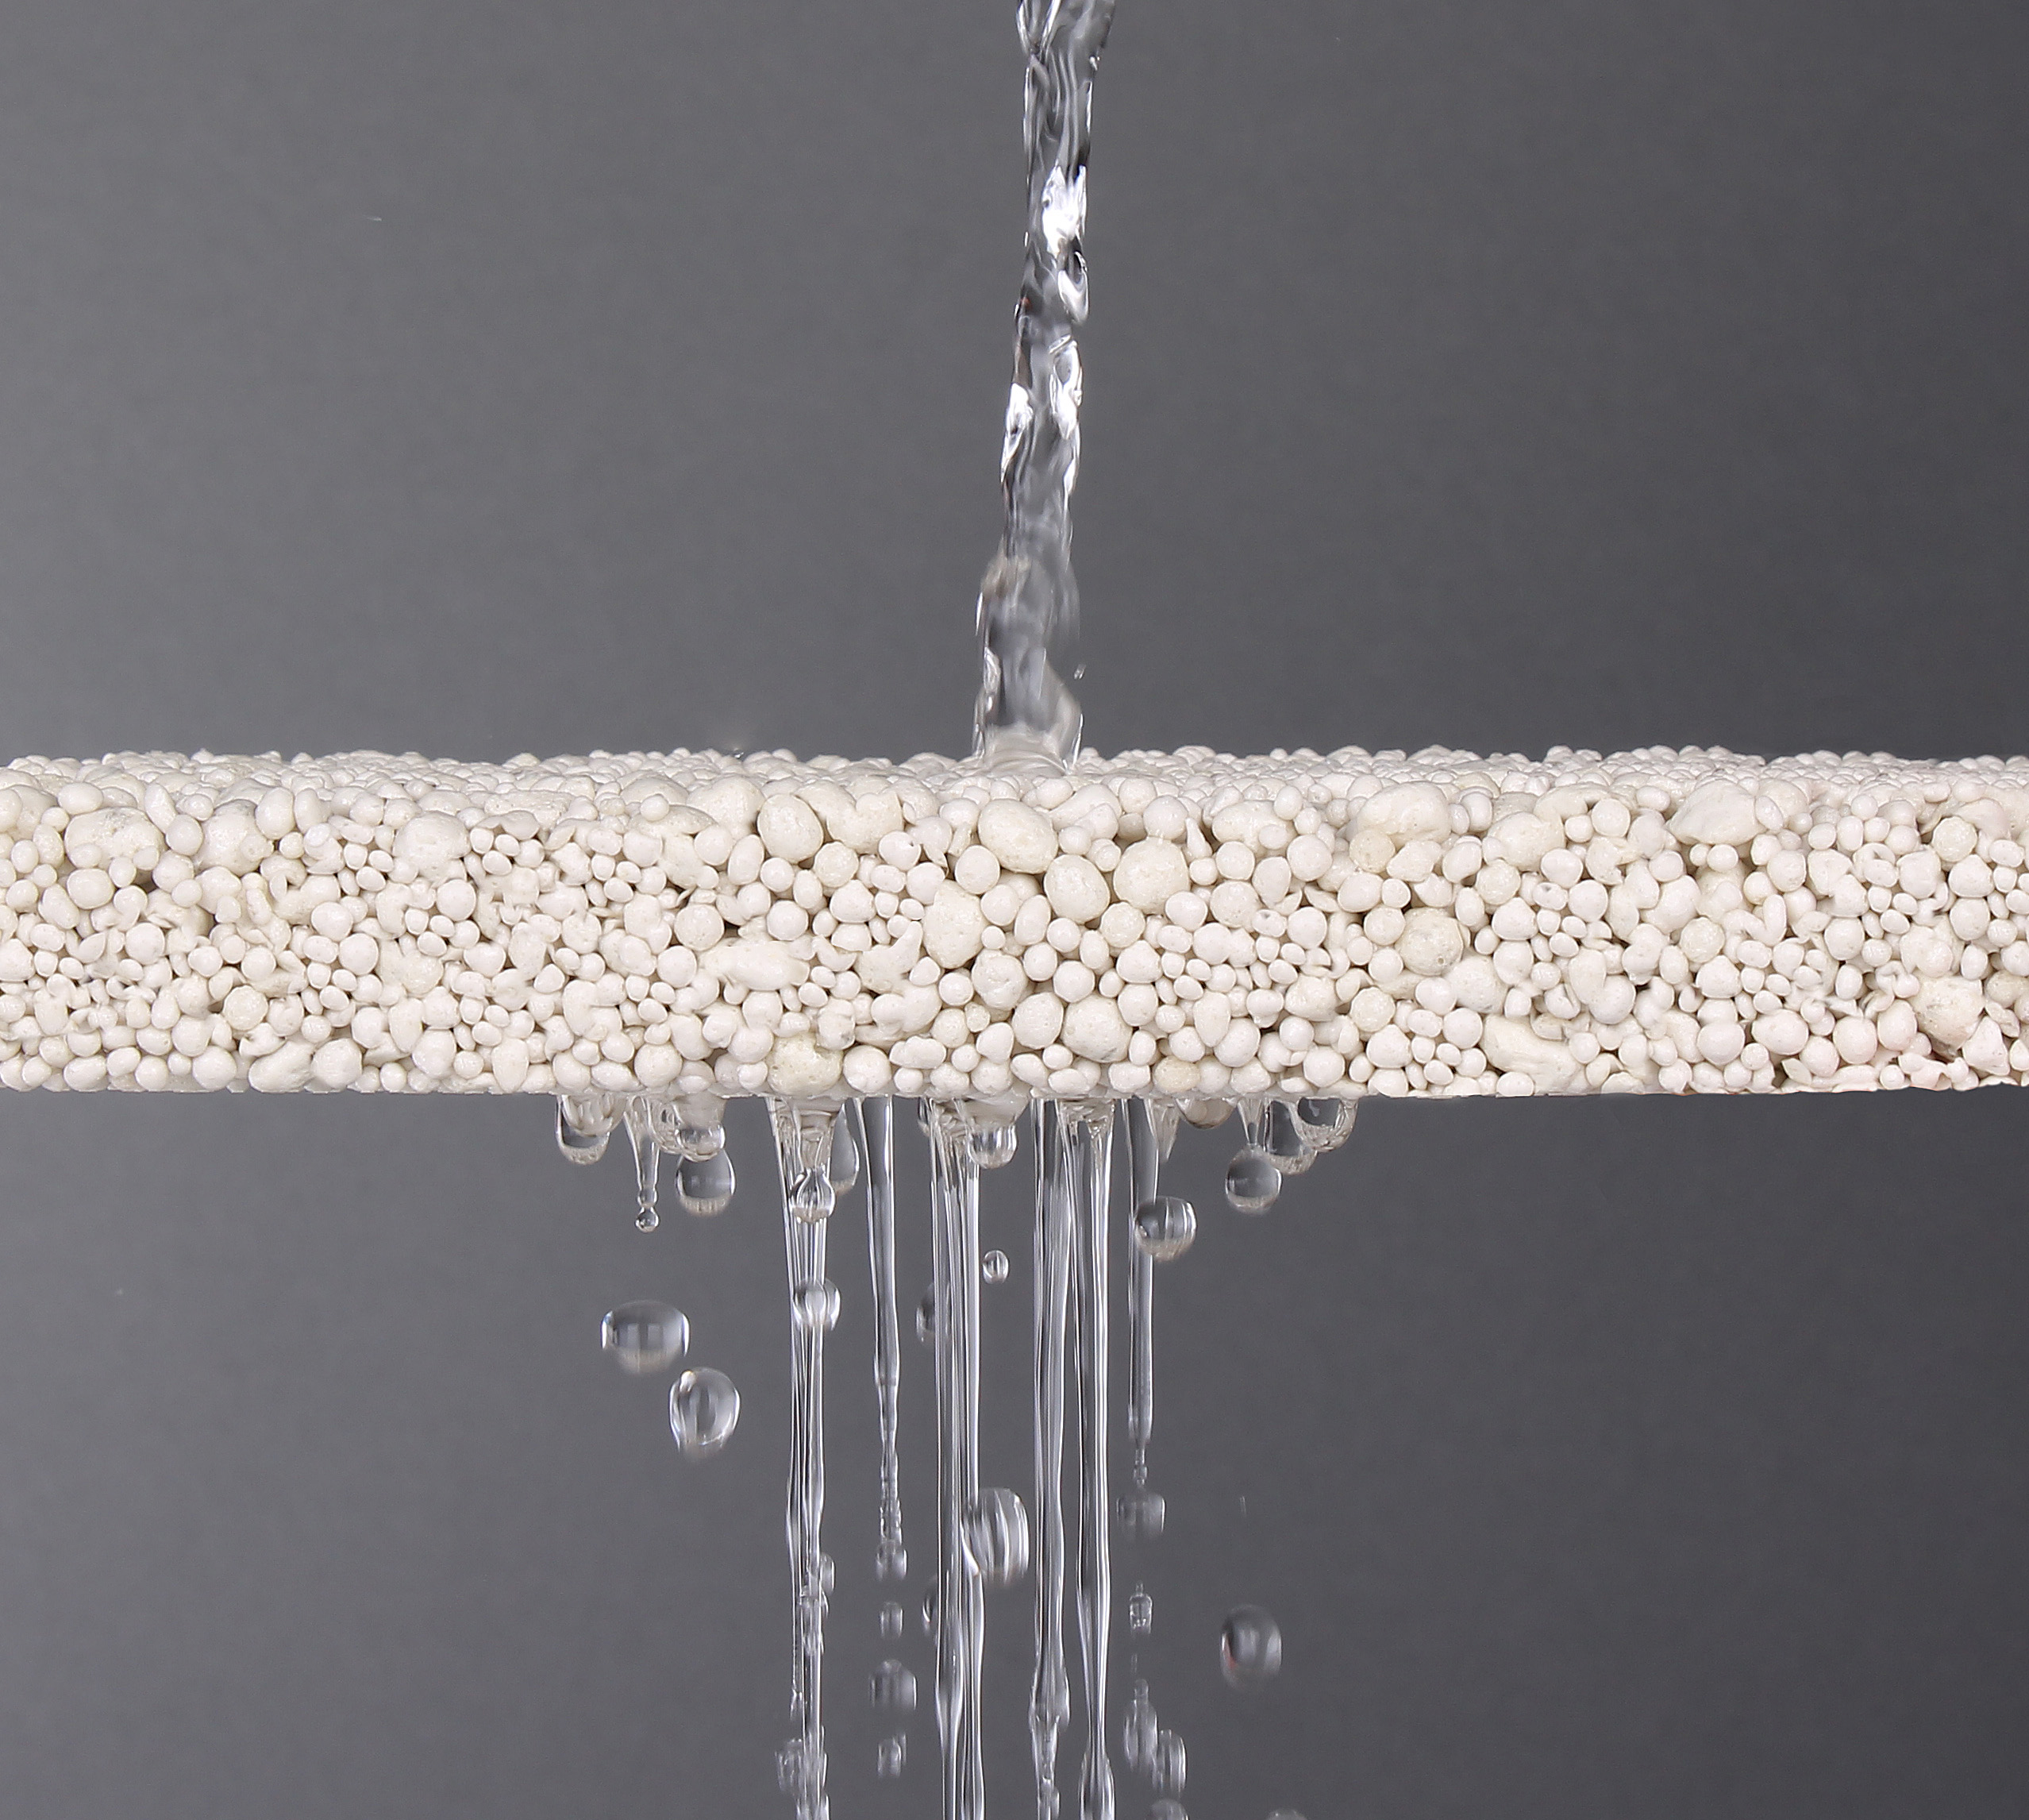 | eSKa_Poraver04.jpg | The cement-free system is bound with a VOC-free epoxy resin, permeable to water and dries quickly.  Photo: Dennert Poraver GmbH

