Ringsted, 14 November 2017
Press release

GLUNZ & JENSEN A/S MOVES THEIR ACTIVITIES TO NEW LOCATIONS IN NYBORG
As part of restructuring their business, Glunz & Jensen A/S will merge departments across Denmark and move their activities and headquarter to Nyborg, the eastern part of Funen.
This will take place from January 1, 2018, where the company will move into new locations on Lindholm Havnevej 33 in Nyborg. The 5.800m² buildings are situated directly at the beautiful harbor front and combines offices and production facilities.
René Normann Christensen, CEO of Glunz & Jensen: "We look forward to moving into our new premises in Nyborg. As an international company, many ends need to meet. Apart from moving our headquarter staff, we will also be moving our Danish production, spare parts stock and R&D. All in all, we look forward to becoming part of the business community in Nyborg.”
For information, please contact:
René Normann Christensen, CEO
Tel.: 2423 4677, e-mail: rnc@glunz-jensen.com

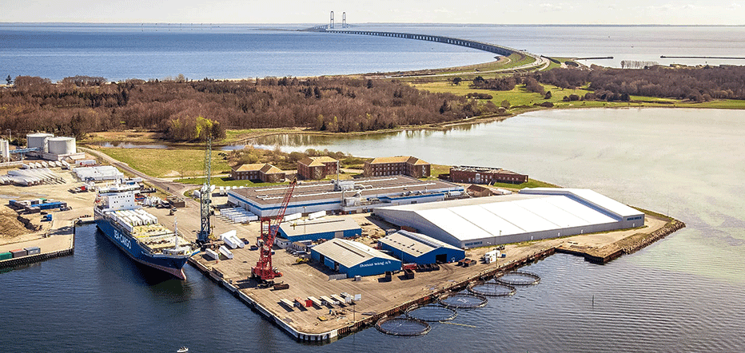

About Glunz & Jensen
Glunz & Jensen is the world’s leading supplier of innovative, high-quality solutions for the global prepress industry. In addition to developing and producing processors for the offset and flexo printing industry, we also offer after sales service. Our product portfolio also includes exposure units, dryers, light finishers, mounting tables, plate stackers and software for monitoring and controlling complete prepress processes.
Glunz & Jensen has been a recognised leader in prepress for more than 40 years. We have long-standing relations with major customers such as Agfa, Asahi, DuPont, Flint, Fujifilm, Heidelberg, Kodak and MacDermid, the world's largest suppliers of printing systems. We market our products through a comprehensive and worldwide network of distributors and dealers, and the Group has approx. 230 employees in our subsidiaries and production facilities in Denmark, Slovakia, USA and Italy.
Our goal is to be the most innovative provider of hardware and services in our product areas and in this way increase our market share with the global customers. We will also strengthen our earnings capacity through the optimisation of prices, production, logistics and capacity utilisation.

