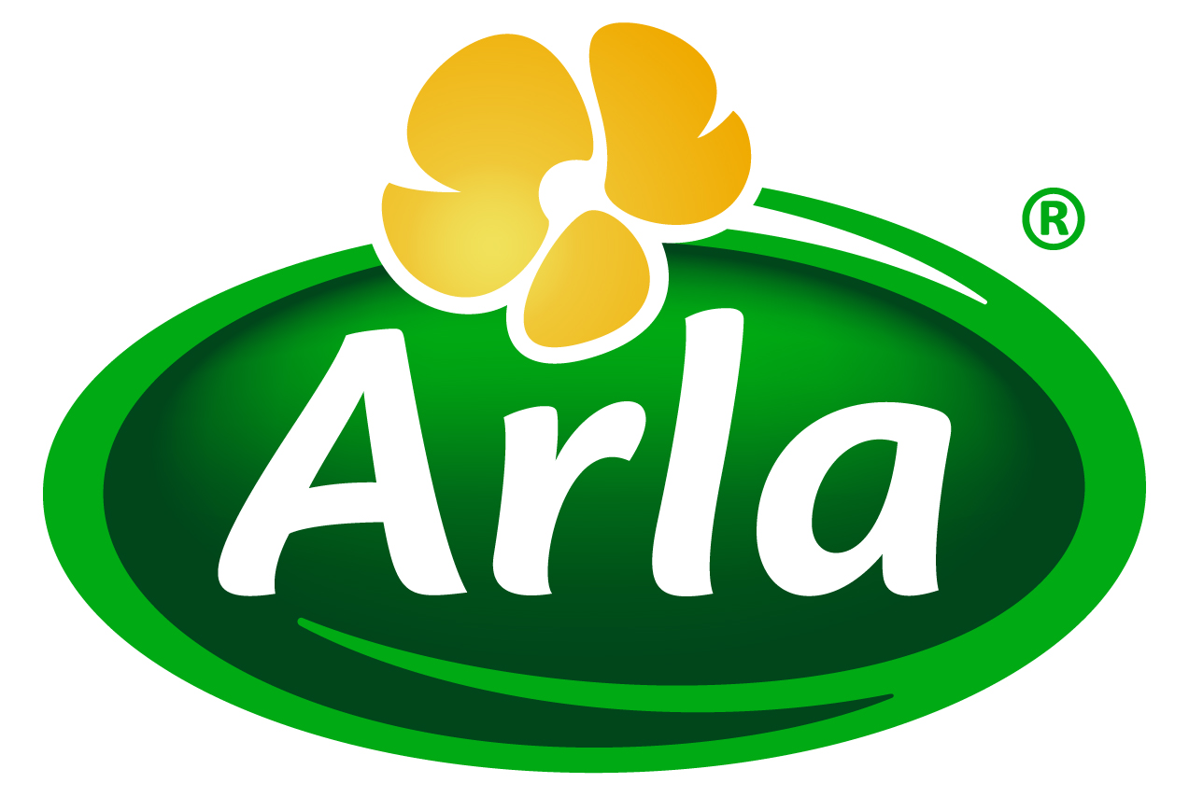
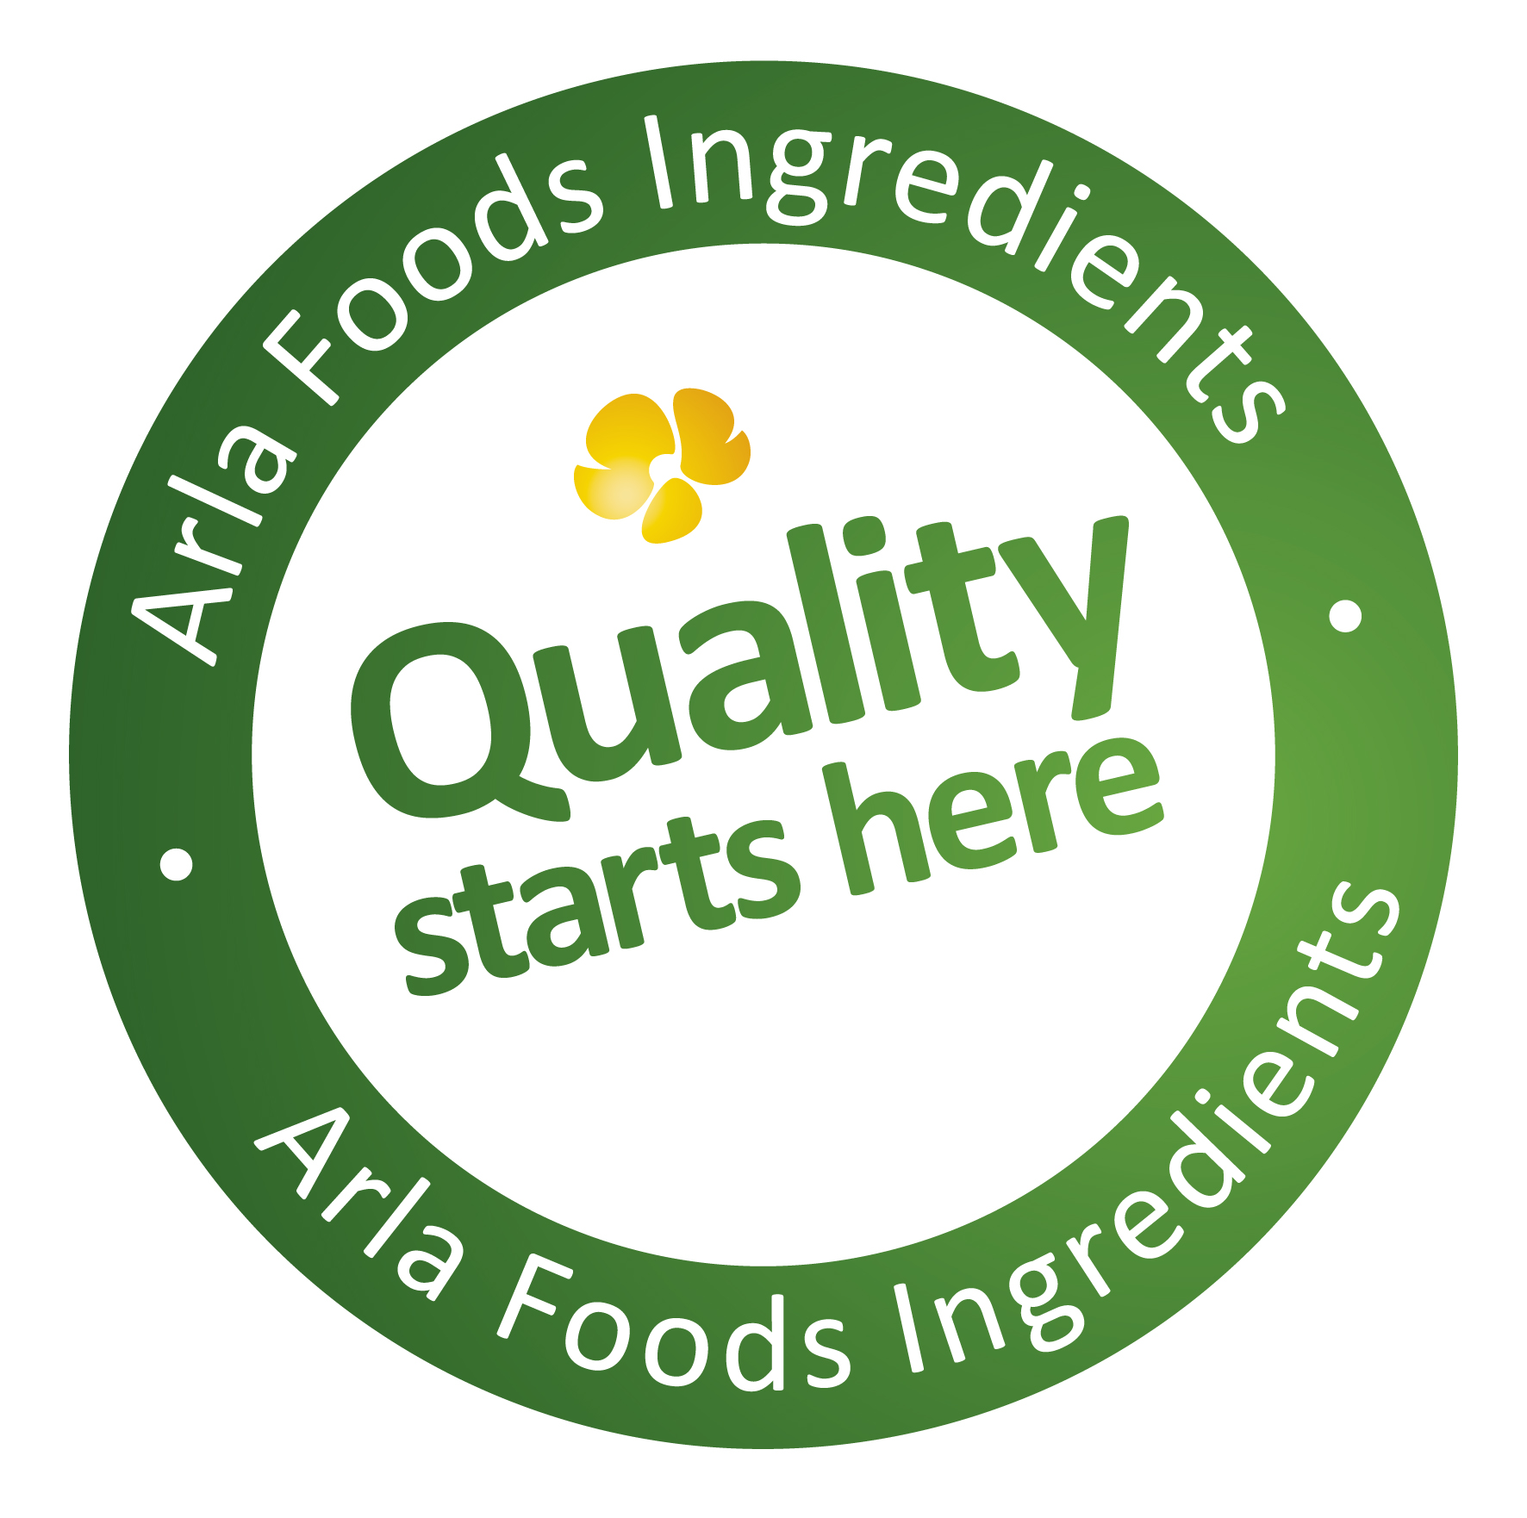

2 October 2014
PRESS RELEASE

Arla Foods Ingredients leads calls for
collaborative industry effort on food aid

Arla Foods Ingredients has highlighted the need for a global industry push to ensure dairy ingredients are included as an integral part of emergency food programmes.

Ingredients derived from milk tend not to be included in such programmes – including the United Nation’s World Food Programme, which fights hunger in the developing world – because of concerns over their cost.

Arla Foods Ingredients is funding research into the benefits of whey protein and permeate in a bid to demonstrate that dairy ingredients are affordable and superior because they are so nutritionally dense. This means smaller quantities can be used compared with alternatives such as vegetable proteins. In addition, dairy ingredients can be blended with proteins of other sources to create food aid products that offer excellent all-round nutrition.

However, Arla Foods Ingredients says a collective industry effort is required to show that dairy ingredients can be an economical option, because for ingredients to be accepted and approved by emergency food programmes they must be available worldwide.

Henrik Jørgen Andersen, Senior R&D Manager at Arla Foods Ingredients, said: “Even though we are an international business, we don’t operate in every region that benefits from aid initiatives like the World Food Programme. This means the global dairy ingredients industry must stand together to make sure we can deliver affordable high quality products in every geography touched by these programmes.”

He continued: “Consequently, only if other major dairy ingredients companies join us in this effort can we succeed in persuading the organisers of food aid programmes that our products have a key role to play in the war on hunger. It’s a fantastic opportunity for the industry to show that we are not just about commercial success, but that together we can also offer the international community powerful solutions to tacking the global challenge of hunger and malnutrition.”

Arla Foods Ingredients showcased its work in this area at the recent International Whey Conference in the Netherlands. Ingredients such as whey and permeate are ideal for use in, for example, ready-to-eat products designed to address moderate malnutrition. They are typically produced as a paste that’s packed with nutrients and easy to consume.

Henrik added: “Arla Foods Ingredients has supported a clinical trial which has shown that it’s possible to make products like these with ingredients such as milk proteins which, due to their exceptional high quality, can be used to reduce overall protein content and make products in a manner that is economical, sustainable and beneficial in a nutritional sense. The full results aren’t yet ready to publish, but we’re confident they will represent a huge step towards documenting the potential role of dairy ingredients as constituents in foods for future emergency aid programmes. However, we can’t do this alone – and we are keen for our fellow dairy ingredients companies to work with us towards this extremely worthwhile goal.”

ENDS

For more information, please contact:

Kine Bjoralt, Ingredient Communications
Tel: +44 141 280 4141
Email: kine@ingredientcommunications.com

About Arla Foods Ingredients
Quality starts here: Arla Foods Ingredients is a global leader in natural whey ingredients for products in a range of categories – from sports nutrition, beverages, bakery, dairy and ice cream to clinical and infant nutrition.
The cornerstones of our business are innovative ingredients, world-class facilities and a staff of dedicated experts. Drawing on our portfolio of functional and nutritional whey proteins, milk minerals, lactose and permeate, our expert team delivers solutions that bring new food products quickly and efficiently to market. Our application centres run hundreds of customer product trials every week. All ingredients are produced using state-of-the-art processing technology at our plant in Denmark, or by one of our joint ventures in Argentina, Germany and the UK.
Arla Foods Ingredients Group P/S is a 100% owned subsidiary of Arla Foods, a global dairy company and cooperative owned by dairy farmers in Denmark, Sweden, the UK, Germany, the Netherlands, Belgium and Luxemburg.

RSS Feed
Visit our website at http://www.mynewsdesk.com/arla-foods-ingredients and sign up to our News RSS feed for all the latest developments – updated regularly.

Twitter
Follow us on twitter for all the latest updates @ArlaIngredients

