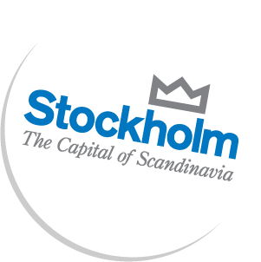



Press release, 9/6/2010

**Stockholm projected to be Sweden’s growth engine for the next 20 years**

**Stockholm will account for 43 percent of Swedish growth up to the year 2030. The driving force in that development is expected to come from the knowledge intense service sector. This prognosis comes from consultancy company WSP, and was presented at a seminar arranged in conjunction with the Stockholm visit of Louis Zacharilla, founder of Intelligent Community Forum.**

The number of jobs has doubled in the service sector in the last two decades. The service sector turnover is now more than SEK 100 billion, and the growth continues. WSP estimates that Stockholm will continue to be the primary growth engine of Sweden for the next 20 years, accounting for 43 percent of Stockholm’s growth.

*“There have been discussions of clusters for a long time, but perhaps not on an adequately large scale. Stockholm is a cluster with hotspots such as Kista, which attract both people and businesses. It’s easier to get well paying jobs and the companies are closer to good infrastructure and higher education. My estimate is that Stockholm will take the lead in services export as well, which may result in even higher growth numbers,”* said Fredrik Bergström, Ph.D. and WSP Director Analysis & Strategy.

The City of Stockholm has a commitment to IT infrastructure and e-services; as well as to collaborations with the private sector and universities, which is considered an important catalyst to create jobs and growth. US think-tank Intelligent Community Forum appointed Stockholm the Intelligent Community of the Year 2009, among other reasons, for the city’s long term vision and IT commitments.

*“I am very impressed by Stockholm’s possibilities to grow and it confirms my view that politicians at community level actually make the difference. They really facilitate development”,* said Louis Zacharilla, founder of Intelligent Community Forum.

The seminar was arranged by the City of Stockholm and Kista Science City.

**For more information:**

**Annica Englund,** Director PR & Communication, Kista Science City

+46 70-771 92 04, annica.englund@kista.com

**Per Holmlund,** PR Manager Stockholm Business Region,

+46 70-472 80 69, per.holmlund@stockholm.se

**About Stockholm Business Region**

Stockholm Business Region is the official investment promotion agency for the Stockholm region. Stockholm is one of Europe’s most dynamic regions. With continual high growth, world-leading clusters within Life Science and ICT, and as a center for fashion and design, Stockholm is the natural capital city of Scandinavia.

www.stockholmbusinessregion.com

**About Kista Science City AB**

Kista Science City’s aim is to improve the business climate and create growth by a deeper collaboration between the private sector, academia and the public sector in Kista Science City. That is achieved by supporting innovation and new growth companies, arranging meetings and network opportunities, and marketing.

http://www.kista.com