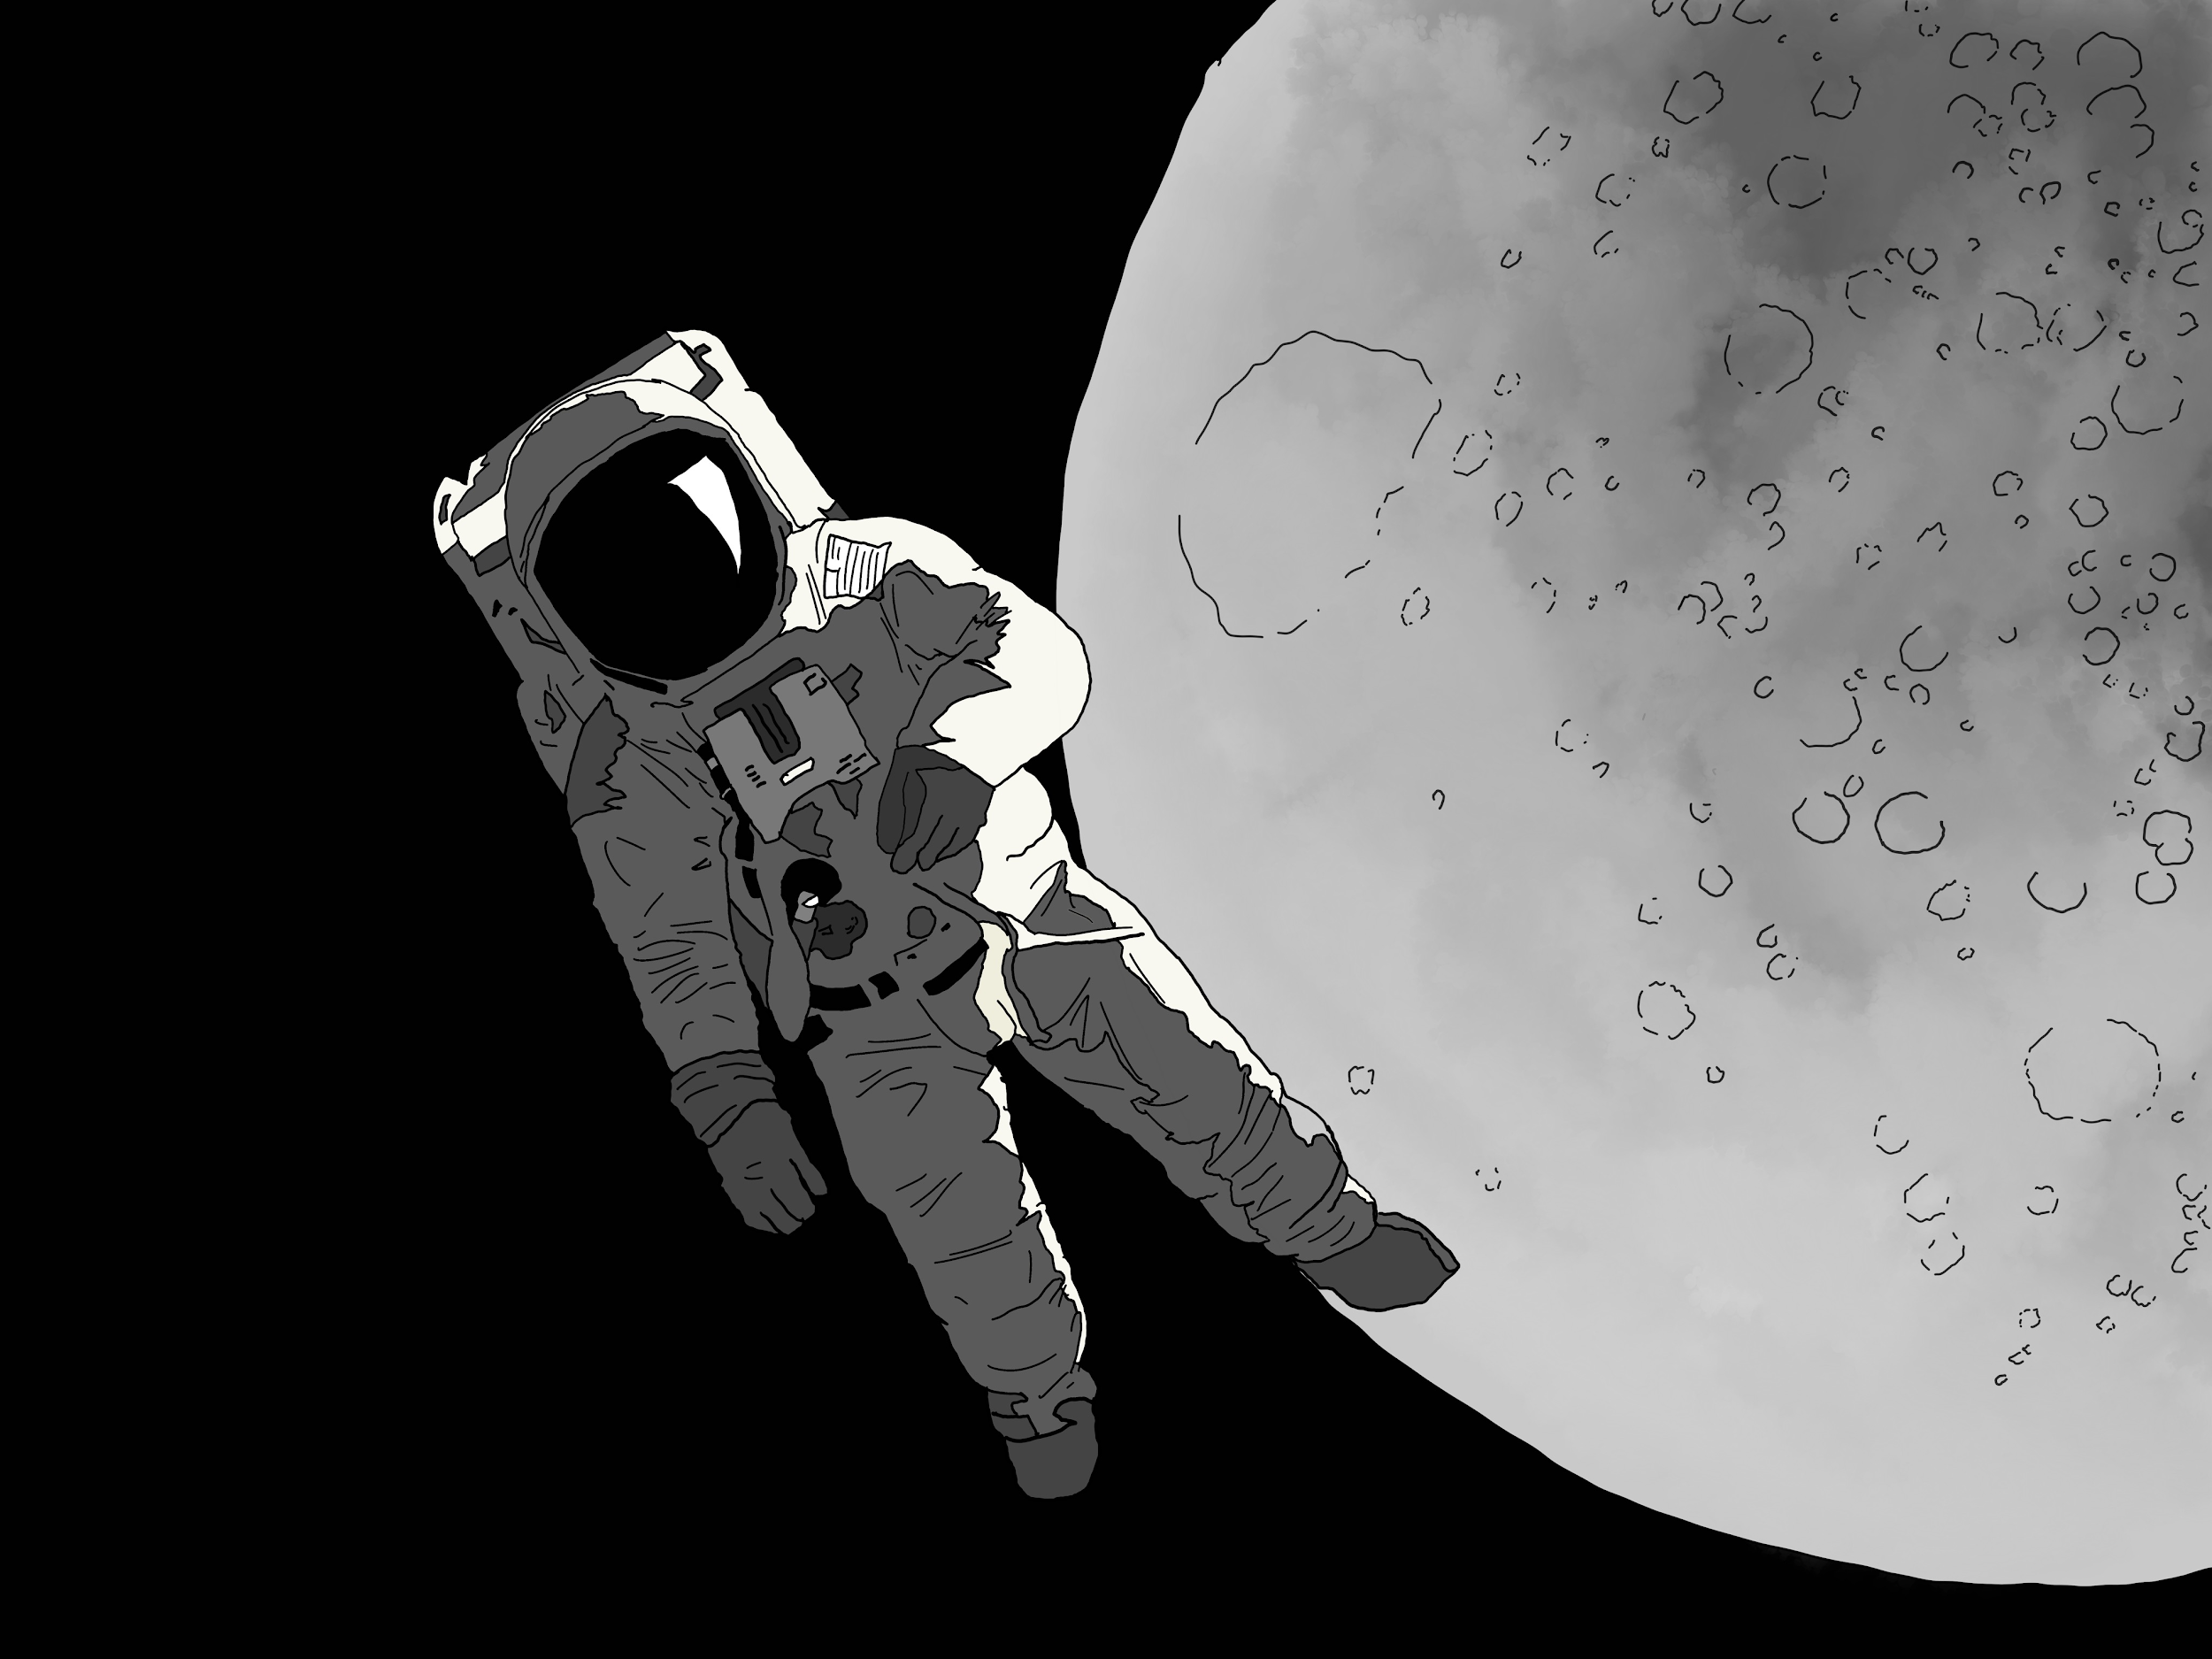
Image gallery: 7 tools abandoned on the Moon

Moon Landing: 7 tools abandoned on the Moon

On July 20, 1969, the first spaceflight landed humans on the Moon. Three names Neil Armstrong, Buzz Aldrin, Michael Collins and the Apollo 11 Space Program will forever remain engraved in history of humankind. For the 50th anniversary of NASA’s breakthrough achievement, TradeMachines prepared an image gallery presenting 7 tools used by the Apollo 11 astronauts during their lunar landing mission.

The historic Moon landing paved the way for future space exploration. The mission allowed the astronauts to take valuable lunar samples like pebbles, rocks, soil, sand or dust back to Earth. Obtaining samples for scientific analysis changed our understanding of our solar system after the Earth and the Moon were formed.

In order to collect the lunar materials, the astronauts were equipped with special tools. However, to get rid off extra kilograms on the way back, many of the tools were left behind. Have a look at the image gallery and find out which of them were abandoned on the Moon.

See image gallery:

https://press.trademachines.com/latest_media

Contact

Beata Majka
Online Marketing Manager
https://trademachines.com/

Tel. +49 30 61 29 71 16
Email: beata.majka@trademachines.com

Press information:

- TradeMachines is a meta search engine for used machinery. We consolidate offers from traders and auctioneers all over the world, and have every type of machine under one roof. Our platform is a convenient way for potential buyers to search for local and global offers online.
- Reprint free of charge.
- Image source can be found in image gallery.
- In case of usage of our work please credit us by inserting a link to trademachines.com
- All pictures used are free of rights.
- For more information about TradeMachines, please contact onlinemarketing@trademachines.com

Sources:

https://www.lpi.usra.edu/lunar/samples/apollo/tools/
https://www.youtube.com/watch?v=Oo8TaPVsn9Y
https://airandspace.si.edu/collection-objects/tongs-lunar-surface-short
https://www.lpi.usra.edu/lunar/samples/apollo/tools/
https://curator.jsc.nasa.gov/lunar/catalogs/other/jsc23454toolcatalog.pdf
https://www.lpi.usra.edu/lunar/samples/apollo/tools/
https://airandspace.si.edu/collection-objects/tool-carrier-small-apollo

Image captions:

Rakes

As it turns out, rakes come in handy not only in gardening - they are quite useful on the Moon too! Apollo astronauts used them to collect pebbles from lunar soil. Gathered samples returned to Earth for further examination.

Hammer

David Scott (Commander of Apollo 15 and the 7th person to walk on the Moon) performed an experiment in front of the television camera. He held a hammer in one hand and a feather in the other. He dropped both objects at the same time. Since there is no air resistance on the Moon, both the hammer and the feather fell at the same rate, which confirms Galileo's theory that all objects fall with the same acceleration regardless of their mass.

Tongs

Astronauts used tongs in order to collect small rock samples (smaller than 10 cm). Those who participated in early Apollo missions used so-called short tongs. Longer, 32-inch tongs were introduced in later missions.

Scoop/Shovel

Just like tongs, scoop was used to pick up samples of the lunar soil. When tongs were useful while picking up rocks, scoop was more convenient when collecting larger quantities of lunar material.

Drill

In order to retrieve samples from greater depths, astronauts used an electric drill. The drill helped them to bore into the lunar surface and gain a better understanding of the Moon’s stratigraphy.

Core Tubes

Core tubes were a practical solution for obtaining samples from below the Moon’s surface. They were hammered into the surface, reaching a maximum depth of 70 centimeters. Apollo 11 astronauts brought 22 kilograms of geologic samples back to Earth. Their two core tubes contained material from up 13 centimeters below the surface.

Tool Carrier

Tool carriers were used to transport equipment while taking samples of the lunar surface. These carriers consisted of a set of racks onto which tools were easily stored. Transported by hand during the first Apollo missions, the carriers were later replaced by Lunar Roving Vehicles.

