PAXYMER newsletter
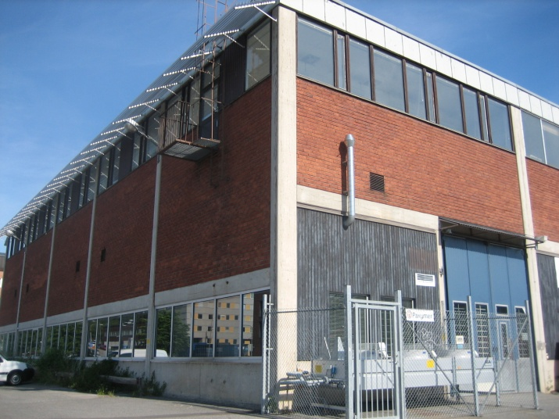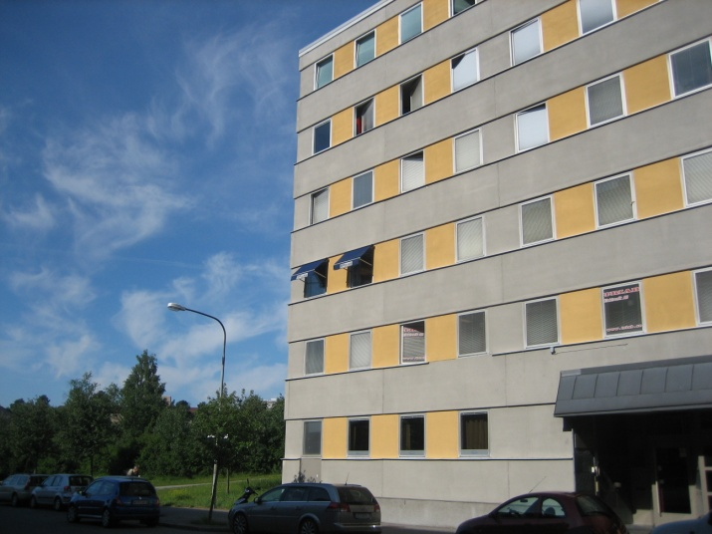
Newsflash
Paxymer signs deal with distributor on Nordic markets.
Paxymer and IMCD Sweden AB have signed a distribution deal for the Nordic markets. IMCD is a Dutch group present worldwide and has vast experience of specialty products for plastics manufacturing. It is well established in the Nordic market with a technical sales force. IMCD has seen an increased focus on safety and environment in the plastics market – especially in the demand for halogen free flame retardants. Paxymer fills a gap in their portfolio.
Why reading our newsletter is good for business
This is our first newsletter from Paxymer. In these letters we will write about health, safety and chemical trends the way we see them on our market – the global flame retardants market.
We believe that substitution and innovation in the area of halogen free flame retardants represents a tremendous business opportunity – enhancing products functionality without compromising on environment or health aspects.
Venture capitalist and author Carl Hall recently wrote in his book “Miljökapitalisterna” (2012) that innovation for green markets is undoubtedly the best opportunity we have to create sustainable new businesses, in order to do that we need to combine ideas and areas of expertise and find ways to collaborate. We hope that these newsletters inspire you and will ultimately lead to opportunities for us to do business together.
/Amit Paul (MD of Paxymer AB)
What drives innovation in the chemicals industry?
Most authorities today focus on Innovation. It is the new buzzword. So does the European Commission. The results from a survey studying what drives innovation in the chemicals industry it states that the SIN-list alongside candidate list in REACH are major drivers of substitution for innovative materials in order to phase out the use of hazardous substances. Partly this is due to the pressure downstream users put on their suppliers to become SIN free.
Chemsec: What drives innovation
15 new substances on the REACH candidate list at the end of 2012.
EU member states have recommended that another 15 chemicals should be included in the REACH candidate list by the end of the year, according to the European Chemicals Agency (ECHA). More than half of the substance dossiers have been submitted by Germany. The 15 new substances include a number of perfluorinated acids and phthalates. Of particular interest is the well-known and frequently used flame retardant Deca-BDE. The 15 newly suggested substances have been added to the European Chemicals Agency's Registry of submitted SVHC (Substances of Very High Concern) intentions on 6th of August.
Chemsec: 15 New substances for SVHC
Toxic free Environment – seminar day on October 15th
The Swedish Chemicals Agency; KemI gave a seminar on October 15th about “Toxic Free Environment” (Giftfri miljö). The audience was from private and public sector as well as from several authorities. The annual seminar is a platform for discussions and a possibility for interaction for Nordic participants. We have summarized the highlights from the day for you:
Are Endocrine Disrupting Chemicals the reason for endemic modern western illnesses?
Yes they are, claims a scientist group (Dr Monica Lind, Prof Lars Lind) from Uppsala University. Their conclusions from several years of research covering a large amount of empirical data including a population of 1000 individuals or more over 10 years time is that the persistent disruptors as defined by the Stockholm Convention (i.e. PCB, phthalates, bromine etc.) increase the number of fat cells and disrupts genetic interactions that regulate fat-cell activity – in effect they have found a clear link between obesity and the presence of the disruptors. They could also show a relation to diabetes, high blood pressure, stroke and arteriosclerosis.
To do wrong cost us dear!
Another interesting perspective presented during the day was the mapping of economic effects of POP (Persistent Organic Pollutant) substances and a summary of some conclusions in that field:
1) Lars Drake from KemI followed the lecture by Prof. and Dr. Lind where he presented his quantification of the societal costs related to substances of POP characteristics. Prof. Drakes study was limited to orally ingested (through food only) Cadmium and the cost of osteoporosis – which is only one of many effects of elevated cadmium levels. Dr Drake could conclude that the costs in Sweden only were close to 4 billion SEK (approx 465 million EUR) per year.
2) Along the same lines Mr Tim Kasten the head of the UNEP chemicals branch presented their estimations. UNEP estimates that there is approximately 1 million lives lost due to chemical pollution (excluding air pollution) per year – this is more than malaria and slightly less than deaths related to road traffic accidents. Mr Kasten also presented their estimates of the savings from imposing the demand to use lead free petrol on a gobal scale to a staggering 2,45 trillion US$ per year or equal to about 4% of global GDP.
KemI: Forum för Giftfri miljö (Sve)
We welcome you to use and refer to the information in this newsletter and are grateful if you mention the source.
Editor: Ann-Christin Paul, ann-christin.paul@paxymer.se

If you do not wish to receive our newsletters please reply to this e-mail: info@paxymer.se with the Subject: “Unsubscribe” and you will be removed from our mailing list.

