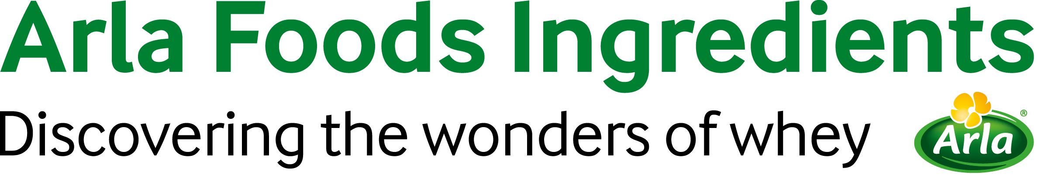

7 February 2018
PRESS RELEASE
Orienteering world champion signs up
to promote Lacprodan® HYDRO.365

Another leading athlete has joined Arla Foods Ingredients’ growing number of brand ambassadors for Lacprodan® HYDRO.365, the gold-standard whey protein hydrolysate for sports nutrition applications.

Denmark’s Maja Alm is one of the world’s most successful orienteers and cross-country runners. She has won six gold medals in the orienteering world championships, including a trio of consecutive victories in 2015, 2016 and 2017.

In cross-country, she has taken gold in the Danish national championships five times and is the current reigning champion, having won the most recent event in 2017. Her goal now is to qualify to represent Denmark in the 5,000m track race at the 2020 Tokyo Olympic Games.

Maja was introduced to Lacprodan® HYDRO.365 when she was involved in a study co-sponsored by Arla Foods Ingredients in 2014. She was one of 18 top-class runners from Team Denmark who participated in a one-week camp during which the athletes took part in 13 training sessions. The runners were divided into two groups of nine, with one group consuming traditional sports drinks containing carbohydrates and electrolytes before and after each session, while the other group consumed pure HYDRO.365 before each session and both a sports drink and HYDRO.365 afterwards.

A 4km run-test was undertaken following the conclusion of all 13 training sessions. The results demonstrated that the athletes who consumed HYDRO.365 before and after training performed better than the sports drink-only group, with a mean improvement of 17 seconds. The whey protein group also experienced less muscle damage compared with the sports drink-only group.

“Taking part in this experiment highlighted to me the benefits of HYDRO.365 whey protein hydrolysates,” said Maja. “I was able to see the clear advantages they offered me as an athlete in terms of enhancing recovery between training sessions and giving my performance a boost. I’m excited to continue my co-operation with Arla Foods Ingredients as an ambassador for HYDRO.365.”

Maja joins three other existing brand ambassadors for Lacprodan® HYDRO.365: Brazilian marathon runner and triathlete Adriano Bastos; Danish CrossFit star Filip Yang Fisker; and triathlete Allan Steen Olesen, who is also from Denmark.

Troels Laursen, Director of Health & Performance Nutrition at Arla Foods Ingredients, said: “The appointment of Maja Alm as our brand ambassador for Lacprodan® HYDRO.365 is exciting news. This outstanding whey protein hydrolysate is targeted at people who take their exercise – and their sports nutrition – seriously. We’re delighted to receive the endorsement of Maja, as well as Adriano, Filip and Allan, who are all top athletes who recognise the value of this exceptional ingredient and its ability to deliver unrivalled muscle recovery and performance benefits.”

Whey protein hydrolysates are premium proteins that have been finely chopped – or ‘pre-digested’ – so they are absorbed more quickly by the body than standard proteins. This ensures they get to work faster on helping the muscles recover after exercise, reducing recovery time between training sessions and events.

ENDS

For more information, please contact:
Richard Clarke, Ingredient Communications
Tel: +44 7766 256176 | Email: richard@ingredientcommunications.com

About Arla Foods Ingredients
Arla Foods Ingredients is a global leader in value-added whey solutions. We discover and deliver ingredients derived from whey, supporting the food industry with the development and efficient processing of more natural, functional and nutritious foods. We serve global markets within early life nutrition, medical nutrition, sport nutrition, health foods and other foods and beverage products.

Five reasons to choose us:
- We have R&D in our DNA
- We offer superior quality
- We are your trusted business partner
- We support sustainability
- We ensure security of supply

Arla Foods Ingredients is a 100% owned subsidiary of Arla Foods. Our head office is in Denmark.

RSS Feed
Visit our website at http://www.mynewsdesk.com/arla-foods-ingredients and sign up to our News RSS feed for all the latest developments – updated regularly.

Twitter
Follow us on twitter for all the latest updates @ArlaIngredients

LinkedIn
http://www.linkedin.com/company/arla-foods-ingredients

Facebook
https://www.facebook.com/arlaingredients

